Printed Documentation
Table of Contents
Getting Started 1
Online Help 1
Account Overview 2
Understanding Corporate Account Settings 4
User Access Roles 5
User Access Roles 5
NowPrint User Roles & Functions 9
Account Administration 11
Corporate Account Admin 11
Admin Home Overview 12
Contact Info 14
Preference Settings 15
Corporate Account Functionality Settings 15
User Interface 18
Update Corporate Account Branding 18
Update Address Fields 20
Update Legal Statements 21
Error Messaging 22
Status Emails 24
User Settings 25
Add New User 25
Bulk Load User 26
Update Access Roles 27
Set a user as an Approver 28
Update User Roles 29
Add User to a Group 30
Update User Group Access Roles 31
Remove User from Group 32
Customize Edit User Display 33
Manage Groups 35
Add a Group 35
Bulk Load Group 37
Delete a Group 38
Edit a Group 39
Add/Edit Payment Method 39
Map/Unmap Print Center 40
Map/Unmap Delivery Services 41
Address Fields 43
Custom Data Fields 44
Custom Data Field Types 44
Creating / Editing Custom Data Fields (Job, Alert, User) 45
Print Centers 47
Edit the Print Center 47
Delivery Services 52
Items 53
Overview 53
The use of Product Name versus Descriptions 53
Item-to-item mapping 54
Updating Items 54
Manage Items 54
Managing Items 55
Add Paper Items 57
Add Impressions 60
Click here to watch a short video on Adding Impressions 62
Add Bindery Items 62
Add Covers 64
Add Tabs 66
Add Finishing Options 68
Add Fees 72
Add Warehouse Items 73
Order Templates 76
Order Defaults 78
Order Workflows 79
Document Submission Workflow Settings 79
Catalog/Personalized Products Workflow 83
Oversized/Wide Format 85
List Manager 88
Personalized Products 92
Personalized Products 92
Creating a Personalized Product with Adobe InDesign® 93
Creating a Personalized Product with Microsoft Publisher® 97
Uploading Personalized Products 100
Preconfiguring a Personalized Product 116
Editing a Personalized Product 119
Deleting a Personalized Product 120
Manage Filing Cabinets/Catalogs 121
Filing Cabinet Overview 121
Accessing Personal Filing Cabinet 122
Filing Cabinet Options 124
Upload File to Personal Filing Cabinet 125
Upload a Catalog Item 128
Edit Preconfigured Item 133
Upload an InDesign® File 135
Create Kit 138
Move Selected Items 142
Copy Selected Items 143
Add New Folder 144
Map Selected Items 145
Delete Files/Folders 146
Address Book 147
Address Book 147
Add Recipient 148
Modify Recipient 149
Move Recipient 150
Add an Address Book Directory 151
Copy Recipient 152
Delete Recipient/Address Book 153
Upload a CSV file with Addresses 154
Reports 157
Reports 157
Homepage 159
NowPrint Home Page 159
Transaction History 160
Track an Order 161
Modify Order 163
Cancel Order 167
View Order 169
Reorder 171
Edit Reorder 172
My Account 175
Edit Account/Login Information 176
Change Password 177
Ordering Preferences 178
Contact Us 180
FAQ 181
Edit Page 182
Catalog Workflow 183
Customized Catalog Workflow 183
Document Catalog 184
Ordering Personalized Products 185
Catalog Order Shopping Cart 187
Select Recipients 188
Review and Place Order 189
Order Confirmation 190
AdHoc Workflow 191
AdHoc Workflow 191
Add Document(s) 192
Print Options 195
Add Tabs and Page Exceptions 197
Tab Wizard 198
Add Tabs by CSV 199
Delivery Options 200
Review and Place Order 201
Order Confirmation 202
Ordering from a Personal Filing Cabinet 203
Placing an Order Using Order Templates 205
Placing a Counter Drop-off Order 208
Customer Service 211
Customer Service 211
Searching Customer Service Queue 213
Changing Customer Service Queue Settings 214
Print Production Queue 215
Print Production Queue 215
Searching for Orders 217
Changing Production Queue Settings 218
Order Ticket 220
Order Status 221
Update Order Status 222
Advanced Order Status Options 223
Assign Order to Print Operator 224
Downloading and Printing Files 226
Batch Process Orders 227
Production Download 228
Order Adjustments 230
Add a Production Note 232
Change an Order Due Date 233
Reprocess Order 234
Print Center Transfer 235
Add Print Production Charge 236
Add Additional Costs 238
Adjust Billing Information 239
Adjust Order Configuration 240
Set Shipment Tracking Number 242
Replace Order Files 243
Add File(s) to Order 243
Replace File 246
View Version History 247
Set Order Exception 248
Cancel Order 249
Split Job 250
Editing Device Usage 251
Adjust Price Prompt Items 253
Manage Line Item Price 254
Manage Alerts 255
Printable Order Ticket 256
Shipping Slip 257
Index 259

Getting Started

Online Help

Getting Started
Welcome to the NowPrint ASAP online help. This help is designed to provide the tools necessary to administer your NowPrint ASAP site. Please log in as the Account administrator to begin configuring your account.

Step | Task
Step 1 | Edit Your Preferences
Step 2 | Edit Your Print Center Details
Step 3 | Edit/Create Items
Step 5 | Map Delivery Services
Step 7 | Create a Payment Methods
Step 10 | Activate Order Workflows
Step 11 | Create a User and Review the Buyer Experience

Account Overview

You have licensed a NowPrint Master Account. Your Master Account can contain multiple Corporate Accounts, which can contain unlimited groups. Users (the individuals who place orders on NowPrint) are created within a Corporate Account and can be mapped to one or more groups defined within that Corporate Account. The graphic below illustrates this relationship.

Groups

Within NowPrint, you can create an unlimited number of groups in order to further segment your users. Each group has its own unique file cabinet (catalog) and address book. Each group can be mapped (associated) to delivery services, print centers, and payment methods. Thus, each group can have a unique set of delivery services, print centers, and payment methods available to the users who belong to the group.

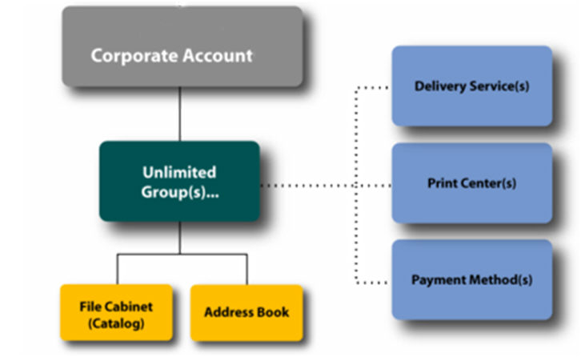

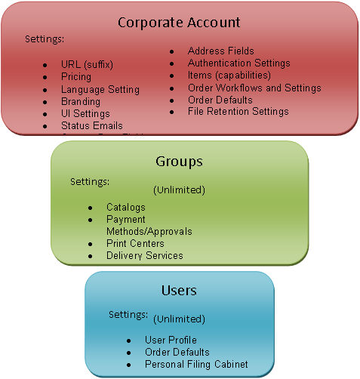

Understanding Corporate Account Settings

Feature | Corporate Account | Inherited from Pricing Template | Inherited from Preferences Template | Cloned from Preferences Template
Contact Info | X
Functional Preferences | X |  | X
Authentication/Registration | X |  | X
UI Preferences | X |  | X
Status Emails | X
Users | X
Groups | X |  |  | X
Groups (File Cabinets) | X | X |  | X
Groups (Address Books) | X | X |  | X
Groups (Payment Methods) | X |  |  | X
Groups (Print Center Mappings) | X |  |  | X
Groups (Service Mappings | X |  |  | X
Address Field Mappings | X
Custom Data Fields | X |  | X
Order Templates | X
Order Workflows | X | X
Order Defaults | X |  | X
Personalized Products | X
Item Pricing (Standard) | X | X
Item Pricing (Tiered) | X | X
List Manager | X

User Access Roles

User Access Roles

A user's access roles determine which NowPrint interface(s) the user is permitted to access, as well as what functionality is available to that user within the interface(s). For example, the Print Production interface is accessible only by users who have been given the appropriate access role. Access roles are set up by the account administrator when adding a user to the system, and can be modified at any time.

User functionally can be updated for multiple users in the Manage Users section of the Admin page.

Access Role | Description | Capabilities
Print Fulfillment Specialist (PFS) | Print Operator | Print Production Capabilities  - Users with access to this group will have the top navigation option to the “Print Production” queue.  - Print center access is based on group membership and the mapping of print centers to those groups. Users with this access role will not be able to modify the order in any way that would cause the order value to be modified. The only Order Adjustment options that will be available are “Add Order Note”, “Set Carrier Tracking Number”, and “Edit Device Usage”.  Report Capabilities  - User with access to the PFS group and the “Report Writer” group will be able to run reports. The reports results will be based on all the groups they are a member of and the print centers mapped to those groups.
Print Center Manager (PCM) | Manager or Senior Level team leads | Print Production Capabilities  - Users with access to this group can do all activities as described in the “Print Fulfillment Specialist” group. In addition to those activities, within Print Production all Order Adjustment options are available.  Account Admin Capabilities  - This group will have the top navigation option to “Account Admin”. The options for “Inventory”, “Vendors”, and “Purchase Orders” are available.  Report Capabilities  - User with access to the PCM group and the “Report Writer” group will be able to run reports. The reports results will be based on all the groups they are a member of and the print centers mapped to those groups.
Sales Manager | Sales Representative in the field that want to see details of orders being placed by their customers. | - Users with access to this group will have the top navigation option to the “Customer Service” queue.  - The search results that are returned will be restricted to the Corporate Accounts that the Sales Manager has access to.  - The Order Adjustment options are not available to this group
Corporate Admin  (CA) | CA manages Users, manages Items, and manages Groups. | Account Admin Capabilities  - Users with this access role do have the top navigation option to “Account Admin”.  - The CA should also be able to set each individual item price for the Corporate Account through the items management interface. However, the CA should not be able to set the item pricing for the Master Account.  - The CA does have access to manage all Users within the Corporate Account.  - User management includes adding new users, resetting existing users’ passwords, and changing access roles to the file cabinets, address books and payment methods of the standard groups for the Corporate Account.
Print Central Administrator (PCA) | Senior Level Operations Staff with responsibility over individual print centers. | Print Production Capabilities  - All of the features that are available to the PCM should also be available to users with access to the PCA group.  Account Admin Capabilities  - Users with this access role do have the top navigation option to “Account Admin”. The PCA has access to all of the same features as that of the PCM. In addition, the PCA should be able to manage the definitions of all Print Centers for which they have access via other group membership and print center mappings.  Report Capabilities  - User with access to the PCA group and the “Report Writer” group will be able to run reports. The reports results will be based on all the groups they are a member of and the print centers mapped to those groups.
Customer Service Representative (CSR) | CSR who interacts with print buyers | Customer Service Capabilities  - Users with access to this group do have the top navigation option to the “Customer Service” queue.  - The search results that are returned will be restricted to the Corporate Accounts that the CSR has access to.  - The Order Adjustment options available to the CSR will only be “Add Order Note and “Cancel Order”. No other status changes will be allowed.  Account Admin Capabilities  - This group has the top navigation option to “Account Admin”.  - The CSR will have access to manage Users and Groups within all Corporate Accounts for which they have access.  - User management includes adding new users, resetting existing users’ passwords, and changing access roles to the file cabinets, address books and payment methods of the standard groups for which that user has access.  Report Capabilities  - User with access to the CSR group and the “Report Writer” group will be able to run reports. The reports results will be based on all the groups they are a member of and the print centers mapped to those groups.
Customer Service Manager (CSM) | Advanced level Print Production Coordinator who coordinates activities between Print Buyers and internal production staff members. | Customer Service Capabilities  - Users with access to this group has the top navigation option to the “Customer Service” queue and the functionality that is described for the CSR – including Corporate Account restrictions. In addition to the available tasks defined for the CSR, the CSM can also perform all Order Adjustment options and make any and all status changes as necessary to an order like that of the PCM.  Account Admin Capabilities  - Users with this access role should also have the top navigation option to “Account Admin”.  - The CSM will be able to set each individual item price per Corporate Account through the items management interface. However the CSM will not be able to set the item pricing for the Master Account. Full access to the “Inventory”, “Purchase Order”, and “Credit” features should also be available.  Special Order Entry Capabilities  - The CSM is able to Order On Behalf of any user within any account to which they have access. This includes adding new Corporate Accounts and adding new users during the process. Additionally the CSM will have access to retrieve/manage Quotes.  Report Capabilities  - User with access to the CSM group and the “Report Writer” group will be able to run reports. The reports results will be based on all the groups they are a member of and the print centers mapped to those groups.

NowPrint User Roles & Functions

 | Customer Service Representative | Print Center Manger | Print Central Administrator | Corporate Account Admin | Customer Service Manager
Corporate User Settings | X |  |  | X | X
Corporate Group Settings | X |  |  | X | X
Corporate Contact Info |  |  |  | X | X
Corporate Functionality |  |  |  | X | X
Corporate User Interface |  |  |  | X | X
Corporate Status E-Mails |  |  |  | X | X
Corporate Address Field Settings |  |  |  | X | X
Corporate Custom Data Field Settings |  |  |  | X | X
Corporate Order Templates |  |  |  | X | X
Corporate Order Workflows |  |  |  | X | X
Corporate Order Defaults |  |  |  | X | X
Corporate Personalized Products |  |  |  | X | X
Print Center Management |  |  | X |  | X
Customer Service Queue | X |  |  |  | X
Item Management |  |  |  |  | X
Corporate Account Management |  |  |  |  | X

Account Administration

Corporate Account Admin

The Admin interface is accessed by clicking the Administration tab at the top of any NowPrint screen. The name of this tab may vary. You will only see this tab if administration rights are associated with your user account. A print buyer will not see the Administration tab nor access the Administration interface.

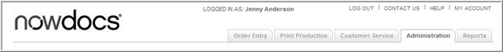

The main Admin area contains several interfaces (series of screens), which are represented as tabs along the top of the screen.
The visibility of each tab (and thus access to the corresponding interface) is dependent upon the user's access roles. For example, if a corporate administrator does not have access to see reports, then the Reports tab would not be visible.
The following interfaces exist within the NowPrint system (based on permissions):
- Order Entry: The Order Entry interface maintains the various user workflows. Users can upload files or order from a catalog, configure print options, and submit orders directly to print providers for delivery to recipients. Master administrators generally do not have access to workflows with the exception of the Order on Behalf of Another User workflow.
- Print Production: The Print Production interface is used by print production staff to view and manage orders. Orders are displayed in a queue that can be filtered and searched, and order tickets containing detailed information for each individual job can be accessed. Print production staff can manage an order's status, access files to be printed, and perform order adjustments.
- Customer Service: The Customer Service interface is used by customer service personnel to view and manage orders.
- Administration: The Administration interface is used by the different corporate or master administrator to manage the NowPrint settings, accounts and website, as well as the groups, users, print centers, products, and other components within the system. Depending on the administrator’s access role, the corporate administrator and master administrator will see different kinds of administration pages.
- Reports: The Reports interface is used to run numerous reports detailing NowPrint activities for a specified range of time.

Admin Home Overview

The NowPrint Admin interface is used by the Corporate Account Administrator to manage the Corporate Account settings, as well as the groups, users, print centers, products, and other components within the system.

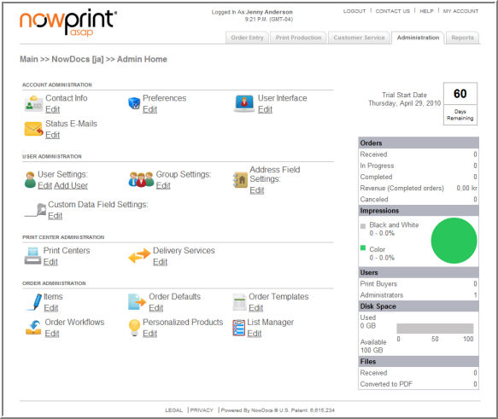

- Contact Info: Specify contact information for the account.
- Preferences: Set preferences related to the Account's functionality.
- User Interface: Configure settings related to the look, feel, and function of the screens within the NowPrint system.
- Status E-mails: Manage email notification messages.
- User Settings: Add and/or edit user account settings.
- Group Settings: Add and/or edit Groups Filing cabinet management and the various mappings can be done here too.
- Address Field Settings: Configure settings for the display of the address fields used to enter contact information.
- Custom Data Field Settings: Allows custom fields to be added to the ordering process to capture this information.
- Print Centers: Manage print information.
- Delivery Services: Manage delivery options.
- Items: Manage the components of print products, such as paper, impressions, bindings, covers, tabs, finishing options, etc.
- Order Defaults: Specify default ordering preferences.
- Order Templates: An order template defines the default print center, paper size, various print options and advanced finishing options. An ad hoc document upload workflow can turn on the order template selection feature. The buyer can choose a template that they prefer at step 1 of the workflow to save some time in customizing the print options later at step 2.
- Order Workflows: Manage predefined workflows.
- Personalized Products: Add/edit personalized templates.
- List Manager: Create and save lists that can be reused in the web forms for drop down lists, radio button lists, and images.

Contact Info

Use the Contact Info page to specify contact information for the Corporate Account.

Use the following steps to update the contact information:

- Click the Admin link from the NowPrint homepage.
- Click the Contact Info link.

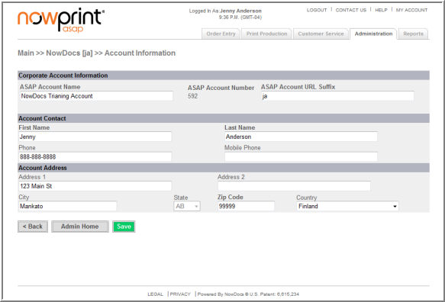

- Update the applicable fields.
- Click the Save button.

Preference Settings

The functional settings screen allows you to modify the Corporate Account preferences. There are many Corporate Account Preferences that also occur as Workflow Preferences. In the event that a Corporate Account Preference conflicts with a like Workflow Preference, the Corporate Account Preference takes precedence.

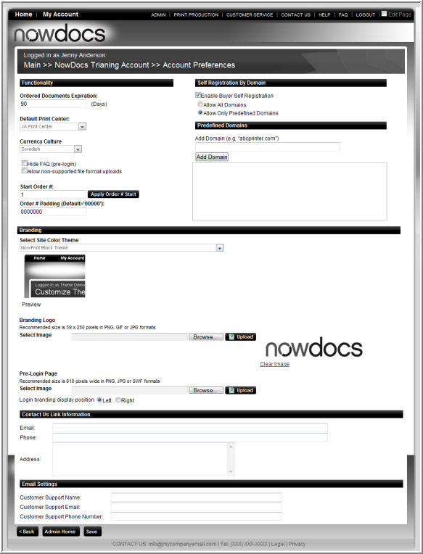

Corporate Account Functionality Settings

Corporate Account administrators have access to the following Functionality Settings:

Function | Description
Order Document Expiration | Dictates how many days after an order is marked complete that the file(s) associated to the order will be deleted.. When no entry is present documents will be kept forever.
Default Print Center | The default print center for order submission for the Corporate Account. When not overridden by a user or workflow preference this is the print center that will be used by orders placed from the account.
Currency Culture | Currency culture defines how NowPrint handles monetary values. Whether it should use decimals (as in the IS) or commas to separate values.  Below are the cultures, symbols that will be displayed and example format:  - English: $ 304,860.00  - Romanian: 304.860,00 lei  - Dutch-Netherlands: € 304.860,00  - Spanish: 304.860,00 €  - German: 304.860,00 €  - English - United Kingdom: £304,860.00  - Swedish: 304.860,00 kr
Hide FAQ (prelogin) | Removes the FAQ link from the login screen.
Allow non-supported file format uploads | Allow the upload of application files that are not supported for automated PDF conversion.
Start Order # | Default value displays the current number of orders submitted for this Account. This feature is useful when migrating from another system to maintain your current order numbers. Entered value must be higher than the current value.
Order # padding (default ‘00000’ | This overrides the default order prefix and will append to the beginning of the order number.
Enable Buyer Self Registration | When enabled, allows the ability for users to access self registration. Controls whether self registration link shows up on the login screen.
Allow Only Predefined Domains | Only users whose email matches the domain will be allowed to self register. Enter the domain “yahoo.com”, and it will appear in the restriction list.
Select the Desired Theme | Update the "skin" or theme of your site. Select a basic theme from the dropdown list box. To view an image of the theme, click the View button.
Branding Logos | Click the Browse button to locate a logo to replace the existing logo(s) in the upper left, center, or right of the screen. Click the Upload button.
Pre-login Page | Click the Browse button to modify the image displayed on the pre-login page. Click the Upload button.
Contact Us Link Information | Enter the information to be displayed when the buyer clicks on the Contact Us link.
Email Settings | Variables can be set-up to be inserted within email notification messages as appropriate. Enter the desired email variables in the desired fields.

User Interface

The user interface settings allows you to customize the Corporate Account.

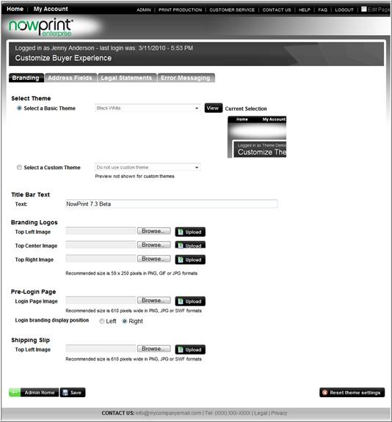

- Branding: update the Corporate Account color theme and logos.
- Address Fields: customize the buyer address fields.
- Legal Statements: customize NowPrint site legal statements.
- Error Messaging: customize NowPrint error messages.

Update Corporate Account Branding

Use the following steps to select update a corporate account branding:

- Click the Admin link from the NowPrint homepage.
- Click the Edit link under the User Interface option.

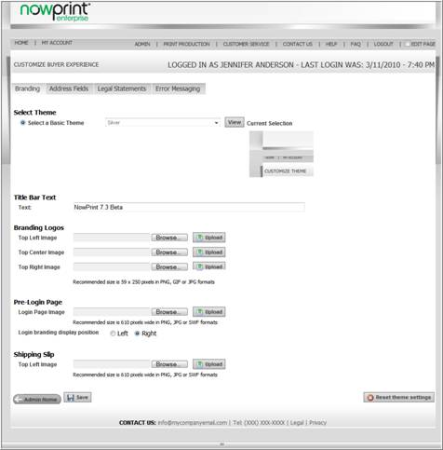

- Select the Desired Theme.
  - Choose a basic theme from the dropdown list box.
  - To view an image of the theme, click the View button.
Note: Master Account Admins have an option to select a basic theme or a custom theme. See page 5-4 for more information on Master Account Branding settings.
- Enter text to displayed in the Title Bar Text field.
- Branding Logos
  - Click the Browse button to locate a logo to replace the existing logo(s) in the upper left, center, or right of the screen.
  - Click the Upload button
- Pre-login Page
  - Click the Browse button to modify the image displayed on the pre-login page.
  - Click the Upload button.
- Shipping Slip
  - Click the Browse button to modify the shipping slip logo.
  - Click the Upload button.
- Click the Save button.

The screen refreshes with the selected changes displayed.

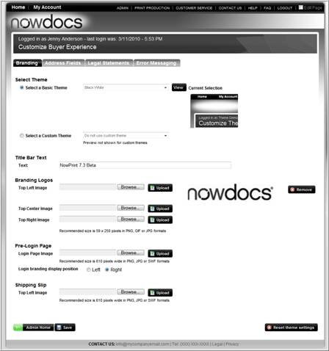

Note: To revert back to the Corporate Account default settings, click the Reset theme settings button.

 Click here to watch a short video on Updating the Corporate Account Branding

Update Address Fields

The Update Address Fields setting allows users to customize the address field labels and error messages.

Use the following steps to update the address fields:

- Click the Admin link from the NowPrint homepage.
- Click the Edit link under the User Interface option.
- Click the Address Fields tab.

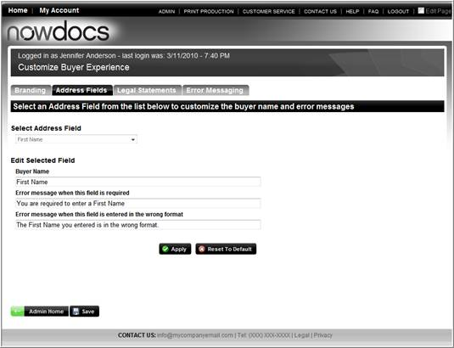

- Select the desired Address Field.
- Enter the desired label for the selected field.
- Enter the desired error message for the desired field.
- Enter the desired error message if the field is in the wrong format.
- Click the Apply button.
- Click the Save button.

Note: to restore to the Corporate Account defaults, click the Reset to Default button.

Click here to watch a short video on Updating the Corporate Account Address Fields

Update Legal Statements

The Update Legal Statements tab allows Corporate Account Administrators to customize the Terms and Conditions, Privacy, and legal statements within the site.

Use the following steps to update the site legal statements:

- Click the Admin link from the NowPrint homepage.
- Click the Edit link under the User Interface option.
- Click the Legal Statements tab.

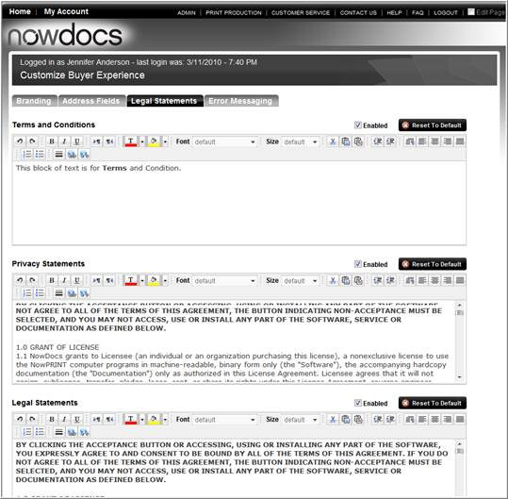

- Select the Enabled checkbox to enable the statement within the site.
- Enter and/or modify the desired text for the selected section.
- Use the HTML editor buttons to modify the formatting of the text.
- Click the Save button.

Note: to restore to the Corporate Account defaults, click the Reset to Default button.

Error Messaging

The Error Messaging section allows Administrators to update the system error message. In addition to the composed message, users will usually get a log error number than should be provided to NowDocs when reporting the error.

Use the following steps to update the site legal statements:

- Click the Admin link from the NowPrint homepage.
- Click the Edit link under the User Interface option.
- Click the Error Messaging tab.

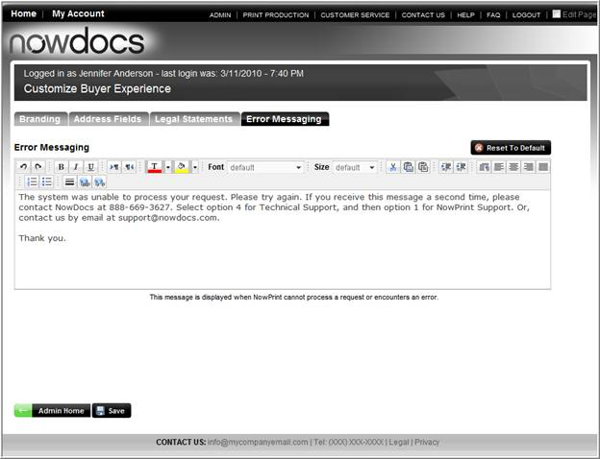

- Enter and/or modify the desired text for the selected section.
- Use the HTML editor buttons to modify the formatting of the text.
- Click the Save button.

Note: To restore to the Corporate Account defaults, click the Reset to Default button.

Status Emails
Variables can be set-up to be inserted within email notification messages as appropriate, such as customer support names, emails, URLs, etc. Email variable settings can be established for each individual Corporate Account, as desired.

Use the following steps to set-up status email variables:

- Click the Admin link from the NowPrint homepage.
- Click the Edit link under the Status Emails section.

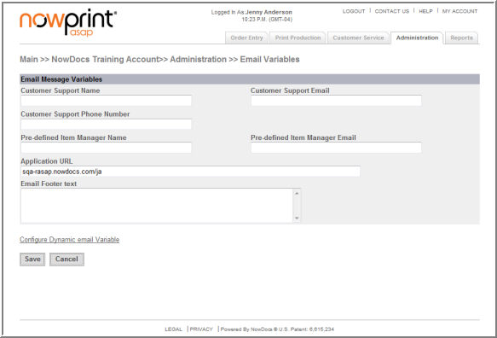

- Specify a default Customer Support Name.
- Specify a default Customer Support Email.
- Specify a default Customer Support Phone Number.
- Specify a default Pre-defined Item Manager Name.
- Specify a default Pre-defined Item Manager Email.
- Specify a default Application URL.
- Specify default Email Footer text.
- Click the Save button

You can create short variable names to be used in email messages that contain the Message Variable Value. This will allow you to create longer snippets of text, like a Privacy Message, and refer to them with short names in the email Text Message: “@Privacy.”

User Settings

The User Settings section allows corporate administrators to view, add, and edit users on the Corporate Account. Users can be added and removed from a Corporate Account Group, as well as have a definition for access privileges within the group.

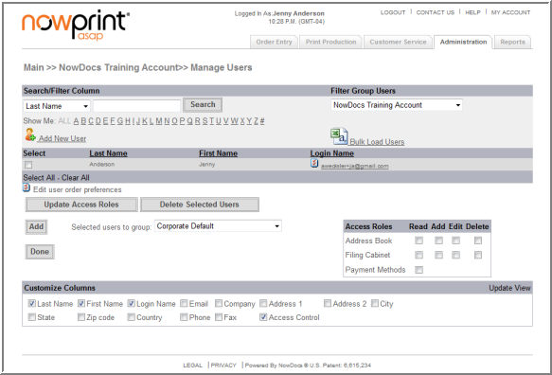

- Add new user – navigates to the add new user screen.
- Bulk Load Users – add multiple users to the Corporate Account by uploading a CSV File.
- Update Access Roles – modify a user’s access to the Group’s Address Book, Filing Cabinet, and Payment Methods.
- Delete User – remove a user from the Corporate Account.
- Add – Add users to a group.
- Customize Columns – modify which data is displayed for the user group.

Add New User

Corporate Account administrators can add users using the Add New User option.

Use the following steps to add a user:

- Click the Admin link from the NowPrint homepage.
- Click the Add User link under the User Interface option.

OR

- Click the Edit link under the User Interface option.
- Click the Add New User link.

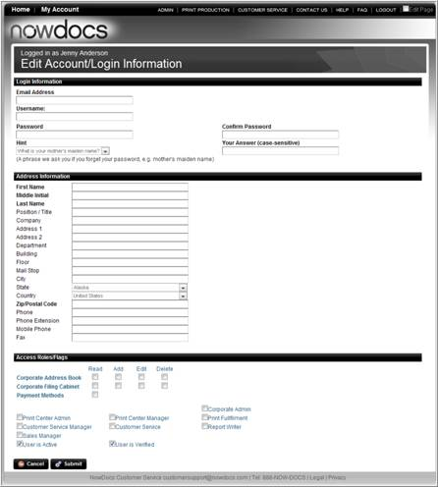

- Enter the new user details.
- Select the Access Role settings.
- Click the Submit button.

Bulk Load User

The Bulk Load User option allows Corporate Account administrators to upload multiple users at once using the Registration Template found in the NowPrint site.

Use the following steps to bulk load users:

- Login as a corporate admin.
- Click the Admin link from the NowPrint homepage.
- Click the Edit link under the User Interface option.
- Click the Bulk Load User link.

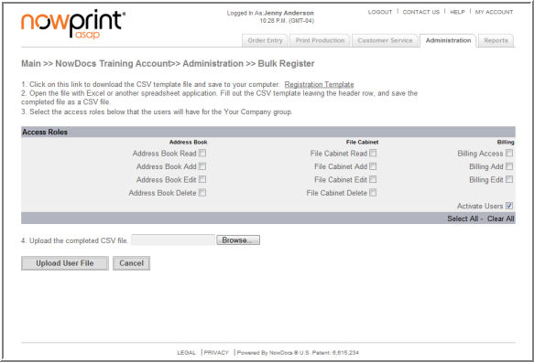

- Click on the Registration Template link. This will download the template to use for the bulk upload of users. Complete the template and save it to your computer.
- Select the Access Roles the users will have.
- Click the Browse button.
- Locate the Registration Template on your computer and click open.
- Click the Upload User File button.

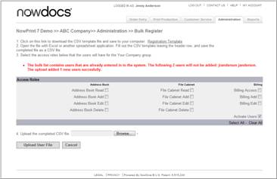

A message displays with the upload results in red.
Click here to watch a short video on Bulk Loading Users

Update Access Roles

A user's access roles determine which NowPrint interface(s) the user is permitted to access, as well as what functionality is available to that user within the interface(s). Access roles are set up by the corporate or master administrator, and can be modified at any time.

User functionality can be updated for multiple users in the Manage Users section of the Admin page.

Use the following steps to update the user functionality for multiple users:

- Click the Admin link from the NowPrint homepage.
- Click the Edit link under the Manager Users option.

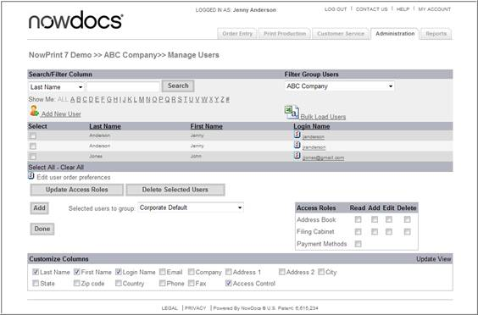

- Select the desired user(s).
- Select the desired Access Roles setting(s) for the users whose access rights are to be updated.
- Click the Update Access Roles button.

Click here to watch a short video on Updating the Corporate Account Access Roles

Set a user as an Approver

A user can be set as an approver so that he/she can view the orders that use payment methods required approval before it can be released to the print production queue. The approvers can then decide to approve or disapprove the orders.

Use the following steps to set a user an an approver:

- Click the Admin link from the NowPrint homepage.
- Click the Edit link under the User Settings option.

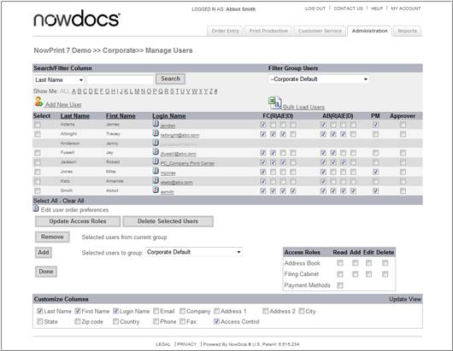

- Select Corporate Default from the Filter Group Users dropdown list.
- Select the checkbox under the Approver column for the users to be set as the approvers.
- Click the Update Access Roles button.

Update User Roles

A user's access roles determine which NowPrint interface(s) the user is permitted to access, as well as what functionality is available to that user within the interface(s). Access roles are set up by the Corporate administrator when adding a user to the system, and can be modified at any time.

User Corporate Account functionality can be updated for individual users.

Use the following steps to update the user Corporate Account settings:

- Click the Admin link from the NowPrint homepage.
- Click the Edit link under the Manage User option.

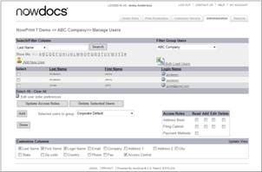

- Click the user login name you wish to edit.

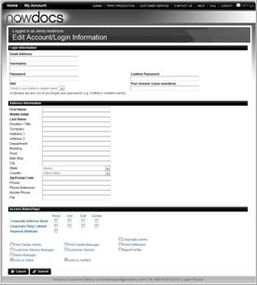

- Select the desired Access Roles setting(s).
- Click the Submit button.

Click here to watch a short video on Updating User Roles

Add User to a Group

Within a Corporate Account, you can create an unlimited number of groups in order to further segment your users. Groups are a collection of users who share the same settings and offerings within NowPrint.

Use the following steps to add a user to a group:

- Click the Admin link from the NowPrint homepage.
- Click the Edit link under the Manage Users option.

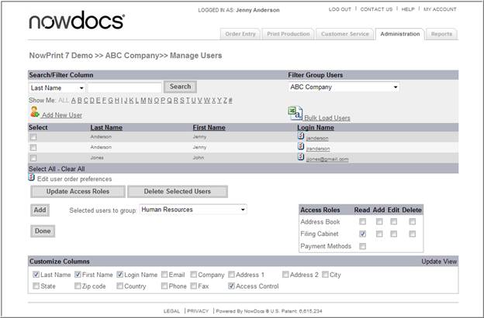

- Select the desired user(s).
- Select the desired group.
- Set the selected users’ access role to the group in the “Access Roles” section on the right.
- Click the Add button.

Click here to watch a short video on Adding Users to Groups

Update User Group Access Roles

Once a user has been added to a group, access settings need to be defined for the user.

Use the following steps to update access settings for users:

- Click the Admin link from the NowPrint homepage.
- Click the Edit link under the Manage Users option.

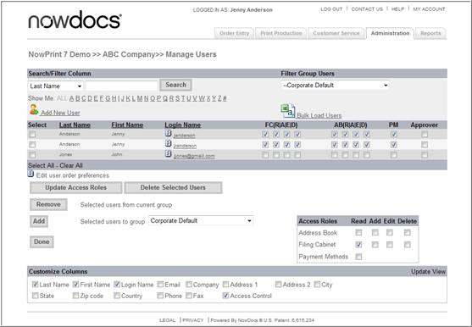

- Select the desired group from the Filter Group Users dropdown list box.
- Select the desired user roles.

  - FC = Group Filing Cabinet. Use this section to define the access levels for the Group Filing Cabinet. The Group Filing Cabinet is displayed in the Catalog Workflow.
  - AB = Group Address Book. Use this section to define the access levels for the Group Address Book.
  - PM = Payment Methods. Use this section to allow users to use the Group Payment Options.
  - Approver = Group Approver. Use this section to define the user as an order Approver for the group.

  - R = Read
  - A = Add
  - E = Edit
  - D = Delete
- Click the Update Access Roles button.

Click here to watch a short video on Updating User Group Access Roles

Remove User from Group

Use the following steps to remove a user from a group:

- Click the Admin link from the NowPrint homepage.
- Click the Edit link under the Manager Users Interface option.

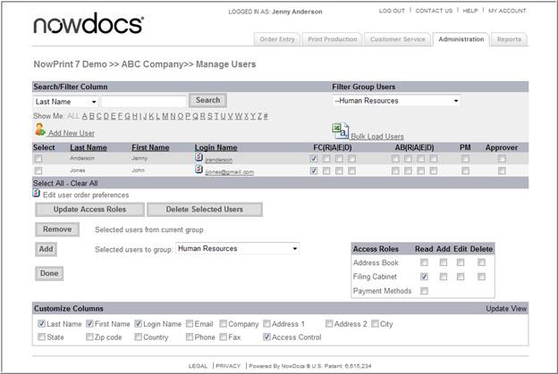

- Select the desired group from the Filter Group Users dropdown list box.
- Select the desired User(s).
- Click the Remove button.
Click here to watch a short video on Removing a User from a Group

Customize Edit User Display

Display columns can be added/removed using the Customize Columns section of the Manage Users window.

Use the following steps to edit the customize user display:

- Click the Admin link from the NowPrint homepage.
- Click the Edit link under the Manager Users Interface option.

- Select the desired columns to be displayed at the “Customize Columns” section on the bottom of the page. to be displayed.
- Click the Update View link.
Click here to watch a short video on Customizing the User Group Display

Manage Groups

Within a Corporate Account, you can create an unlimited number of groups in order to further segment your users. Groups are a collection of users who share the same settings and offerings within NowPrint. Each group has its own unique file cabinet (catalog) and address book. Each group can be mapped (associated) to delivery services, print centers, and payment methods. Thus, each group can have a unique set of delivery services, print centers, and payment methods available to the users who belong to the group.

Every Corporate Account has a Corporate Default group. This is where the default filing cabinet, address book, delivery services, print centers, and payment methods are stored.

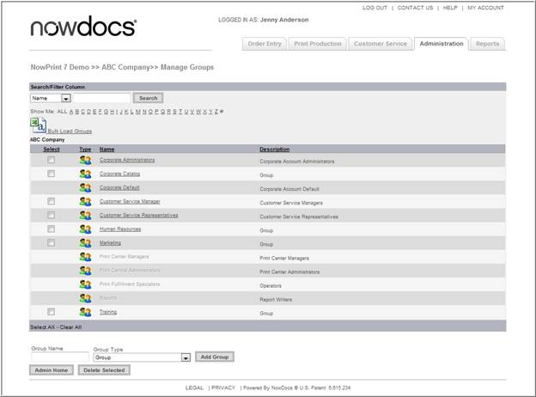

1 Bulk Load Groups – add multiple groups from a CSV File
2 Delete Selected – delete a group from the Corporate Account
3 Add Group – add a group to the Corporate Account

Add a Group

Individual Groups can be added using the Add Group option.

Use the following steps to add a group:

- Click the Admin link from the NowPrint homepage.
- Click the Edit link under the Group Settings option.

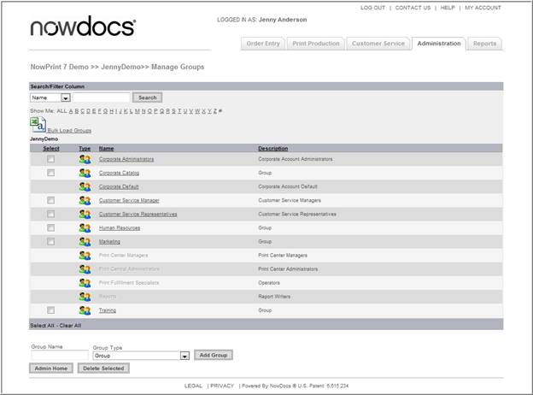

- Enter a group name in the Group Name text box.
- Select a group type from the Drop Down List box. Group type categories pertain to special permissions associated with the group you have selected. Customer Service, Print Center Manager, etc have restricted access to different admin functions. Placing a user into one of these groups and checking the box to enable the corresponding permission in their profile will allow them to have access to functionality associated with this group.
1 Corporate Administrators: This group can access the Administration interface for a Corporate Account and manage the users, print centers, and products within the Corporate Account.
2 Corporate Default: All users of the system are automatically part of the Corporate Default group.
3 Customer Service Manager: This group can access the Customer Service interface and coordinate activities between print buyers and internal production staff members.
4 Customer Service Representatives: This group can access the Customer Service interface and interact with print buyers.
5 Print Center Managers: This group can access the Print Production interface and perform all order adjustments.
6 Print Center Administrators: This group can access the Print Production interface and manage print center definitions.
7 Print Fulfillment Specialists: This group can access the Print Production interface and produce orders.
8 Reports: This group can access the Reports interface and run reports.

- Click the Add Group button.

Click here to watch a short video on Adding a Group

Bulk Load Group

The Bulk Load Group option allows Corporate Account administrators to upload multiple Groups at once using the Batch Group Template found in the NowPrint site.

Use the following steps to Bulk Load Groups:

- Click the Admin link from the NowPrint homepage.
- Click the Edit link under the Group Settings option.

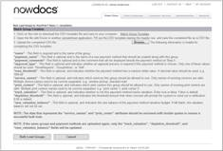

- Download, complete, and save the Batch Group Template to your computer. Table definitions are below:

1 Name - This field is required and is the name of the group.
2 Payment_name - This field is optional and is the name of a new payment method that should be created along with this group.
3 Payment_comments- This field is optional and is the comment that will be displayed beside the payment method on Step 4.
4 Approval_type - This field is optional and indicates whether an approval process is required if this payment method is chosen. Only one of these values should be used: ‘nonerequired’, ‘groupadmin’, or ‘Self’.
5 Max_threshold - This field is optional, and indicates whether the payment method has a maximum dollar value. A decimal value should be used; e.g. ‘999.00’
6 Service_names - This field is optional, and indicates which services this group should be allowed to use. Only names of existing services are valid. Multiple service names need to be comma separated. E.g. ‘window pickup, standard mail.’
7 Print_centers - This field is optional, and indicates which print centers this group should be allowed to use. Only names of existing print centers are valid. Multiple print centers names need to be comma separated. E.g. ‘print center 1, print center 2’.
8 Track_valuation - This field is optional, and indicates whether or not this payment method tracks valuation. Enter true or false. False is default.
9 Depletion_threshold - This field is optional, and indicates the threshold amount that when crossed will prompt the system to send out a notification. 0.00 is default.
10 New_valuation_balance - This field is optional, and indicates the new balance of the payment method valuation budget. If left blank, the valuation balance will not be set.

Note: The data that represents the service_names and print_center attributes should be enclosed with double quotes to ensure a successful bulk load.

Note: If the same groups and payment methods are uploaded again, only the track_valuation, depletion_threshold, and new_valuation_balance fields will be updated.

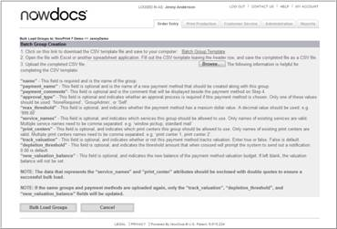

1 Click the Browse button.
2 Locate the completed Batch Group Template and click the Open button.
3 Click the Bulk Load Groups button.
Click here to watch a short video on Bulk Loading a Group

Delete a Group

Unneeded groups can be removed from the site using the Delete Group function.

Note: All users need to be removed from a group prior to deleting a group.

Use the following steps to delete a group:

- Click the Admin link from the NowPrint homepage.
- Click the Edit link under the Group Settings option.

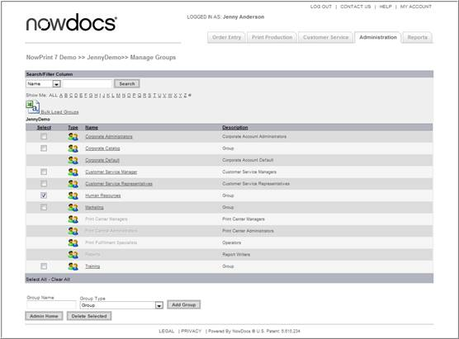

- Select the desired group(s).
- Click the Delete Selected button.

Click here to watch a short video on Deleting a Group

Edit a Group

Each group has its own unique file cabinet (catalog) and address book. Each group can be mapped (associated) to delivery services, print centers, and payment methods.

Grayed out options can be edited by the Master Account Administrator.

Add/Edit Payment Method

Use the following steps to Add/Edit Payment Method for a group:

- Click the Admin link from the NowPrint homepage.
- Click the Edit link under the Group Settings option.
- Select the desired group.

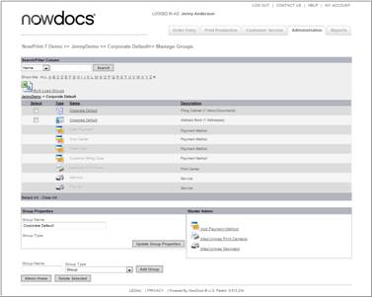

- Click the Add Payment Method link.

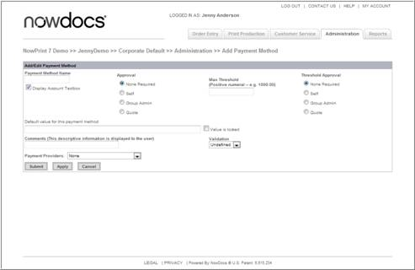

- Enter a payment method name.
- Select the appropriate Approval method:
After an order is placed by the users in the group using this payment method, the order will be held and appeared on the home page of the specified approver(s). The order will be considered successfully created and available in the print production queue after the one of the approvers approves it.
  - Non Required – no approval is required.
  - Self – users can have a chance to review their order before they submiting their orders for production.
  - Group Admin – the group admin needs to approve the order prior to submission to the print center. See page 6-32 to define group admin approvers.
  - Quote – When an order is placed with this payment method, the customer is asking for a quote on this item, and this order should NOT be produced.
- Enter a Max Order amount in the Max Threshold text box.
- Select the Max Threshold Approval requirement.
With a Max Threshold value entered and an approver type selected, if an order using this payment method has its order total value over the specified max threshold, the order will be held for approval before it can appear in the print production queue. If more than one approver are assigned (e.g. more than one group approver when Group Admin is selected), only one approver needs to approve the order.
1 Non Required
2 Self
3 Group Admin
4 Quote
- Enter a Default Value Payment Method. If you have selected the Display Account Textbox, use the Default value for this payment method field to specify the value that will appear in that field by default (for example, a specific purchase order number). Select the Value is locked checkbox to prevent users from changing the default value. If you would like users to have the ability to change the default value, then do not select this checkbox.
- Select an appropriate payment provider.
- Click the Submit button.

Click here to watch a short video on Adding a Payment Method

Map/Unmap Print Center

Corporate Print centers can be mapped to specific groups within a Corporate Account. In a case where a system is set up with multiple print centers, users have the ability to select the desired print center when placing their order(s) (if the print center selection feature is enabled in the workflow setup). See page 6-46 for more information on print center settings.

Use the following steps to map or unmap a print center:

- Click the Admin link from the NowPrint homepage.
- Click the Edit link under the Group Settings option.
- Select the desired group.

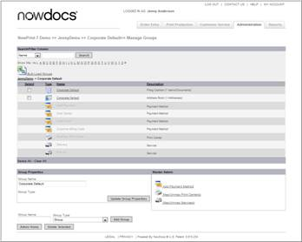

- Click the Map/Unmap Print Centers link.

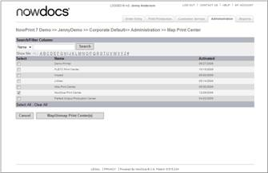

- Select or deselect the desired print center(s).
- Click the Map/Unmap Print Center(s) button.

Click here to watch a short video on Mapping/Unmapping a Print Center

Map/Unmap Delivery Services

Delivery options can be mapped to specific groups. Users have the ability to select their desired delivery options when placing their order(s).

Use the following steps to map and/or unmap delivery services:

- Click the Admin link from the NowPrint homepage.
- Click the Edit link under the Group Settings option.
- Select the desired group.

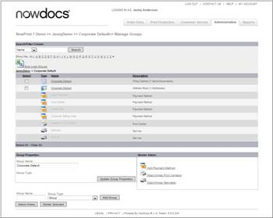

- Click the Map/Unmap Services link.

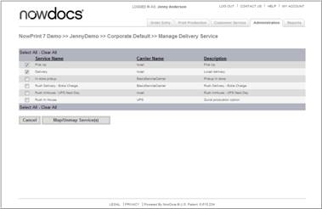

- Select or deselect the desired delivery service(s).
- Click the Map/Unmap Service(s) button.

Click here to watch a short video on Mapping/Unmapping a Delivery Service

Address Fields

Configure settings for the display of the address fields used to enter contact information, for a specific Corporate Account. These changes will override the master level settings.

Use the following steps to edit the Corporate Account address fields:

- Click the Admin link from the NowPrint homepage.
- Click the Edit link under the Address Field Settings option.

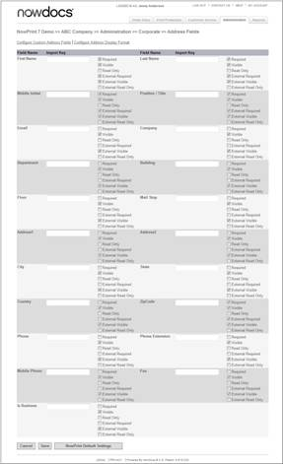

- Use the Import Key field to add custom data for 3rd party plug-ins, external systems, etc.
- Select or clear the checkboxes as appropriate to indicate whether you would like the address fields to be Required, Visible, and/or Read Only for internal and external users.
- Click the Save button to save your settings.

If you would like to erase your settings and revert to the default system settings, click the NowPrint Default Settings button.

Custom Data Fields

NowPrint provides functionality that allows custom fields to be added to the ordering process to capture this information. These fields are highly configurable with options to define how the data is collected, default values, minimum/maximum lengths and specific validations.

- Capturing special delivery information
Example: Dropdown list with special delivery options (Front desk, Mailbox, None)

- Capturing additional fields of information during order checkout
Example: Prompting the print buyer to enter special fields such as a department code, or other value

- Requesting information from the Print Buyer that needs to be shown on the production job ticket
Example: Adding a dropdown list that reads “Please call me to discuss my order.”

Custom Data Field Types

There are four types of Custom Data Fields in NowPrint:

- User: User custom data fields allow information to be captured during the ordering process from fields that are also available as part of the user profile.
- Job: Job custom data fields allow information to be captured during the ordering process.
- Alert: Alert custom data fields allow for the capture and notification on the production job ticket of special information associated with the job. These fields can also be searched by in the CSR queue based on Corporate Account and Data field value.
- Delivery: Delivery custom date fields are used to capture custom information that is associated with the delivery step of the order workflow. Only one of these fields can be active at a time, per workflow.

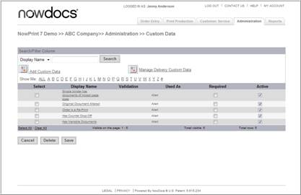

Adding Standard Custom Data Fields: Select “Add Custom Data” to add a custom data field.

Managing existing Standard Custom Data Fields: Within the datagrid, you can delete, enable/disable (active) and make a Custom Data Field required.

Creating / Editing Custom Data Fields (Job, Alert, User)

Use the following steps to create and/or edit a custom job, alert, or user custom data field:

- Click the Admin link from the NowPrint homepage.
- Click the Edit link under the Custom Data Field Settings option.

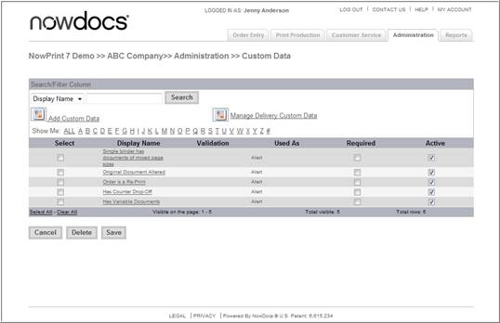

- Click the Add Custom Data link.

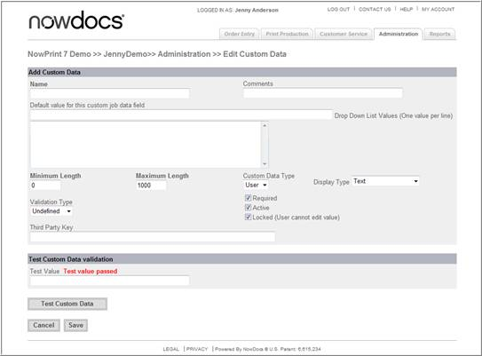

- Using the configuration screen above, the custom data field can be configured. Options include:
  - Name and Comments (displayed to the buyer).
  - Default value : an optional default value.
  - Dropdown list values: the list of dropdown values presented to the buyer when the Display Type is List.
  - Minimum / Maximum Length: the least or most amount of characters that are allowed for this field.
  - Custom Data Type: Defines whether the custom field will be an Alert, User, or Job field type. See above for more details on each of these.
  - Display Type: Allows for selection between textbox and dropdown list for the input control type.
  - Validation Type: Allows for the selection of a validation from the system. Validations are configured and saved at the Master Account level in the Validations Functional Area.
  - Required: Configures the field to require input.
  - Active: Enables of disables the field.
  - Locked:Populates the field and does not allow the user to enter a value.
  - Third Party Key: This field is only used in external integrations.

Print Centers

A print center is a logical entity most often represents a physical location. A print center also represents the production activities accomplished within a facility.

Edit the Print Center

Use the following steps to add a print center:

- Click the Admin link from the Homepage.
- Click the Add link under the Print Centers icon.

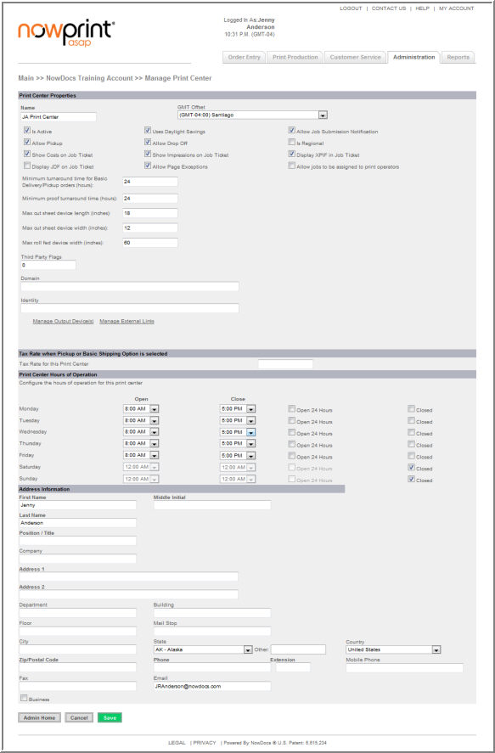

Below is an overview of the Print Center fields:

Field | Description
Name | Enter a name for the print center.
GMT Offset | Select the print center's time zone.
Is Active | If you are ready for this print center to be immediately available for producing orders, select the checkbox.
Uses Daylight Savings | Select the checkbox if the print center observes daylight savings time.
Allow Job Submission Notification | Select the checkbox if you would like an email to be sent to the print center whenever an order is submitted.
Allow Pickup | Select the checkbox if the print center supports the ability for users to physically pick up their orders from the print center in person.
Allow Drop Off | Select the checkbox if the print center supports the ability for users to submit a document in hard copy (paper) format by physically taking the document to the print center.
Is Regional | This preference is used to indicate that the print center has a defined regional location that it services. Unless there is the need to preselect a production facility based on the submitter’s postal code, then this should be left unset.
Show Costs on Job Ticket | Select the checkbox if you would like to display pricing on job tickets and thus make this information visible to production staff.
Show Impressions on Job Ticket | Select the checkbox if you would like to display impression information on job tickets.
Display XPIF in Job Ticket | Select the checkbox to allow access to XPIF instructions from the job ticket.
Allow Page Exceptions | Select the checkbox if the print center supports the ability for users to designate that specific pages in a document be printed differently from the rest (for instance, printing certain pages in a document in color instead of black & white).
Download Order Files | Select the checkbox to allow the ability to download order files from the job ticket.
Allow jobs to be assigned to print operators | Select the checkbox to allow an order's fulfillment to be assigned to a specific operator at the print center.
Use NowDocs Inventory Tracking | Select the checkbox if you would like to track inventory for this print center.
Allow Backordered Inventory | When the inventory feature is enabled, this preference is used to determine whether an order can be placed that contains materials that do not have an on-hand inventory value to support the number of items required for the order.
Allow Meter Reads | Select the checkbox if you would like to track the total number of impressions produced.
Minimum turnaround time for Basic Delivery/Pickup orders (hours) | Enter the minimum number of hours required for the print center to produce a job that requires delivery and/or pickup in the field.
Minimum proof turnaround time (hours) | Enter the minimum number of hours required for the print center to produce a proof in the field.
Max cut sheet device length (inches) | Defined max length of sheet fed paper at print center. Default is 18.
Max cut sheet device width (inches) | Defined max width of sheet fed paper at print center. Default is 12.
Max roll fed device width (inches) | Defined max width of roll fed device at print center. Default is 60.
Third Party Flags | This is left blank unless a custom integration has been completed.
Mass Transit transfer folder | Use the field to specify the folder where files will be queued for transfer to the print center.
Mass Transit destination folder | Use the field to specify the print center's local folder where files will be retrieved.
Days before archiving completed/cancelled orders | Use the field to indicate when you would like completed/cancelled orders to be archived.
Import item setting from | Use the drop-down menu if you would like to copy settings for items from an existing print center. Items are the components of a print product, such as paper, impressions, bindery, covers, tabs, etc.
Tax Rate for this Center | Flat tax rate applied to all jobs produced at the print center.
Configure the hours of operation for this print center | Sites set to EU languages use the 24 hour clock. We do have a minor bug on this where the opening time is at 12 Hr.
Address Information | Enter the print center's physical address, phone numbers, and email address in the fields, along with the first and last name of the person who is the main contact at the print center.

- Click the Save button.

Delivery Services

From the Custom Data Field functional area, you can select Manage Delivery Custom Data to add, delete or edit a Delivery Custom Data Field.

Use the following steps to map a delivery service:

- Click the Admin link from the NowPrint homepage.
- Click the Edit link under the Delivery Services icon.

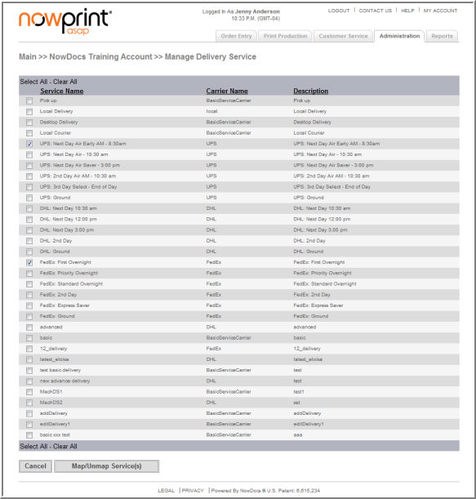
- Select the desired delivery options.
- Click the Map/Unmap Services button.

Items

Overview

Within the NowPrint application, an item is considered any product or production service that could have a cost associated with it. There are three categories of items.

- General Items
This category of items consists of paper, impressions, bindery, front and back covers, tabs and separators, warehoused items, and fees. With the exception of “fee” and “impression” item types, all of the items in this category can be physically inventoried. One other concepts to note is the inter-relationship that these items may have with one another. The page size and page count of the documents identified, can affect whether an item can be selected by a requestor based on relationship mappings.

- Advanced Finishing Option Items
These items are typically service oriented in nature and are performed off-line after printing has completed. They are considered advanced because an average order would not make use of these items. In fact the average requestor may be unaware of their existence or at least how to apply them to their order. The application allows for these items to be selected and often require special detailed instructions from the requestor to indicate the exact application of the finishing option to their order. The availability of these items is independent of the documents that were specified in the order. Examples of these items include folding, cutting, and drilling.

- Production Charges Items
These items are typically labor efforts performed by the production staff. These items are never displayed during the Order Entry process. They can only be applied by the production staff after the order has been submitted, and result as additional line items to the order for billing purposes. These items are independent of any option that was selected during the Order Entry process by the requestor. Examples of these items include typesetting, spell checking, and project management.

The use of Product Name versus Descriptions

One important concept is the use by the application of the product name and the product description. A general rule is that the product name is always what is displayed within the Order Entry portion of the application, and the Description is always what is displayed within the Print Production portion of the application. If there are items with the same product name that could be displayed within the Order Entry, then the application will filter out only uniquely named ones to be displayed. As an example, when the admin is setting up bindery options, there could be several different sizes of a particular bindery option. The admin can add the various sizes keeping the name the same, but the text used in the description would be unique based on the specific size. For instance Black GBC Coil has several different sizes that are measured in millimeters ranging from 6mm to 25mm. It would be confusing to the requestor if the application required them to have to choose the specific millimeter size of the coil to accommodate their document(s). Instead the application displays Black GBC Coil only once. If the requestor chooses this bindery type, then the application will determine which specific Black GBC Coil item should be used. This logic is based on matching the page count of the document(s), with the value indicated in the max pages field listed for the paper selected for that bindery option.

Item-to-item mapping

- Paper items have special relationships to two other item types; binders and impressions. The requirement for this relationship exists to allow the application to perform logic to guide the requestor in selecting the right options for their order.

- The relationship between paper and bindery is required to indicate which binder options should be displayed as valid options after the user has selected a particular type of paper. For instance if the requestor chose a multipart carbonless paper, GBC Comb binding is not a logical binding option that should be displayed. Additionally if a document consisted of 300 printed pages, then there would be a limited number of bindery options that could be used due to the thickness of the 300 sheets of paper. The appropriate relationships can be defined in the “Mapped Items” section to indicate whether the items have a relationship, and then further define the max page count that a particular bindery option can accommodate for that specific paper item.

- The relationship between paper and impressions is a bit more straightforward. Impressions are defined as the ink/toner applied to a single side of media (paper, transparency, etc). Generally speaking there are two types of impression; Black & White, and Color. The application accommodates the admin to define the relationship between every paper item defined and an impression. This is particularly handy when impressions are accounted for based on paper size. Additionally there may also be the case where a paper should not be printed using Color ink/toner.

Updating Items

With the installation of NowPrint, common items are preloaded into the site. A user with Master Account administrative privileges can add and modify items within the application at the Master Account level. This area allows the admin to define the item’s attributes and global pricing. If the Master Account has multiple Corporate Accounts, items can be defined either globally or restricted to a specific Corporate Account. If item pricing is specific to a particular corporation, then items can be mapped to that corporation with different prices defined.

Corporate Account administrators can select which items are available and the applicable pricing at the Corporate Account level.

Manage Items

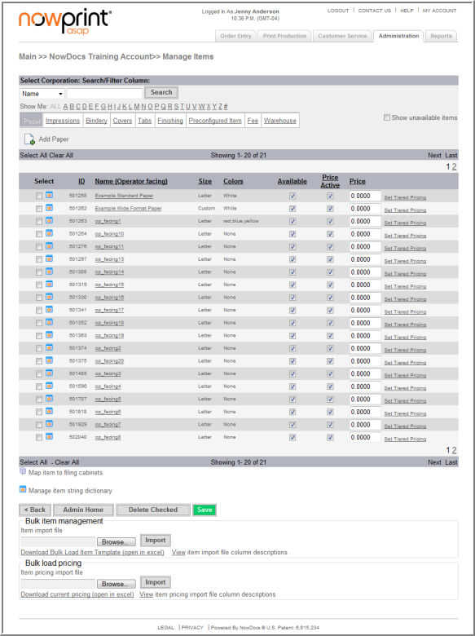

- Delete Checked – allows users to delete selected items.
- Bulk Item Management, import – allows users to upload items in bulk using the Bulk Load Item Template.
- Bulk Item Management, item pricing – allows users to update pricing in bulk using the Download Current Pricing template.

Managing Items

Items can be edited at the Corporate Account level if the Master Account Administrator has given rites to the Corporate Account Administrator.

Use the following steps to manage items:

- Click the Admin link from the NowPrint homepage.
- Click the Edit link under the Items option.

- Paper items are displayed. Select the desired item type (paper, impressions, etc.)
  - Restrict Availability – click the availability checkbox for the item to remove it from the Corporate Account options.
  - Price Active – click the price active checkbox to make the pricing active at the Corporate Account level.
  - Price – enter a price for the item.
- Click the Save button when complete.

Click here to watch a short video on Managing Items

Add Paper Items

Use the following steps to add paper items:

- Click the Admin link from the NowPrint homepage.
- Click the Edit link under the Items option.

- Click the Add Paper icon.

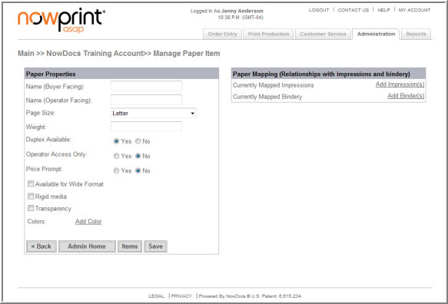

  - Name (Buyer Facing) – The text displayed in the drop down list within Order Entry for the item.
  - Name (Operator Facing) – The text displayed on the Job Ticket for the item.
  - Page Size – Correlates to standard page sizes. Options are Letter, Legal, 11X17, A4, A3, and Custom.
- Note: If the system detects the page size of an uploaded document that is not a standard size, it will always assume a “Custom” size. However if there are no paper items in the system that have been created as a “Custom” size, then the application will return an error message back to the user indicating that the document is incompatible and cannot be submitted. In order to accommodate non-standard page sizes, a separate paper item will need to be created with the designation of its paper size being “Custom.”
  - Weight – The weight in ounces of the item. This field is defaulted to 0.000, and it is not currently used in any calculation logic within the application.
  - Duplex Available – By checking this box, the paper item can be printed on both sides
  - Operator Access Only – By checking this box, the item will be hidden within Order Entry and will only be available while performing adjustments within Print Production.
  - Price Prompt – by – Use the Price Prompt option to indicate whether the operator will be required to enter a price for the item during the fulfillment process.
  - Available for wide format – makes the paper available for wide format impressions
  - Rigid Media – Used to indicate the page is not “flexible” and should be represented in the active preview as a rigid item
  - Transparency – Refers to preview for this paper type would be transparent or clear media - such as a clear cover.
  - Add Color – Clicking the “Add Color” link will permit the user to enter the name of a color to describe the paper into the adjacent text box. Upon clicking “Add” after the name has been entered, the user will have the option to add a preview swatch color by selecting from the list that appears when clicking the “Select Image” link or a HTML hex value can be entered to display a specific color swatch that is not available.
  - Delete Selected Colors – Selection of a color followed by clicking this button will remove the color from the list.
  - Mapped Items Table – This table will display all Impressions and Bindery items that have been added to the system. Selecting the box beside a particular item will map the paper to that item. Modifying the “Max Pages” field for each item indicates the number of sheets that can be accommodated by that particular item. The value of “999999999” indicates that there is no limitation in the relationship between the two items. This is typically the case for the relationship between paper and impressions.
  - Save/Cancel - Click the Save button to apply the configuration.
Click here to watch a short video on Adding Paper Items

Add Impressions

Use the following steps to add impression items:

- Click the Admin link from the NowPrint homepage.
- Click the Edit link under the Items option.

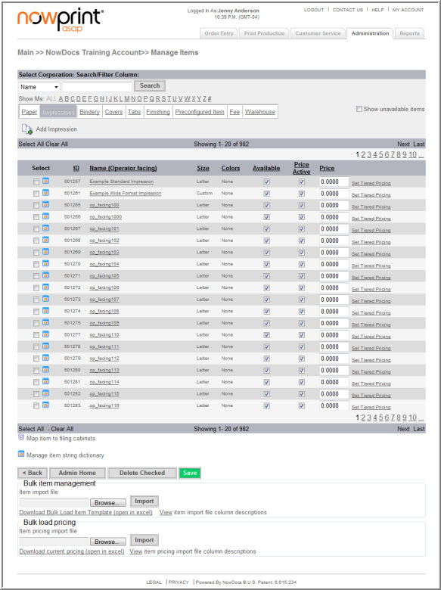

- Click the Impressions link.
- Click the Add Impressions icon.

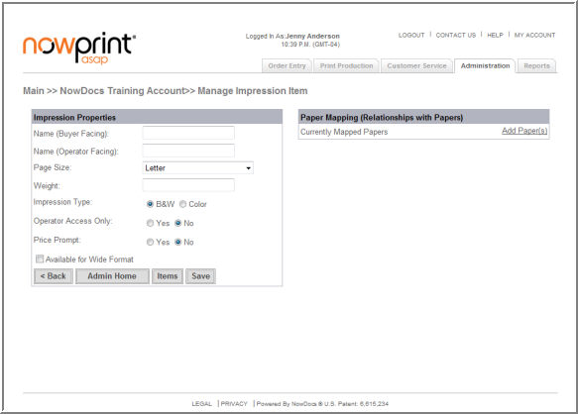

  - Name (Buyer Facing) – The text displayed in the drop down list within Order Entry for the item.
  - Name (Operator Facing) – The text displayed on the Job Ticket for the item.
  - Page Size – Correlates to standard page sizes. Options are Letter, Legal, 11X17, A4, A3, and Custom.
  - Weight – The weight in ounces of the item. This field is defaulted to 0.000, and it is not currently used in any calculation logic within the application.
  - Impression Type – Select Black and White or Color.
  - Only available to Print Operators – By checking this box, the item will be hidden within Order Entry and will only be available while performing adjustments within Print Production.
  - Price Prompt – Use the Price Prompt option to indicate whether the operator will be required to enter a price for the item during the fulfillment process.
  - Available for wide format – impression type would be available for wide format.
  - Mapped Items Table – This table will display all paper items that have been added to the system. Selecting the box beside a particular paper item will map the impression to that paper. There is no need to modify the value that appears in the “Max Pages” field for any item.
  - Save/Cancel - Click the Save button to apply the configuration.

Click here to watch a short video on Adding Impressions

Add Bindery Items

Use the following steps to add bindery items:

- Click the Admin link from the NowPrint homepage.
- Click the Edit link under the Items option.

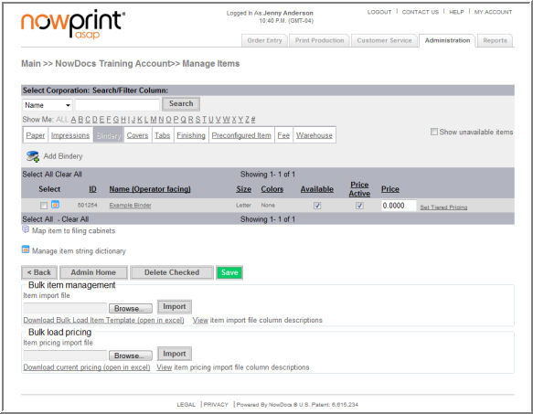

- Click the Bindery link.
- Click the Add Bindery icon.
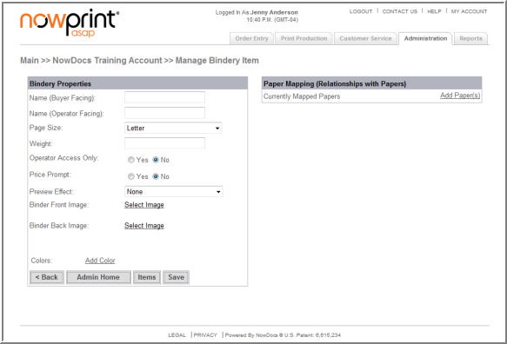

  - Name (Buyer Facing) – The text displayed in the drop down list within Order Entry for the item.
  - Name (Operator Facing) – The text displayed on the Job Ticket for the item.
  - Page Size – Correlates to standard page sizes. Options are Letter, Legal, 11X17, A4, A3, and Custom.
  - Weight – The weight in ounces of the item. This field is defaulted to 0.000, and it is not currently used in any calculation logic within the application.
  - Operator Access Only – By checking this box, the item will be hidden within Order Entry and will only be available while performing adjustments within Print Production.
  - Price Prompt – Price Prompt – Use the Price Prompt option to indicate whether the operator will be required to enter a price for the item during the fulfillment process
  - Preview Effect – select the option to be displayed in the dynamic preview on the AdHoc Workflow.
  - Binder Front Image – select the option to be displayed in the dynamic preview on the AdHoc Workflow.
  - Binder Back Image – select the option to be displayed in the dynamic preview on the AdHoc Workflow.
  - Colors – This text is displayed alongside the binder selection that indicates the colors for which the binder is available. Adding the text and then clicking the “Add Color” button will add the color to the binder.
  - Colors Select Box – This box displays colors that have been added, and allows for the removal of a color if necessary.
  - Remove – Selection of a color followed by clicking this button will remove the color from the list.
  - Mapped Items Table – This table will display all Paper items that have been added to the system. Selecting the box beside a particular item will map the binder to that item. Modifying the “Max Pages” field for each item indicates the number of sheets of paper that can be accommodated by binder for that paper item. The value of “999999999” indicates that there is no limitation in the relationship between the two items.
  - Save/Cancel - Click the Save button to apply the configuration.

Click here to watch a short video on Adding Bindery Items

Add Covers

Use the following steps to add cover items:

- Click the Admin link from the NowPrint homepage.
- Click the Edit link under the Items option.

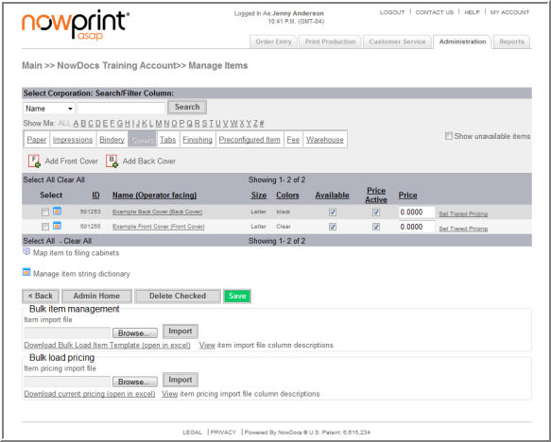

- Click the Covers link.
- Click the Add Front Cover or Add Back Cover icon.

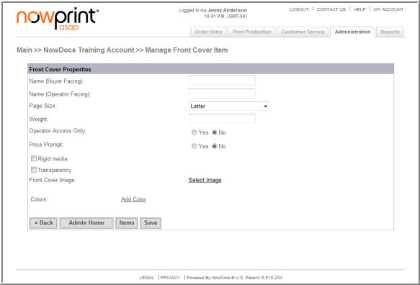

  - Name (Buyer Facing) – The text displayed in the drop down list within Order Entry for the item.
  - Name (Operator Facing) – The text displayed on the Job Ticket for the item.
  - Page Size – Correlates to standard page sizes. Options are Letter, Legal, 11X17, A4, A3, and Custom.
  - Weight – The weight in ounces of the item. This field is defaulted to 0.000, and it is not currently used in any calculation logic within the application.
  - Operator Access Only – By checking this box, the item will be hidden within Order Entry and will only be available while performing adjustments within Print Production.
  - Price Prompt – Use the Price Prompt option to indicate whether the operator will be required to enter a price for the item during the fulfillment process
  - Rigid Media – used to designate a plastic cover or sheet. In the active preview that image won't bend when you're turning the pages.
  - Transparency – Preview for this cover would be transparent
  - Front Image – Clicking this link renders a new page that allows for a mapping of an image that represents the image of the front or back cover. Several of the most common cover images are already included in the system, but new ones can be uploaded as well.
  - Colors – This text is displayed alongside the cover selection that indicates the colors for which the cover is available. Adding the text and then clicking the “Add Color” button will add the color to the cover.
  - Colors Select Box – This box displays colors that have been added, and allows for the removal of a color if necessary.
  - Remove – Selection of a color followed by clicking this button will remove the color from the list.
  - Save/Cancel - Click the Save button to apply the configuration.
Click here to watch a short video on Adding Covers

Add Tabs

Use the following steps to add tab items:

- Click the Admin link from the NowPrint homepage.
- Click the Edit link under the Items option.

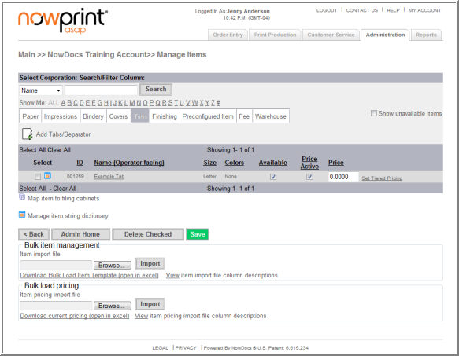

- Click the Tabs link.
- Click the Add Tabs/Separator icon.

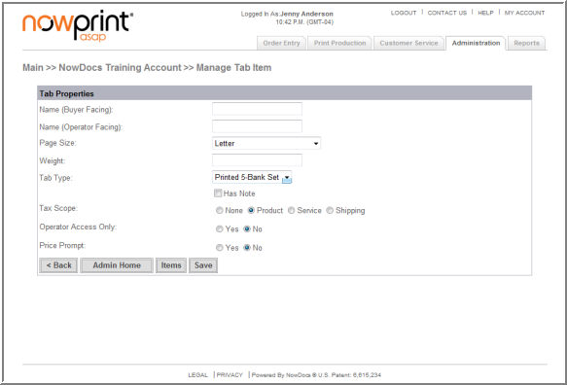

  - Name (Buyer Facing) – The text displayed in the drop down list within Order Entry for the item.
  - Name (Operator Facing) – The text displayed on the Job Ticket for the item.
  - Page Size – Correlates to standard page sizes. Options are Letter, Legal, 11X17, A4, A3, and Custom.
  - Weight – The weight in ounces of the item. This field is defaulted to 0.000, and it is not currently used in any calculation logic within the application.
  - Tab Type – There are four choices: Printed 5 Bank Set, Printed 3 Bank Set, Preprinted, or Divider. A printed tab is the type where the system allows the requestor to type in their own text for each line on the tab. The tab can accommodate two lines of 19 characters each.
  - Has Note – Select the Has Note checkbox if you would like a display on the screen during ordering process in which the user can enter additional information regarding the application of the tab to the order.
  - Tax Scope –
    - None - No tax is applied for this item.
    - Product - This item is considered a product for taxation purposes.
    - Service - This item is considered a service for taxation purposes.
    - Shipping - This item is considered part of a shipping expense.
  - Operator Access Only – By checking this box, the item will be hidden within Order Entry and will only be available while performing adjustments within Print Production.
  - Price Prompt –Use the Price Prompt option to indicate whether the operator will be required to enter a price for the item during the fulfillment process.
  - Save/Cancel - Click the Save button to apply the configuration.

Add Finishing Options

Use the following steps to add finishing items:

- Click the Admin link from the NowPrint homepage.
- Click the Edit link under the Items option.

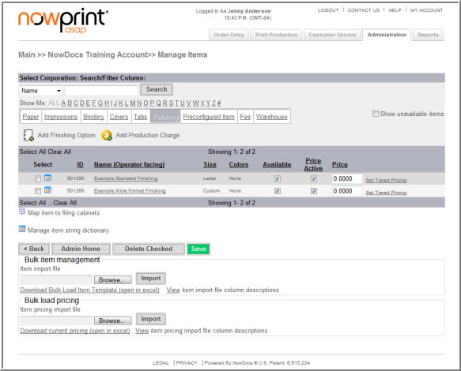

- Click the Finishing link.
- Click the Add Finishing Option icon.

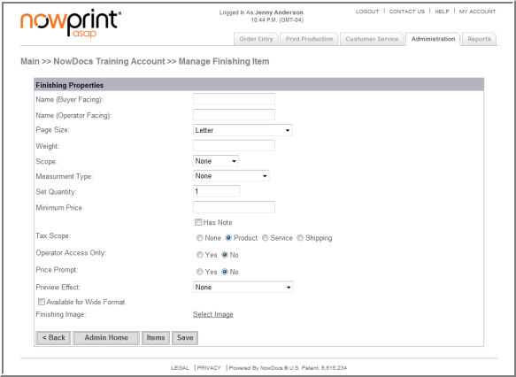

  - Name (Buyer Facing) – The text displayed in the drop down list within Order Entry for the item.
  - Name (Operator Facing) – The text displayed on the Job Ticket for the item.
  - Page Size – Correlates to standard page sizes. Options are Letter, Legal, 11X17, A4, A3, and Custom.
  - Weight – The weight in ounces of the item. This field is defaulted to 0.000, and it is not currently used in any calculation logic within the application.
  - Scope – Use the Scope drop-down menu to indicate whether the finishing item is applied at the document, binder, or order level.
  - Measurement Type – Use the Measurement Type drop-down menu to indicate how this item is measured.
  - Set Quantity Enter a value in the Set Quantity field to indicate how many finished products will be in a set when that finishing is applied. For example, if a shrink wrap finishing is applied and the Set Quantity is 10, then in an order calling for 120 binders the shrink wrap would be applied 12 times.
  - Minimum Price – Defines the minimum price this item will calculate to before the set price. Note: The line item will be given a per unit price * quantity to hit that total.
  - Has Note – Select the Has Note checkbox if you would like a display on the screen during ordering process in which the user can enter additional information regarding the application of the tab to the order.
  - Tax Scope –
    - None - No tax is applied for this item.
    - Product - This item is considered a product for taxation purposes.
    - Service - This item is considered a service for taxation purposes.
    - Shipping - This item is considered part of a shipping expense.
  - Operator Access Only – By checking this box, the item will be hidden within Order Entry and will only be available while performing adjustments within Print Production.
  - Price Prompt – Use the Price Prompt option to indicate whether the operator will be required to enter a price for the item during the fulfillment process. This is often used for items that require outsourcing to complete.
  - Preview Effect – select the option to be displayed in the dynamic preview on the AdHoc Workflow.
  - Available for Wide Format – finishing option would be available for wide format
  - Finishing Image - Clicking this link renders a new page that allows for a mapping of an image that represents the image of the front or back cover. Several of the most common cover images are already included in the system, but new ones can be uploaded as well.
  - Save/Cancel - Click the Save button to apply the configuration.
Click here to watch a short video on Adding Finishing Items

Add Production Charges

Use the following steps to add finishing items:

- Click the Admin link from the NowPrint homepage.
- Click the Edit link under the Items option.

- Click the Finishing link.
- Click the Add Finishing Option icon.

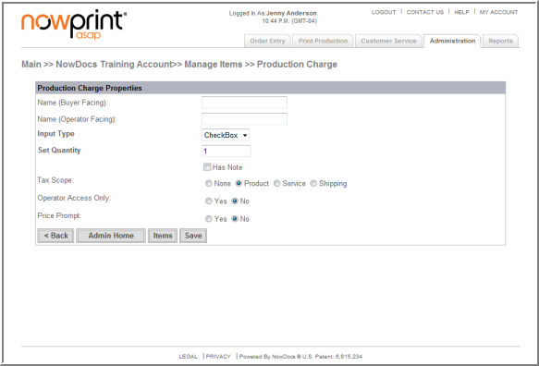

  - Name (Buyer Facing) – The text displayed in the drop down list within Order Entry for the item.
  - Name (Operator Facing) – The text displayed on the Job Ticket for the item.
  - Input Type - select the desired input type
  - Has Note – Select the Has Note checkbox if you would like a display on the screen during ordering process in which the user can enter additional information regarding the application of the tab to the order.
  - Tax Scope –
    - None - No tax is applied for this item.
    - Product - This item is considered a product for taxation purposes.
    - Service - This item is considered a service for taxation purposes.
    - Shipping - This item is considered part of a shipping expense.
  - Operator Access Only – By checking this box, the item will be hidden within Order Entry and will only be available while performing adjustments within Print Production.
  - Price Prompt – Use the Price Prompt option to indicate whether the operator will be required to enter a price for the item during the fulfillment process. This is often used for items that require outsourcing to complete.
  - Save/Cancel - Click the Save button to apply the configuration.

Add Fees

Use the following steps to add fees items:

- Click the Admin link from the NowPrint homepage.
- Click the Edit link under the Items option.

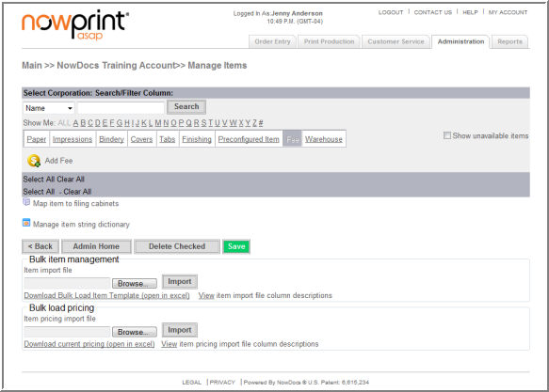

- Click the Fees link.
- Click the Add Fee icon.

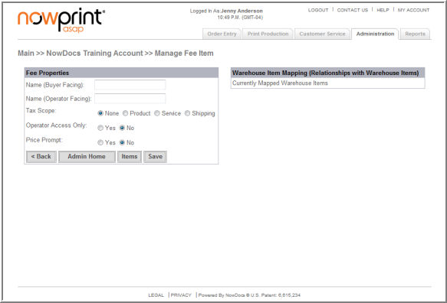

  - Name (Buyer Facing) – The text displayed in the drop down list within Order Entry for the item.
  - Name (Operator Facing) – The text displayed on the Job Ticket for the item.
  - Tax Scope –
    - None - No tax is applied for this item.
    - Product - This item is considered a product for taxation purposes.
    - Service - This item is considered a service for taxation purposes.
    - Shipping - This item is considered part of a shipping expense.
  - Operator Access Only – By checking this box, the item will be hidden within Order Entry and will only be available while performing adjustments within Print Production.
  - Price Prompt – Use the Price Prompt option to indicate whether the operator will be required to enter a price for the item during the fulfillment process.
  - Mapped Items Table – This table will display all Paper items that have been added to the system. Selecting the box beside a particular item will map the binder to that item. Modifying the “Max Pages” field for each item indicates the number of sheets of paper that can be accommodated by binder for that paper item. The value of “999999999” indicates that there is no limitation in the relationship between the two items.
  - Save - Click the Save button to apply the configuration.
Click here to watch a short video on Adding Fees

Add Warehouse Items

Warehouse items are physical objects that are not necessarily related to printing. These items are typically inventoried in a warehouse as pick-n-pack items that are kitted together. Warehouse items can be associated with fee items. When a warehouse item that is associated with a fee is ordered, the user is charged the fee in addition to the cost of the warehouse item. In addition, warehouse items can be mapped to file cabinets in order to make them available in that file cabinet for selection during the ordering process.

Use the following steps to add warehouse items:

- Click the Admin link from the NowPrint homepage.
- Click the Edit link under the Items option.

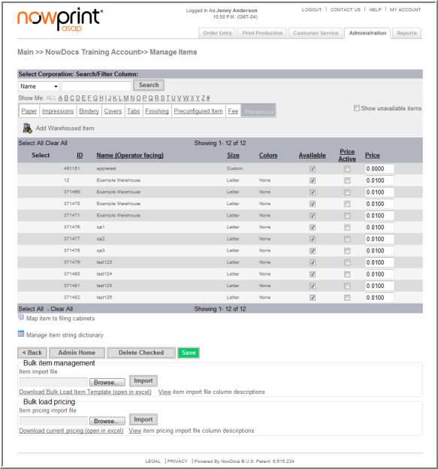

- Click the Warehouse link.
- Click the Add Warehoused Item icon.

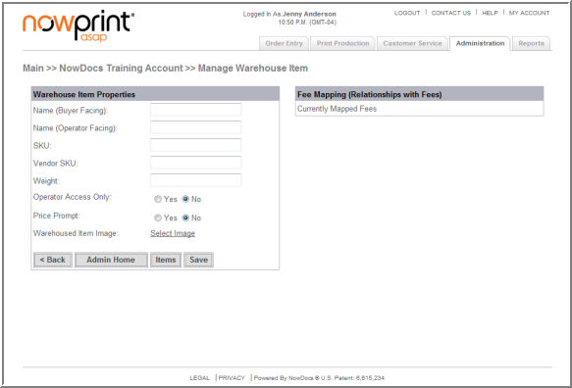

  - Name (Buyer Facing) – The text displayed in the drop down list within Order Entry for the item.
  - Name (Operator Facing) – The text displayed on the Job Ticket for the item.
  - SKU – Enter a desired SKU.
  - Vendor SKU – Enter a desired vendor SKU.
  - Weight – The weight in ounces of the item. This field is defaulted to 0.000, and it is not currently used in any calculation logic within the application.
  - Operator Access Only – By checking this box, the item will be hidden within Order Entry and will only be available while performing adjustments within Print Production.
  - Price Prompt – Use the Price Prompt option to indicate whether the operator will be required to enter a price for the item during the fulfillment process.
  - Warehoused Item Image - Clicking this link renders a new page that allows for a mapping of an image that represents the image of the front or back cover. Several of the most common cover images are already included in the system, but new ones can be uploaded as well.
  - Mapped Items Table – This table will display all Paper items that have been added to the system. Selecting the box beside a particular item will map the binder to that item. Modifying the “Max Pages” field for each item indicates the number of sheets of paper that can be accommodated by binder for that paper item. The value of “999999999” indicates that there is no limitation in the relationship between the two items.
  - Save - Click the Save button to apply the configuration.
Click here to watch a short video on Adding Warehouse Items

Order Templates

You can create order templates for Corporate Accounts to define specific production characteristics for orders. Users can choose from the order templates in Step 1 of the AdHoc workflow. Order templates may be added, edited, or deleted when desired.

Note: In order for Order Templates to be displayed, the “Enable Order Templates” need to be checked in the AdHoc Workflow settings.

Use the following steps to add an order template:

- Click the Admin link from the NowPrint homepage.
- Click the Edit link under the Order Templates option.

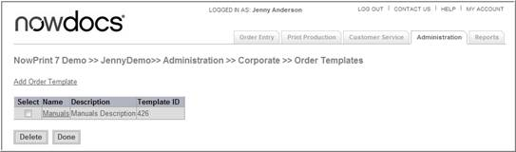

- Click the Add Order Template link.

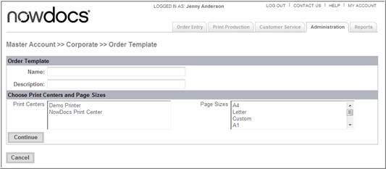

- Use the Name field to specify a name for the order template.
- Enter a description for the order template in the Description field.
- Use the Print Centers menu to select the print center to which the order will be routed.
- Use the Page Sizes drop-down menu to specify a page size.
- Click the Continue button. The system opens a new screen.

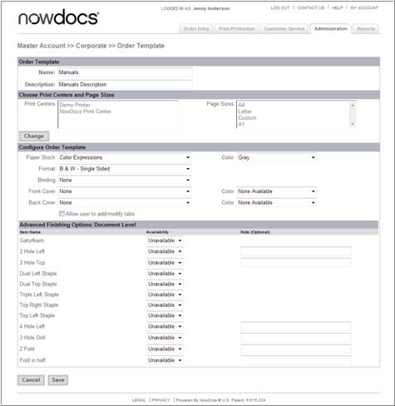

If you would like to change the Print Centers or Page Sizes, click the Change button and follow the steps above.

- Use the Paper Stock and adjacent Color drop-down menu to select the paper type and color.
- Use the Format drop-down menu to choose the format method.
- Use the Binding drop-down menu to choose a binding.
- Use the Front Cover and Back Cover and adjacent Color drop-down menus to select covers.
- Select the Allow user to add/modify tabs checkbox if you would like users to have the ability to add tabs to the document during the ordering process.
- Use the Advanced Finishing Options: Order Level fields to select specific finishing options to be applied at the order level (i.e., for all documents in the order as a whole). The Note field beside some of the finishing options can be used to enter any special notes or instructions.
- Use the Document Level Finishing Options fields to select specific finishing options to be applied at the individual document level. The Note field beside some of the finishing options can be used to enter any special notes or instructions.
- Click the Save button.
Click here to watch a short video on Order Templates

Order Defaults

You can specify default ordering preferences for a Corporate Account to save users from having to select the most commonly used settings when placing orders. The selections you choose will automatically be selected by default when orders are placed. However, if a user chooses to make changes during the ordering process, those changes will override the default settings.

Use the following steps to set order defaults:

- Click the Admin link from the NowPrint homepage.
- Click the Edit link under the Order Defaults option.

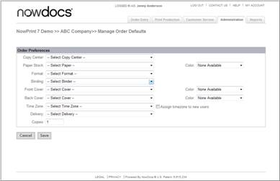

- Use the Copy Center drop-down menu to specify the print center to which orders should be sent by default.
- Use the Paper Stock and Color drop-down menus to set the default paper type and color.
- Use the Binding drop-down menu to set the binding preference.
- Use the Front Cover and Back Cover and corresponding Color drop-down menus to specify the default covers.
- Use the Time Zone drop-down menu to set the time zone of your default location. This is important, as the system will use this information to calculate estimated delivery time and to time stamp each step of the order process.
- Use the Assign time zone to new user’s checkbox to automatically assign the time zone you specified with the Time Zone drop-down menu to users who self-register.
- Use the Delivery drop-down menu to specify the default delivery method.
- Use the Copies field to specify the default number of copies.
- Click the Save button.

Order Workflows

Order workflows are the configurable processes through which users procure print. Users choose their desired order workflow from the Order Entry main screen at the beginning of the ordering process.
Order workflows include:
- Document Submission. This order workflow allows users to upload files directly from their personal computer or system network and configure print options as desired.
- Catalogs/Personalized Products. Catalogs contain preconfigured documents and personalized products that are available for ordering in a shopping environment where they can be browsed, previewed, and procured.

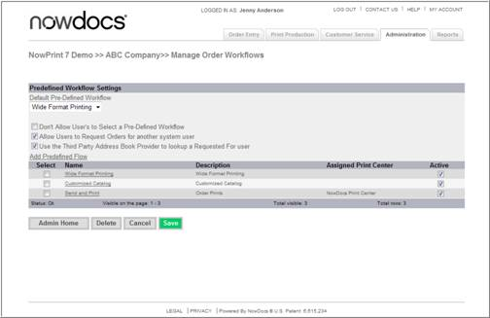

- Active defines if the workflow is displayed. To make active or inactive, click the active checkbox and click Save.

Document Submission Workflow Settings

This order workflow allows users to upload files directly from their personal computer or system network and configure print options as desired.

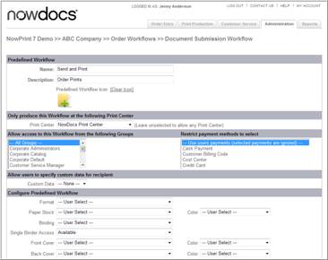

  - Enter a name for the order workflow in the Name field.
  - Enter a description of the order workflow in the Description field. This is the label for the order workflow that users will see on the Order Entry screen.
  - To select an existing image, use the Display Images of Type drop-down menu to choose a category of images. Then click the Use link next to the image you would like to use.
  - To upload a new image, click the Upload New Image(s) link. The system displays a new screen from which you can upload up to five images. Click the Browse button to select the image file(s) from your system. Enter a Description and select an image category from the Type drop-down menu. Then click the Upload Images button.
  - If you would like to designate only one print center to produce orders placed with this workflow, select it from the Print Center drop-down menu. Do not make a selection if you would like users to have the ability to select a print center.
  - Use the drop-down menu Allow access to this Workflow from the following Groups to specify which groups of users are permitted access to this workflow. If you would like all users to have the ability to access this workflow, select All Groups.
  - Use the Restrict payment methods to select drop-down menu if you would like to restrict this workflow to a particular payment method.
  - Use the Custom Data drop-down menu to indicate whether users can specify custom data for a recipient during the ordering process.
  - Use the Format drop-down menu to restrict the format method to only one option. Users will not be able to select a different format method during the ordering process. Select "User Select" to allow the user to select from multiple formats.
  - Use the Paper Stock and corresponding Color drop-down menus to restrict the paper stock/color to only one option. Users will not be able to select a different paper stock/color during the ordering process. Select "User Select" to allow the user to select from multiple paper stocks/colors.
  - Use the Binding drop-down menu to restrict the binding to only one option. Users will not be able to select a different binding during the ordering process. Select "User Select" to allow the user to select from multiple bindings.
  - Use the Single Binder Access drop-down menu to specify whether the ability to combine files into a single document is available, unavailable, required, or the default option.
  - Use the Front Cover and Back Cover and corresponding Color drop-down menus to restrict the front/back cover and color to only one option. Users will not be able to select a different front/back cover and color during the ordering process. Select "User Select" to allow the user to select from multiple front/back covers and colors.
  - Use the Number of Documents Allowed field to restrict the number of files users can upload. For no restriction, leave the value as 99999.
  - Use the Minimum Order Quantity field to set the minimum order quantity for this workflow. This value is typically left at 1.
  - Use the Special Production Instructions field to enter any production instructions you would like to include with every order.
  - Use the checkboxes in the Additional Instructions section to configure the interface users will see during this workflow. Select or clear each checkbox as desired for each option:

Preference | Description
Display Pricing to the Buyer | Displays pricing to the buyer as they make their product selections.
Show only order totals on the receipt | Will not itemize pricing. The total order value will be shown on the receipt the cost of the items ordered will not be itemized.
Require orders to be named | Require users to specify a name for the order.
Enable print buyer to select print center | Allow users to select from a list the print center to which the order will be routed.
Restrict Print Center to buyer region | If print center regions have been defined, in Step 1 of the ordering process show only the print centers in the user's region.
Enable order templates | Allow users to select an order template which defines specific production characteristics for the order.
Require print buyer to approve preview | Do not allow users to proceed to Step 2 until they have selected a checkbox to confirm that they have previewed the files for accuracy.
Enable production charge items for Operators/CSR roles | Allows the addition of production charge items when an administrator or CSR is ordering on behalf of another user. The buyer will not see these options.
Enable special instructions | Allow users to enter special instructions for the order.
Enabled print buyer to select email notifications for recipient(s) | Allow notification emails to be sent to order recipients.
Enable Print Buyers to upload files | Allow users to upload files from their system.
Enable Personal Filing Cabinet for Print Buyers | Allow users to select files from a file cabinet.
Enable print buyer to bypass PDF conversion | Allows buyer to skip conversion process not creating a PDF file.
Enable network file paths | Allow users to specify a network file path for the order to be available as a link from which the print center will retrieve the file for printing.
Enable Hardcopy drop-off | Do not allow users to submit documents in hard copy (paper) format by physically taking them to the print center.
Enable page exceptions | Allow users to indicate that specific pages in a file should be printed differently from the rest.
Enable mixed page sizes for combined documents | In Step 2 of the ordering process
Enable print buyer to add tabs | Allow users to add tabs and dividers.
Enable buyer to change finished size | Allow users to select the finished size for their document.
Enable unique print options for each recipient | Allow users to change the configuration of the order per recipient.
Enable quantity per recipient instead of per document | Allow users to specify the number of copies to be sent to each recipient.
Enable cover pages | Allow users to include cover pages for order recipients.
Enable delivery time selection | Allow users to specify a delivery time.
Limit delivery address to print buyer | Do not allow buyer to select additional delivery addresses.
Enable recipient list upload | Allow users to add multiple recipients to an order by uploading a CSV file.
Enable print buyer to select delivery date and time | Allow users to indicate the date and time by which they would like the order delivered.
Enable the print buyer to be the default recipient for orders | The buyer is automatically set as the recipient of any order they create as opposed to selecting themselves as the user as a recipient.
Enable unique special instructions per recipient | Allow users to indicate special instructions for each recipient.
Enable proof requests | Allow users to request a hard copy proof of the order before it is produced.
Enable print buyer to select proof date and time | Allow users to specify the date and time by which they would like to receive a proof.
Enable print sample recipient | Enables the buyer to set a different recipient for a sample or proof of the order.
This workflow is not displayed on the user home page | Does not display workflow on the homepage
This workflow is framed within another site | Used in cases when a user is “punching out” from another website. The UI behaves differently.
Product preview mode | Set the type of preview available to the customer. Options are Do not display preview, document level preview, and full page preview.

- Use the Advanced Finishing Options: Order Level fields to indicate whether specific finishing options are available in this workflow at the order level (i.e., for all documents in the order as a whole). The Note field beside some of the finishing options can be used to enter any special notes or instructions.
- Use the Document Level Finishing Options fields to indicate whether specific finishing options are available in this workflow at the individual document level. The Note field beside some of the finishing options can be used to enter any special notes or instructions.
- Click the Save button.

Catalog/Personalized Products Workflow

Catalogs contain preconfigured documents (Filing Cabinet documents) and personalized products that are available for ordering in a shopping environment where they can be browsed, previewed, and procured.

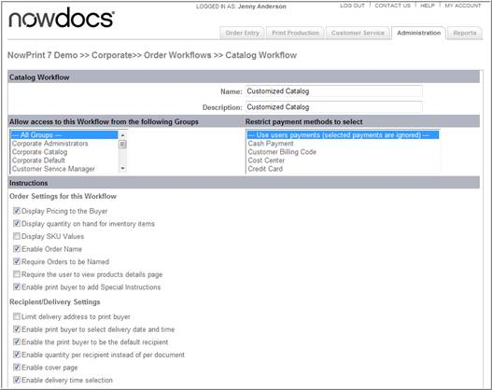

- Enter a name for the order workflow in the Name field.
- Enter a description of the order workflow in the Description field. This is the label for the order workflow that users will see on the Order Entry screen.
- Use the Allow access to this Workflow from the following Groups drop-down menu to specify which groups of users are permitted access to this workflow. If you would like all users to have the ability to access this workflow, select All Groups.
- Use the checkboxes in the Instructions section to configure the interface users will see during this workflow. Select or clear each checkbox as desired for each option:

Preference | Description
Display pricing to the buyer | Displays pricing to the buyer as they make their product selections.
Display quantity on hand for inventory items | Show the available quantity of each item.
Display SKU values | Display the SKU for the filing cabinet item.
Enable Order Name | Allows users to enter a name for their order.
Require orders to be named | Require users to specify a name for the order.
Require the user to view products details page | Do not allow users to proceed to Step 2 until they have selected a checkbox to confirm that they have previewed the files for accuracy.
Enable print buyer to add special instructions | Allow users to indicate special instructions.
Limit delivery address to print buyer | Do not allow buyer to select additional delivery addresses.
Enable print buyer to select delivery date and time | Allow users to indicate the date and time by which they would like the order delivered.
Enable the print buyer to be the default recipient | The buyer is automatically set as the recipient of any order they create as opposed to selecting themselves as add the user as a recipient.
Enable quantity per recipient instead of per document | Allow users to specify the number of copies to be sent to each recipient.
Enable cover page | Allow users to include cover pages for order recipients.
Enable delivery time selection | Allow users to specify a delivery time.
Enable proof requests | Allow users to request a hard copy proof of the order before it is produced.
Enable print buyer to select proof date and time | Allow users to specify the date and time by which they would like to receive a proof.
Enable external link for recipient selection | Enables external recipients to be selected.
This workflow is not displayed on the user home page | Does not display workflow on the homepage.
This workflow is framed within another site | Used in cases when a user is “punching out” from another website. The UI behaves differently.

Oversized/Wide Format

This workflow allows users to order Oversized and/or Wide format Documents.

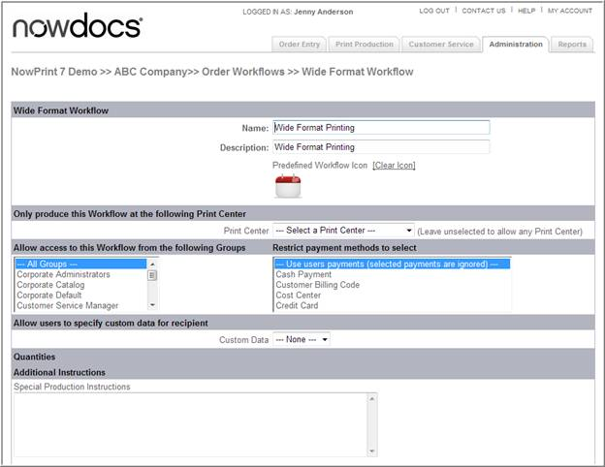

- Enter a name for the order workflow in the Name field.
- Enter a description of the order workflow in the Description field. This is the label for the order workflow that users will see on the Order Entry screen.
- Use the Allow access to this Workflow from the following Groups drop-down menu to specify which groups of users are permitted access to this workflow. If you would like all users to have the ability to access this workflow, select All Groups.
- Use the checkboxes in the Instructions section to configure the interface users will see during this workflow. Select or clear each checkbox as desired for each option:

Preference | Description
Display Pricing to the Buyer | Displays pricing to the buyer as they make their product selections.
Show only order totals on the receipt | The total order value will be shown on the receipt the items ordered will not be itemized.
Require orders to be named | Require users to specify a name for the order.
Enable print buyer to select print center | Allow users to select from a list the print center to which the order will be routed.
Restrict Print Center to buyer region | If print center regions have been defined, in Step 1 of the ordering process show only the print centers in the user's region.
Enable order templates | Allow users to select an order template which defines specific production characteristics for the order.
Require print buyer to approve preview | Do not allow users to proceed to Step 2 until they have selected a checkbox to confirm that they have previewed the files for accuracy.
Enable production charge items for Operators/CSR roles | Allows the addition of production charge items when an administrator or CSR is ordering on behalf of another user. The buyer will not see these options.
Enable special instructions | Allow users to enter special instructions for the order.
Enabled print buyer to select email notifications for recipient(s) | Allow notification emails to be sent to order recipients.
Enable Print Buyers to upload files | Allow users to upload files from their system.
Enable Personal Filing Cabinet for Print Buyers | Allow users to select files from a file cabinet.
Enable print buyer to bypass PDF conversion | Allows buyer to skip conversion process not creating a PDF file.
Enable network file paths | Allow users to specify a network file path for the order to be available as a link from which the print center will retrieve the file for printing.
Enable Hardcopy drop-off | Do not allow users to submit documents in hard copy (paper) format by physically taking them to the print center.
Restrict to large format paper size(s) | This does not allow a user to upload a standard size and then increase the size to wide format. The buyer must upload a wide format document.
Enable page exceptions | Allow users to indicate that specific pages in a file should be printed differently from the rest.
Enable mixed page sizes for combined documents | In Step 2 of the ordering process.
Enable print buyer to add tabs | Allow users to add tabs and dividers.
Enable unique print options for each recipient | Allow users to change the configuration of the order per recipient.
Enable quantity per recipient instead of per document | Allow users to specify the number of copies to be sent to each recipient.
Enable cover pages | Allow users to include cover pages for order recipients.
Enable delivery time selection | Allow users to specify a delivery time.
Limit delivery address to print buyer | Do not allow buyer to select additional delivery addresses.
Enable recipient list upload | Allow users to add multiple recipients to an order by uploading a CSV file.
Enable print buyer to select delivery date and time | Allow users to indicate the date and time by which they would like the order delivered.
Enable the print buyer to be the default recipient for orders | The buyer is automatically set as the recipient of any order they create as opposed to selecting themselves as the user as a recipient.
Enable unique special instructions per recipient | Allow users to indicate special instructions for each recipient.
Enable proof requests | Allow users to request a hard copy proof of the order before it is produced.
Enable print buyer to select proof date and time | Allow users to specify the date and time by which they would like to receive a proof.
Enable print sample recipient | Enables external recipients to be selected.
This workflow is not displayed on the user home page | Does not display workflow on the homepage.
This workflow is framed within another site | Used in cases when a user is “punching out” from another website. The UI behaves differently.
Advanced Finishing Options: Order, Document or Binder level Options | This area allow you to select which finishing option are available for user selection during the workflow. Finishing items not set to Operator Access Only will appear. Items set to Required will be included in orders placed with this workflow –users will not be able to deselect.

List Manager

Account Administrators can create and save lists that can be reused in the web forms for drop down lists, radio button lists, and images. This provides the ability for an admin to create commonly used lists only once and reuse it on many web form fields and products. It also allows the ability to upload the list via a data file and zip file (images) for quick setup.

Create a Drop Down or Radio Button List

Use the following steps to add a dropdown/Radio Button list:

- Create a list file saved in CSV format. The first column is the name of the list item, the second column is the value to be displayed. For example, if a state abbreviation list is desired, the Name is New York and the is NY.
- Click the Admin link from the NowPrint homepage.
- Click the Edit link under the List Manager option.

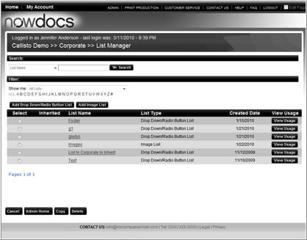

- Click the add Drop Down/Radio Button List Button.

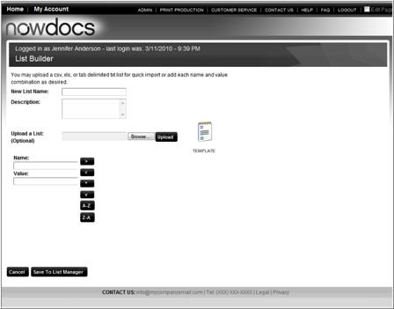

- Enter a New List Name.
- Enter a Description for the list.
- Click the Browse button to locate the list saved on your computer.
- Click the Upload button.

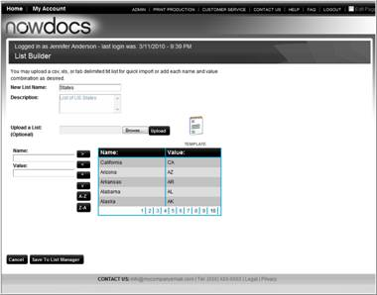

- Verify the list data.
- Click the Save to List Manager button.
Click here to watch a short video on Creating a Dropdown or Radio List

Create an Image List

Image lists can be bulk loaded or uploaded individually.

Use the following steps to add a dropdown/Radio Button list:

- Create a list file saved in CSV format. The first column is the image name, the second column is name to be displayed, the third column is the keyword for searching.
- Click the Admin link from the NowPrint homepage.
- Click the Edit link under the List Manager option.

- Click the Add Image List button.

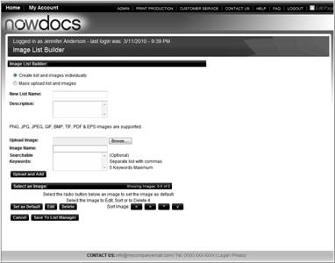

Create and list and images individually.

- New List Name
- Description
- Browse
- Image Name
- Searchable keyword
- Upload and add

Mass Upload list and images:

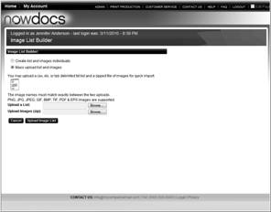

- Click the Browse button to upload the list.
- Click the Browse button to upload a zip file of the images.
- Click the Upload List button.

Click here to watch a short video on Uploading an Image List

Personalized Products

Personalized Products

Personalized products are items on which variable text and images may be placed, such as business cards, brochures, direct mail, and other types of documents that have a template form overlaid with variable content.

Personalized products can be created with Microsoft Word®, Adobe InDesign®, or Microsoft Publisher®. You must first design and establish the personalized product with one of these applications. Then, you will upload to NowPrint, where you will create a web form to collect data from users during the ordering process, and then preconfigure the personalized product to make it available for ordering in the catalog environment.

Creating a Personalized Product with Adobe InDesign®

Below is a basic overview of creating personalized products using Adobe InDesign®. For more information on creating InDesign® templates, consult your InDesign® user manual.

Follow these steps to create a personalized product with Adobe InDesign®:
1 Using Adobe InDesign®, create your design. Include static elements (which appear on every template) and variable elements (the text and graphics the users will enter on the web form).
In the illustration below, the following elements are static:
  - Jersey graphic
  - Xerox logo
  - "Get in the Web-to-Print Game!" text
  - Border
In the illustration below, the following elements are variable:

  - Last name on the jersey (text on a curve)
  - First name
  - Graphic under the "&" symbol

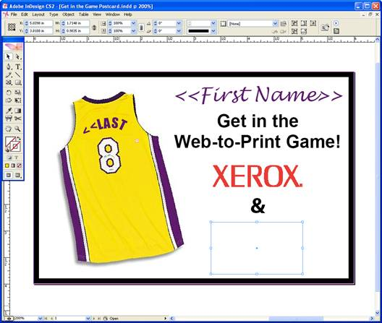

- Using Microsoft Excel®, create a CSV file (comma delineated file) containing the variable elements for the personalized product. Variable text fields are plain text. Graphics fields have a "@" symbol in the column. To add a symbol in Excel®, type a single quote (‘) in front of it and Excel will take it as a plain string instead of functions. Or, add the "@" symbol by opening the file in WordPad or NotePad.
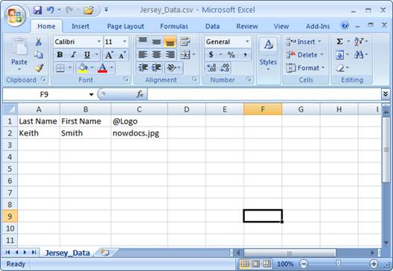

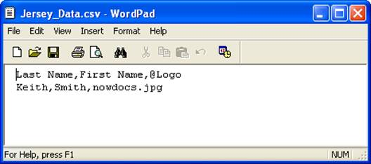

  - Using InDesign®, tag the variable elements for the graphics and text associated with the personalized product.
  - From the Window menu, select Automation and then Data Merge. The system opens the Data Merge window.
  - Choose Select Data Source. Highlight the text and click the corresponding field in the Data Merge window, as shown in the illustration below.

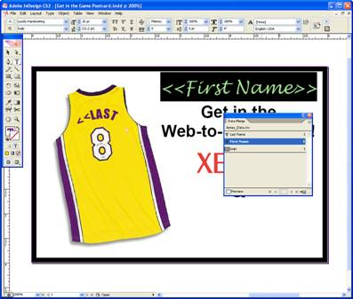

  - Then, click on the graphics box (it must be empty), and click the corresponding graphics field in the Data Merge window, as shown in the illustration below.

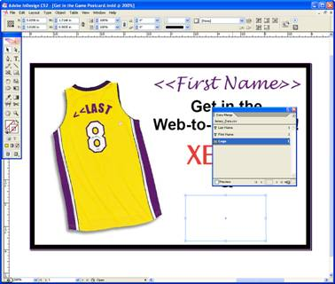

- Specify placement options for the graphics and specify rules for text adjustment. In the Data Merge window, select Content Placement Options.
- The system opens the Content Placement Options window. Specify placement options for the graphics. If you would like text to adjust when there are empty fields, select the checkbox Remove Blank Lines for Empty Fields.

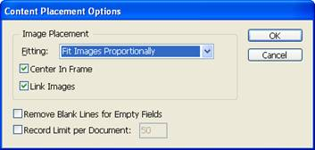

  - Now that you have created the personalized product with Adobe InDesign®, you must upload it to NowPrint, create the web form, and preconfigure the personalized product.

Creating a Personalized Product with Microsoft Publisher®
Below is a basic overview of creating personalized products using Microsoft Publisher ®. For more information on creating Microsoft Publisher ® templates, consult your Microsoft Publisher ® user manual.

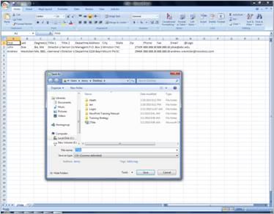

- Create a data source using Excel®.
- Enter the fields you would like to appear on your template.
- Save your data source in CSV format.
- Open Publisher.
- Design the Template layout.

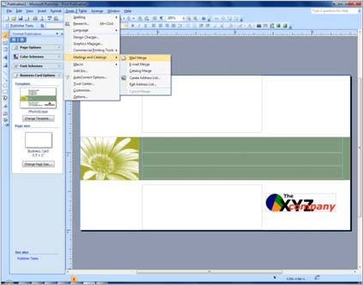

- Select Tools.
- Mailings and Catalog.
- Mail Merge.

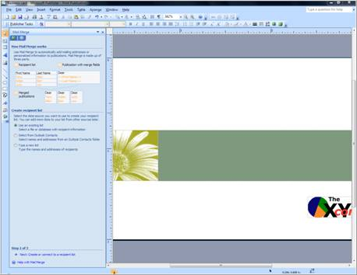

- Select Next to locate recipient list.

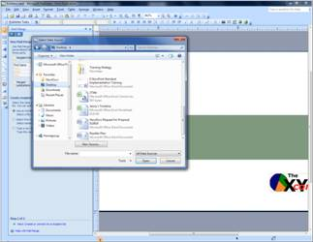

- Browse your computer.
- Locate the file.
- Click the Open button.
- In the Text File Connection, click the Comma radio button.
- Click the OK button.
- In the Mail Merge Recipients window, click the OK button.
- Click Next to add your form fields.

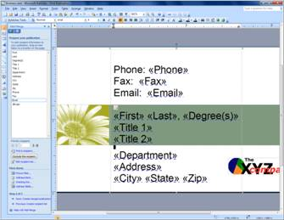

- Position your cursor in the document.
- Click the form name to add it to the document.
- Continue the above two steps until you have completed your form.
- Ensure your font and size re exactly as you want it to appear.
- Save your business card template (File, Save).

Now that you have created the personalized product with Microsoft Publisher®, you must upload it to NowPrint, create the web form, and preconfigure the personalized product.

Click here to watch a short video on Creating a Personalized Product with Microsoft Publisher®

Uploading Personalized Products

After you have designed and established the personalized product with any of the above technologies, you are ready to upload the template to NowPrint.

Once you have successfully completed the steps, the personalized product will be available in the Document Catalog.

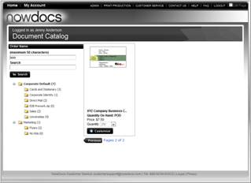

You will have mapped the data fields in the webform to create an easy method for users to enter or upload their data.

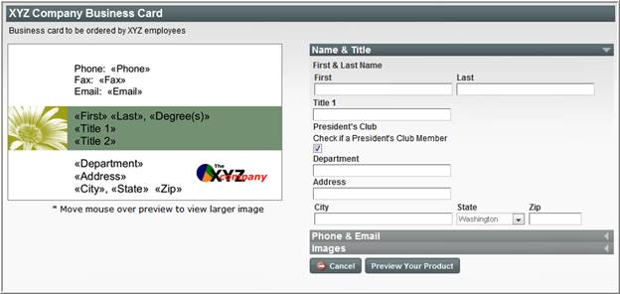

Use the following steps to upload a personalized product:

- Click the Admin link from the homepage. (if signed in as a Master Account Admin, Click the Edit link for the corporate account you’d like to add personalized products for, click the Corporate account.)
- Click the Edit link under the Personalized Products section.

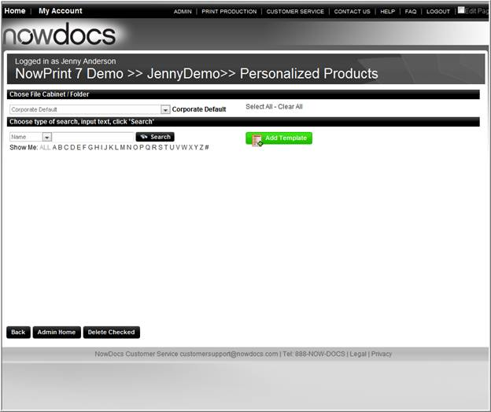

- Click the Add Template button.

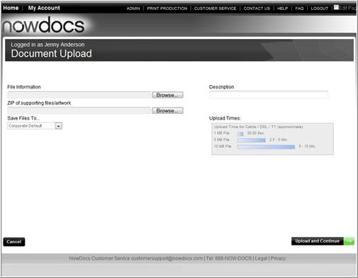

- Click the Browse button by the File Information field to select the template to be uploaded from your system.
  - Adobe InDesign®: Upload only your InDesign template file.
  - Microsoft Publisher®: Upload only your Publisher template.
  - Adobe Indesign®/XMPie®: Upload the .cpkg package.
- Click the Browse button by the ZIP of supporting files/artwork field to select the ZIP file containing the STATIC graphics associated with the template. These are the graphics that are linked to the template file, NOT the graphics you would like users to select for a variable graphics field.
  - Adobe InDesign®: Upload your zip with the supporting fonts and images files.
  - Microsoft Publisher®: Upload your zip with the supporting fonts and images files.
  - Adobe Indesign®/XMPie®: Since all files are in the .cpkg package, you do not add any files in this option.
- Enter a brief description of the personalized product in the Description field.
- If you would like the personalized product to be available to all users, you will upload it to the Corporate Default group file cabinet. If you would like the personalized product to be available to only the users in a specific group, you will upload it to the specific group's file cabinet. Choose the appropriate group from the Save Files To drop-down menu.
- Select the Upload and Continue button.
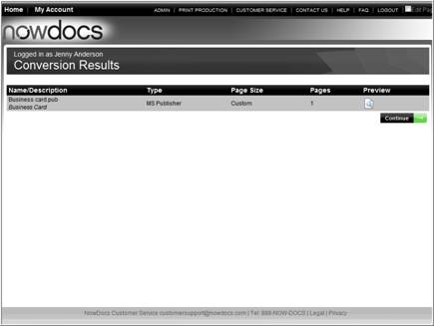

- Click the Preview icon to see the product image(s) if desired. On the preview screen, select Exit and Return button to return to the Conversion Results screen.
- Select the Continue button.
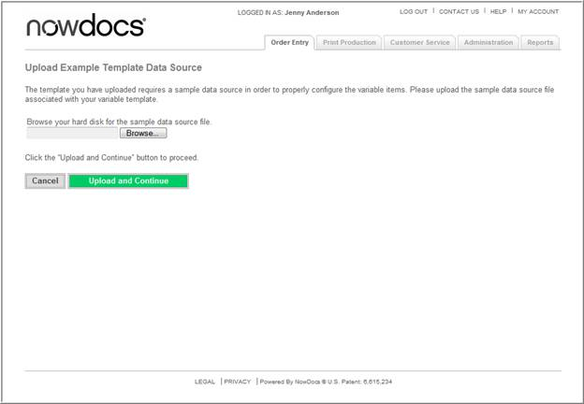

Note: This step is not displayed if you uploaded a XMPie .cpkg package, because your data source file is with the package.

- Select the Browse button to select the CSV file associated with the template.
- Select` the Upload and Continue button.

Update the Webform

After you have uploaded the template to NowPrint, you will specify settings for the web form that will be used to collect data from the user during the ordering process.

On template upload, the web form is auto-generated with one section and all datasource fields displayed as text fields.

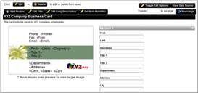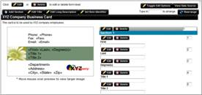

At any time you can select Toggle Edit Options if you would like to hide the section and field editing features to see what the end-user would see for the web form. By selecting the Toggle Edit Options again, it will display the editing features again.

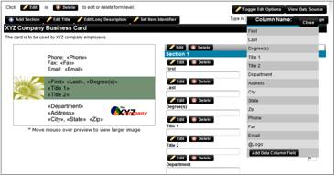

At any time, you can select View Data Source to see what fields are available in the datasource to be used in the web form.

- You can select the header of the datasource window and drag it to any location on your screen to continue to see the fields while you work.
- Select Add Data Column Field if you require an additional web form field that collects data for the order. This may be used to collect information from the end-user that doesn’t populate into the product template. Or it may be an additional web form field you need to add after replacing the existing template that does require an additional web form field to populate the new template.
- Select the Close button to close the window.

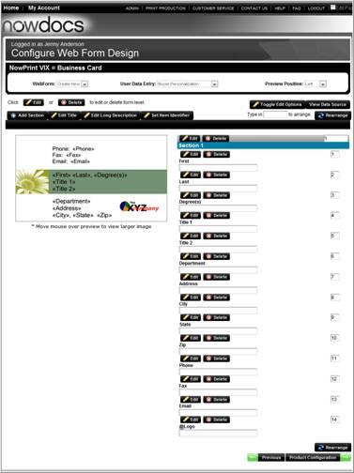

- Select your desired User Data Entry Option:
  - Buyer personalization – Buyer enters variable data directly on the form.
  - Mass personalization – Buyer uploads a CSV file with variable content.
  - Buyer select – Buyer chooses to enter variable data or upload a CSV file.
  - Combination personalization - The buyer uploads a CSV file with multiple records. Then the buyer is able to add some personal information and the data will apply to all the records.
- Choose the option desired for where the preview will position on the web form screen by selecting Left, Right or Hidden from the Preview Position drop down list.

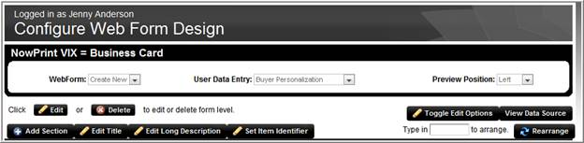

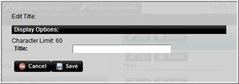

- Add text in the Edit Title if you would like a title to display in the bar above the preview and web form.

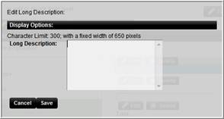

- Add text in the Edit Long Description field for any specific instructions or text you would like to display to users on-screen, if desired. If this product is to be sold in lot sizes, you might want to include the lot size in the description (for example, "Box of 250").
  - You can use basic HTML commands to format the long description.

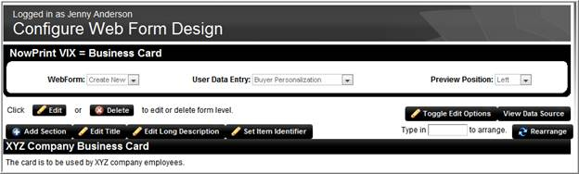

- The Title and Long Description are displayed on the screen.

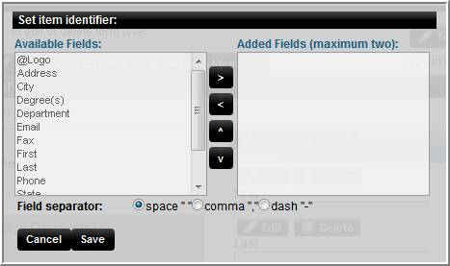

- Set an Item Identifier if desired. The shopping cart displays the Item Short Description for each item placed in the cart. This can be confusing for a end user if they are ordering multiple items of the same product for different people.

Example: If you are ordering cards for John Doe and Suzy Smith for ‘Employee Business Card’ item, it will show ‘Employee Business Card’ twice in the shopping cart. If you want to edit or remove only one of the cards from the shopping cart, you may not know which one to choose as there is no identifier between the two items.
  - Select Item Identifier. Choose the field(s) you want to use as an item identifier and select the left arrow to set the identifying fields.
  - Choose the type of separator you want to use if multiple fields are chosen (space, comma or dash).
  - Use the right arrow to remove a field.
  - Use the up/down arrow to sort the order of the fields display.
  - Save to store your selections.

- By choosing a web form field(s) as an Item Identifier, this helps identify the items in the cart more easily. In the example above, you may want to see the Name field as the Item Identifier.

- The value entered in the field(s) indicated as the Identifier for the product will be displayed below the Product name in the shopping cart, approval system, reorder and order history pages. It will show the comma or space between the fields if multiple fields are set.

Section Options

Sections allow you to group variable data fields.

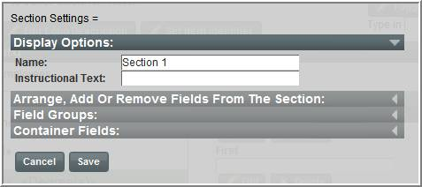

- Display Options – display the header for the section.

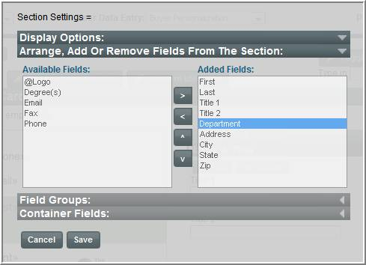

- Arrange, Add, or Remove Fields from the Section – allows you to define which fields should be displayed in the section.

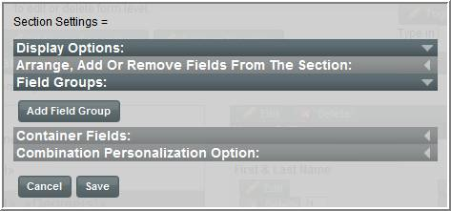

- You can set a Field Group in the Edit Section function if applicable. This will allow you to set a rule that only a defined number of fields out of the total fields indicated can be entered.

Example: You could have 6 fields, but you set a rule to only allow 5 out of 6 fields to be entered because your product brand only allows 5 lines to fit. Select Save to save the Field Group configuration. Once it is saved, you will be able to edit the rule from this same screen.

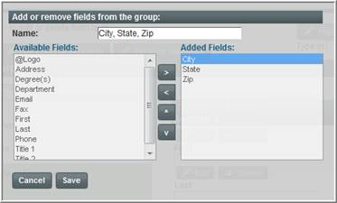

- When you select Add Container Field in the Edit Section function, you can create a single row with multiple fields displayed. This is often used for Phone Prefixes and Phone Numbers, or City, State Zip.
- Select Save to save the Container Field configuration. Once it is saved, you will be able to edit the rule from this same screen.

Add a Section

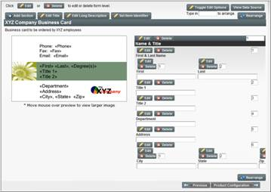

- Select Add Section for creating any additional sections of web form fields to be displayed.

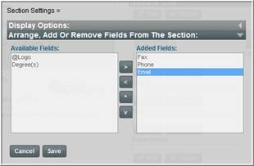

- The same options are available for Add Section as the Edit Section.

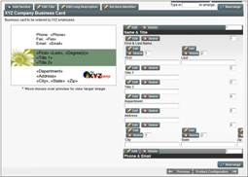

You can select Delete for a Field or for a Section. Any fields deleted are still available to be added back into a section. Once a section is deleted, that section is not retrievable, but can be recreated.

Field Settings Options

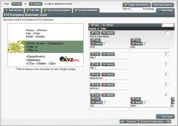

- When you select Edit on a Text field, you can configure the field as required for the end-user data selection or entry.

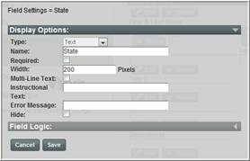

- Field Types:
  - Text – user enters text into the text box field.
  - Drop Down – user selects text from the drop-down list.
  - Radio Button – user selects a choice.
  - Checkbox – user checks a box for predefined data.
  - Image Select – user selects an image or uploads their own image.

Note: Depending on the field type chosen, the applicable options for that type will be displayed. If you change field types, a warning message will alert you that any previous settings will be lost. The following options are available on the various field types:

Display Options:
  - Name: the field label that will display to the end-user.
  - Required: end-user must choose or enter data for the field in order to preview and/or add the item to the order.
  - Width: The pixel width of the field.
  - Instructional Text: Information that is displayed to the end user below the field label.
  - Error Message: Not applicable in this version.
  - Hide: The field will not display to the end user, but any data mapped or defaulted will be used in the process.
  - Text Field Type only - Multi-Line Text: configurable text area for paragraph type content entry. This has a maximum of 2000 characters.
  - Text Field Type only - Multi-Line Text Row: configure the height of a drop down list window display.
  - Drop Down Type only - Allow User Entry: the end-user can choose an item from the drop down list or they can enter in their own ‘custom value’ if that is chosen from the drop down list.

List Builder Options

Drop Down | Radio Button
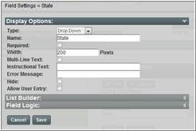 | 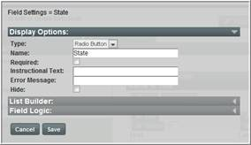

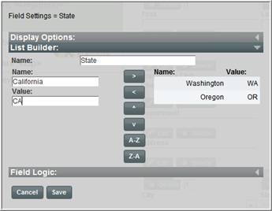

Drop Down and Radio Button List Builder:
- Enter a Name as a short description of what the list is.
- Description – Not applicable in this version.
- Enter a Name/Value combination for the list’s item. The Name is what will be displayed in the list to the end-user. The Value is the actual data to be used if that Name is selected from the list.
- Example: Name=United States / Value=US,
- Example: Name=Select One / Value= (blank)
- Select the left arrow (è) to save your item to the list.
- Select the right arrow (ç) to delete your item to the list.
- Select the up or down arrows (êé) to sort your item in the list.
- Select A-Z or Z-A to sort by value alphabetically.
- Select the 1, 2 etc. to page through the additional items defined in the list.

Field Logic Options

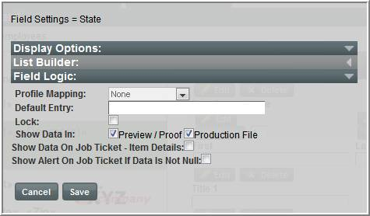

- Profile Mapping: the user’s profile data will populate this field. Options in the profile mapping drop down list are dynamically driven by what is set up in the Address Field Settings admin tool.
- Default Entry: data entered here will populate into the web form field and display to the end-user. This overrides any default entry data if both are applied to a web form field.
- Lock: The data in this field is locked for editing. Typically used in conjunction with Default Entry and/or Profile Mapping.
- Show data in Preview/Proof or Production Files: If you want the user data displayed in the preview and/or production file, you will leave the checkboxes checked. If the data is not to display on the preview or production file (maybe it is for order collection only), then uncheck the appropriate checkbox.
- Show data on Job Ticket – Item Details: If you want the user data to be displayed on the job ticket in Print Production and in Customer Service, you will check the box. If the information is not required to be on the job ticket, then you will leave the box unchecked.
- Show Alert on Job Ticket if Data is Not Null: If you want the user data to be displayed on the job ticket alerts and in the alert area in Print Production and in Customer Service queues, you will check the box. If the information is not required to be on the job ticket, then you will leave the box unchecked. If the user does not choose or enter any data for the field, it will not be displayed as an alert.

Checkbox Settings

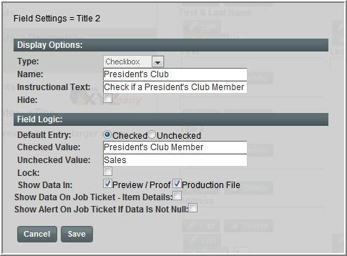

- Select the desired display default of the box to be Checked or Unchecked and then enter Checked and Unchecked values to be used based on user selection.
- Lock: The data in this field is locked for editing. Typically used in conjunction with Default Entry and/or Profile Mapping.
- Show data in Preview/Proof or Production Files: If you want the user data displayed in the preview and/or production file, you will leave the checkboxes checked. If the data is not to display on the preview or production file (maybe it is for order collection only), then uncheck the appropriate checkbox.
- Show data on Job Ticket – Item Details: If you want the user data to be displayed on the job ticket in Print Production and in Customer Service, you will check the box. If the information is not required to be on the job ticket, then you will leave the box unchecked.
- Show Alert on Job Ticket if Data is Not Null: If you want the user data to be displayed on the job ticket alerts and in the alert area in Print Production and in Customer Service queues, you will check the box. If the information is not required to be on the job ticket, then you will leave the box unchecked. If the user does not choose or enter any data for the field, it will not be displayed as an alert.

Image Select Options

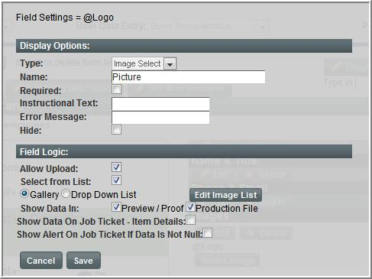

- Allow Upload: Allow users to upload their own image.
- Select from list: Allow users to select from an image gallery.
- Gallery or Drop Down List: allow users to select from a visual image gallery or from a dropdown list box.
Note: If you select either ‘Select from list’ options, then you will need to select Edit Image List to upload the images. See page 6-129 for details on editing the image gallery.
- Show Data In Preview/Proof and/or Production File: If you want the user data displayed in the preview and/or production file, you will leave the checkboxes checked. If the data is not to display on the preview or production file (maybe it is for order collection only), then uncheck the appropriate checkbox.
- Show Data On Job Ticket – Item Details: If you want the user data to be displayed on the job ticket in Print Production and in Customer Service, you will check the box. If the information is not required to be on the job ticket, then you will leave the box unchecked.
- Show Alert on Job Ticket if Data is not Null: If you want the user data to be displayed on the job ticket alerts and in the alert area in Print Production and in Customer Service queues, you will check the box. If the information is not required to be on the job ticket, then you will leave the box unchecked. If the user does not choose or enter any data for the field, it will not be displayed as an alert.

Edit Image Gallery

The Gallery Image list management function allows you to add a new image, delete an existing image, sort the image or set the default.

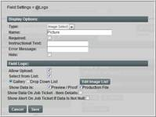

- From the Image Select window, click the Edit Image List button.

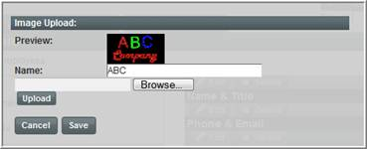

- Enter a name for the image.
- Click the Browse button and locate the image on your computer.
- Click the Upload button.
- Click the Save button.

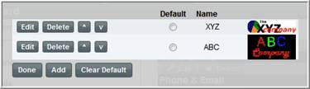

- If desired, select a Default image.
- Click the Done button.

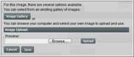

Example: End-user display for Image Upload & Select from Image Gallery

Sort form Fields

There are two ways to sort fields. You can sort them using the sort arrows in the Edit Section admin function, or you can renumber the web form fields and select Rearrange button.

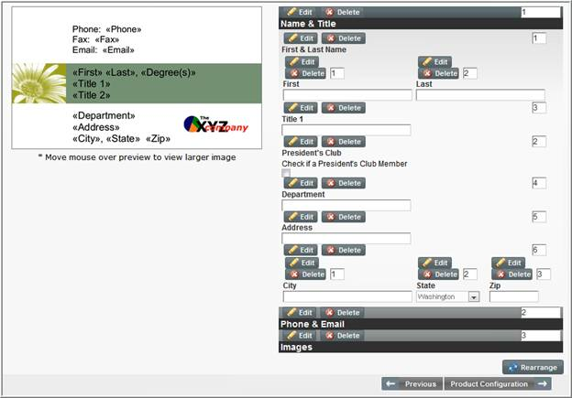

• Example: if you want Address1 to be below the City, State Zip container field, you would enter a ‘2’ in the Address1 sort field and select Rearrange. The system will know to put the new ‘2’ web form field in the 2nd position and move the original ‘2’ web form field (or container fields) into the position above that number.
• You can also renumber all web form fields to the order you desire and select Rearrange and it will rearrange all fields accordingly.
• You can use this Rearrange option for sorting container fields, as well as the ability to sorting those through the Edit Section, Edit Container Group function.
• This Rearrange button is the only method to sort sections for the web form.
• The Previous button on the web form configuration screen will return you to the Personalized Products list.
Note: if you have not gone to product configuration step, your edits will not be saved.
• The Product Configuration will save your web form and progress you to the final preconfiguration process for the item details.

Click here to watch a short video on Uploading Personalized Products

Preconfiguring a Personalized Product

After creating the web form, you must preconfigure the personalized product in order for it to be available for catalog ordering. Preconfiguring is the process of setting up production and configuration options for the personalized product, such as its format, finishing, and pricing. The personalized product is then available in that format for ordering through the catalog.

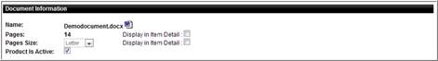

- Select the Paper size.
- Select the respective Display Item Detail checkboxes if you wish to have the number of pages or page size displayed in the catalog.
- Check the Product is Active checkbox if you wish to have the product displayed in the catalog.

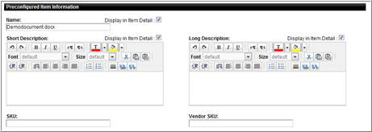

- Enter the Preconfigured Item Name. Select the Display in Item Detail to display the preconfigured item name.
- Enter a Short Description for the preconfigured item. Select the Display in Item Detail to display the preconfigured item Short Description. Modify the formatting of the text using the formatting options.
- Enter a Long Description for the preconfigured item. Select the Display in Item Detail to display the preconfigured item Long Description. Modify the formatting of the text using the formatting options.
- Enter a SKU (if desired).
- Enter a Vendor SKU (if desired).

- Select a Print Center if the preconfigured item should be printed at a specified print center.

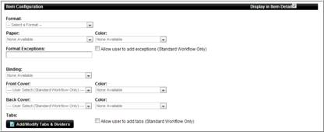

- Select the applicable Item Configuration options.
- Click the Add/Modify Tabs & Dividers to add Tab options. See page 4-8 for more information on adding tabs and/or page exceptions.

- Select the applicable Product Download Options.

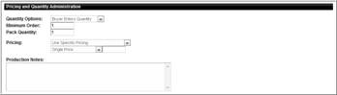

- Enter the Quantity Options
  - Buyer Enters Quantity – enters quantity in quantity field on catalog.
  - Buyer Chooses Quantity – buyer selects quantity from quantity dropdown. When this item is selected, complete the Add/Edit Specific Quantities Pop-up.

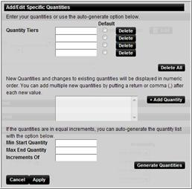

  - Complete one of the three sections in the Add/Edit Specific Quantities window.
    - Quantity Tiers – type in the desired quantity tiers.
    - New Quantities – quantities can be added by typing the quantities in the text box and clicking the Add Quantity text box. The additional quantities are displayed in the Quantity Tiers boxes
    - Equal Increments – enter the minimum start, maximum end, and quantity Increments in the text boxes. Click the Generate Quantities button. Verify and/or modify the quantity tiers.
    - Click the Apply button.
  - Enter the Pricing Options
    - Use Sum of Component Items in Pricing – The system calculates the price based on the individual items selected.
    - Use Specific Pricing – Enter pricing based on quantity tiers.
      - Single Price – user specifies a fixed price for the item.
      - Use Tiered Unit Pricing – user sets different unit prices for different quantity ranges.

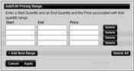

- Enter the quantity increments start and end amounts and price for each quantity tier.
- Click the Apply button.
- Use Tiered Pack Pricing – user sets different prices for different quantity. It is to be used in association with the “Buyer Chooses Quantity” option. The list of quantities can be easily auto-generated based on the quantities set for the “Buyer Chooses Quantity” option.

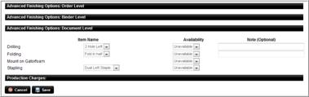

- Select the desired Advanced options.
- Click the Save button.

Click here to watch a short video on Editing a Preconfigured Item
Click here to watch a short video on setting Quantity and Tiered Pricing

Click here to watch a short video on setting Quantity options

Editing a Personalized Product

Use the following steps to edit a personalized product:

- Click the Admin link from the homepage.
- Click the Edit link under Personalized Products.

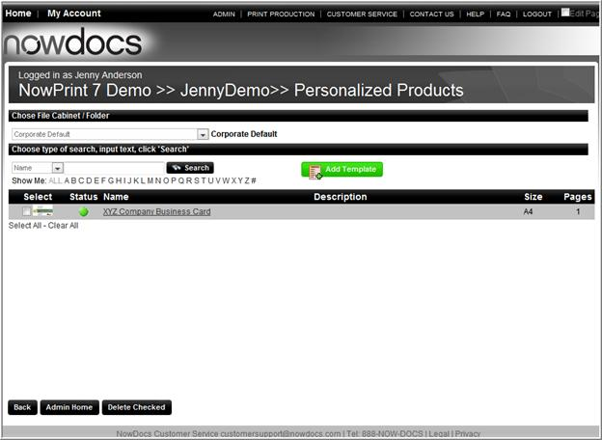

- Select from the Choose File Cabinet/Folder drop-down menu the file cabinet containing the personalized product you would like to edit.
- Select the name of the personalized product.
- Edit the product the same as if you were adding the product.

Click here to watch a short video on Editing Personalized Products

Deleting a Personalized Product

Use the following steps to delete a personalized product:

- Click the Admin link from the homepage.
- Click the Edit link under Personalized Products.

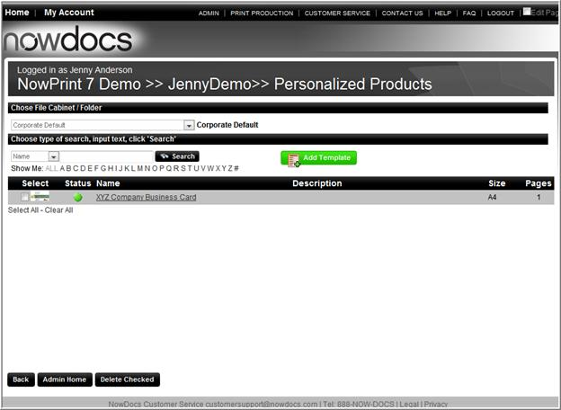

- Select from the Choose File Cabinet/Folder drop-down menu the file cabinet containing the personalized product you would like to delete.
- Indicate which personalized product you would like to delete by clicking the checkbox in the Select column next to that personalized product's name. You may select multiple personalized products to delete, if desired.
- Click the Delete Checked button.

Manage Filing Cabinets/Catalogs

Filing Cabinet Overview

The Filing Cabinet enables users to view and manage their personal filing cabinet. The Personal Filing Cabinet gives users the option to store documents in the NowPrint system to order at future times. Personal Filing Cabinet items are ordered from the Ad Hoc Workflow.

Depending on the User Permissions, the user may have the ability to view, add, edit or delete items in a corporate filing cabinet. The corporate filing cabinet is displayed in the Catalog Workflow for the Corporate Account. The catalog can contain static and variable documents.

Users can be assigned to multiple Filing Cabinets based on assigned User Groups. In the example below, each user has their own Personal Filing Cabinet. Each user also has access to the Corporate Default filing cabinet if they are granted with the Read access to the Corporate Default filing cabinet. Users can be assigned to additional user groups as needed. For Example, a person with a Sales function may only need access to the Marketing folder, not the Training folder. Someone in Training may need access to the Training and Marketing folders, not the HR folder.
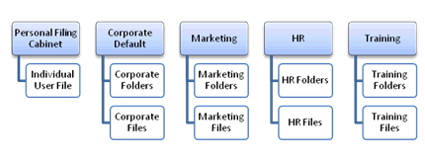

In the example below, the user has access to the Corporate Default folder as long as they are granted with the read access to the Corporate Default and the Marketing folder.

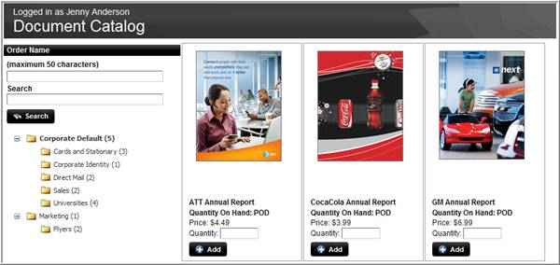

Accessing Personal Filing Cabinet

Use the following steps to view/modify your Filing Cabinet:

- Click the My Account link from the Homepage.
- Select the Manage File Cabinet icon.

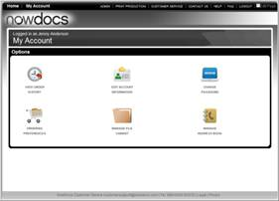
OR

Administrators can manage the Corporate Filing Cabinet options by using the following steps:

- Click the Admin link from the Homepage

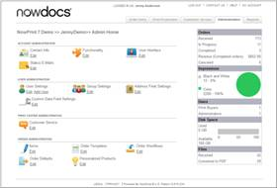

- Click the Edit link under Group Settings.

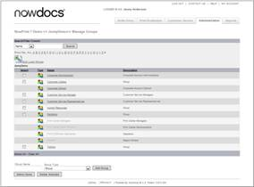

- Select the Group you wish to edit.
- The group page will display.
- Select the filing cabinet for the group.

Click here to watch a short video on Accessing the Personal Filing Cabinet

Click here to watch a short video on Accessing the Corporate Filing Cabinets

Filing Cabinet Options

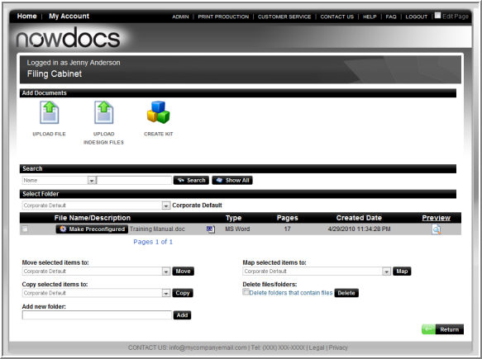

- Upload File: allows users to upload a file to the desired Filing Cabinet. A file can be uploaded to a selected filing cabinet (available filing cabinets are different for each user depending on their settings) Filing Cabinet while ordering from the Desired workflow or a file can be uploaded to a Corporate Default Filing Cabinet with appropriate access. The file can then be pre-configured for multiple users to view and/or order the file.
- Upload InDesign File: allows users to upload an InDesign file to the desired Filing Cabinet for VDP document creation.
- Create Kit: allows users to select multiple filing cabinet items and combine them into one order item as a kit.
- Move selected items to: move selected files to a desired folder in the drop-down list box.
- Copy selected items to: adds selected files to a desired folder in the dropdown list box.
- Add new folder: creates a new folder.
- Map selected items to: creates an image of a Filing Cabinet item in the mapped folder.
- Delete files/folders: removes selected files/folders from the Filing Cabinet.

Upload File to Personal Filing Cabinet

The Upload File Function allows users to upload a file to the desired Filing Cabinet. When the user selects the Manage File Cabinet option from the My Account link, they have the option to upload the file to their Personal Filing Cabinet. If managing files from the Admin page, the user does not have the option to upload the file to their Personal Filing Cabinet.

Use the following steps to upload a file to a Personal Filing Cabinet:

- Navigate to the Filing Cabinet.

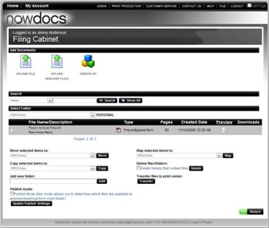

- Select the desired Filing Cabinet.
- Click the Upload File icon.

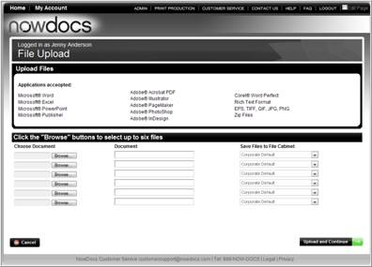

- Click the Browse button.
- Locate and select the desired file on your computer. (Repeat steps five and six to add multiple items or upload a zip file to upload multiple files).
- (Optional) Enter a Description for the file.
- Select “PERSONAL” from the filing cabinet dropdown list.
- Click the Upload and Continue button.

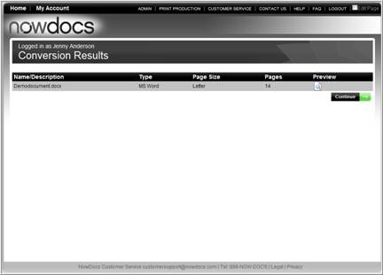

- Preview the document by clicking the Preview icon.
- When finished previewing, click the Exit and Return button.
- Click the Continue button.

- The Document is now located in your personal Filing Cabinet.

Click here to watch a short video on Uploading a Personal Filing Cabinet item

Upload a Catalog Item

In order for buyers to order Preconfigured items from the catalog, a corporate administrator must upload and Pre-configure the item. Pre-configuring the item allows you to predefine the paper, finishing options, minimum, order quantity, and pricing that will be offered for the item in the catalog.

Use the following steps to upload a catalog item:

- Navigate to the Filing Cabinet.

- Select the Corporate Default Filing Cabinet.
- Click the Upload File icon.

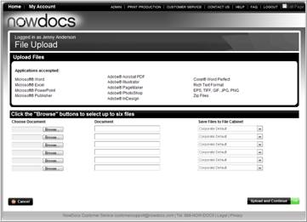

- Click the Browse button.
- Locate and select the desired file.
- (Optional) Enter the description for the file.
- Select a destination filing cabinet from the dropdown list.
- Click the Upload and Continue button.
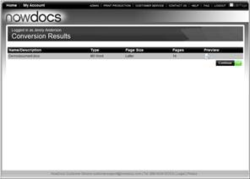

- Preview the document by clicking the Preview icon.
- When finished previewing, click the Exit and Return button.
- Click the Continue button.

- Click the Make Preconfigured button.

Complete the Preconfigured Item screen.

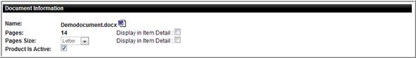

- Select the Paper size.
- Select the respective Display Item Detail checkboxes if you wish to have the number of pages or page size displayed in the catalog.
- Check the Product is Active checkbox if you wish to have the product displayed in the catalog.

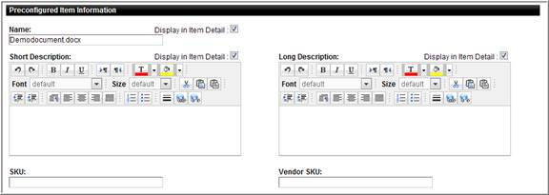

- Enter the Preconfigured Item Name. Select the Display in Item Detail to display the preconfigured item name on the Item Detail page.
- Enter a Short Description for the preconfigured item. This will display as a tooltip on the catalog product image. Select the Display in Item Detail to display the preconfigured item Short Description on the Item Detail page. Modify the formatting of the text using the formatting options.
- Enter a Long Description for the preconfigured item. Select the Display in Item Detail to display the preconfigured item Long Description on the Item Detail page. Modify the formatting of the text using the formatting options.
- Enter a SKU (if desired).
- Enter a Vendor SKU (if desired).

- Select a Print Center if the preconfigured item should be printed at a specified print center.

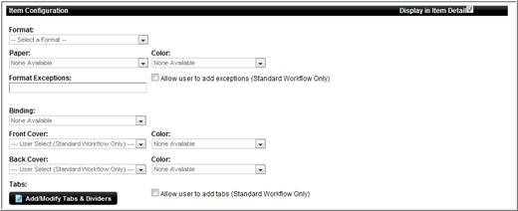

- Select the applicable Item Configuration options. Select the Display in Item Detail to display the item configurations on the Item Detail page.
- Click the Add/Modify Tabs & Dividers to add Tab options.

- Select the applicable Product Download Options. This will provide the buyer with a download button on preconfigured items or on the web form for variable products.
  - If you select the Product Download option, then the option to not allow the item to be ordered is available to enable. If checked, the buyer can only download the item and not order it.

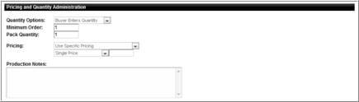

- Enter the Quantity Options
  - Buyer Enters Quantity – buyer enters quantity in quantity field on catalog.
  - Buyer Chooses Quantity – buyer selects quantity from quantity dropdown. When this item is selected, complete the Add/Edit Specific Quantities Pop-up. Note: This option is not functional for mass personalization variable items. Mass Personalization quantities are based on the uploaded record count from the buyer uploaded data file. Buyer enters quantity is the best option for mass personalization items.

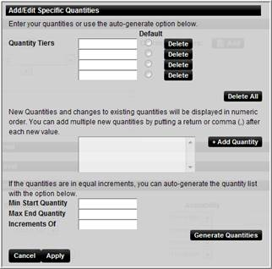

  - Complete one of the three sections in the Add/Edit Specific Quantities window.
  - Quantity Tiers – type in the desired quantity tiers.
  - New Quantities – quantities can be added by typing the quantities in the text box and clicking the Add Quantity text box. The additional quantities are displayed in the Quantity Tiers boxes
  - Equal Increments – enter the minimum start, maximum end, and quantity Increments in the text boxes. Click the Generate Quantities button. Verify and/or modify the quantity tiers.
  - Click the Apply button.
- Enter the Pricing Options
  - Use Sum of Component Items in Pricing – the system calculates the price based on the individual items selected.
  - Use Specific Pricing – enter pricing based on quantity tiers.
    - Single Price – user specifies a fixed price for the item.
    - Tiered Unit Pricing – user sets different unit prices for different quantity ranges.

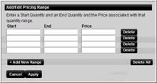
  - Enter the quantity increments start and end amounts and price for each quantity tier.
  - Click the Apply button.
  - Use Tiered Pack Pricing – user sets different prices for different quantity. It is to be used in association with the “Buyer Chooses Quantity” option. The list of quantities can be easily auto-generated based on the quantities set for the “Buyer Chooses Quantity” option.

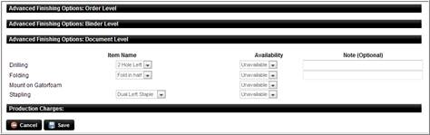

- Select the desired Advanced options.
- Click the Save button.

Click here to watch a short video on Uploading a Catalog Item

Click here to watch a short video on setting Quantity and Tiered Pricing

Click here to watch a short video on setting Quantity options

Edit Preconfigured Item

Preconfigured Filing Cabinet items can be modified as needed.

Use the following steps to edit a preconfigured item:

- Locate the file in the Catalog
- Click on the preconfigured item name you wish to modify.

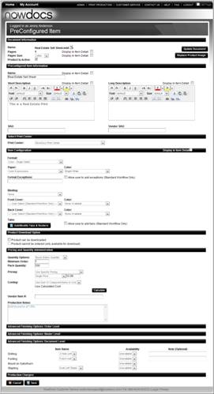

- Modify each section as desired.

Click here to watch a short video on Editing a Preconfigured Item

Upload an InDesign® File

The Upload InDesign® File option allows users to upload an InDesign file and supporting zip files to the desired Filing Cabinet.

NowPrint supports the uploading of InDesign® CS3 files. It currently does not support CS4 or CS5 InDesign® files.

Use the following steps to upload an InDesign® file:

- Navigate to the Filing Cabinet.

- Select the Upload InDesign Files icon.

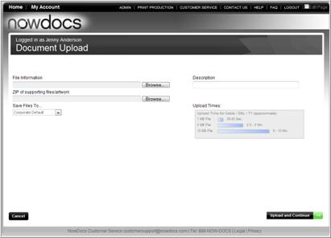

- Browse your computer for the InDesign® file (indd).
- Browse you computer for the supporting zip file documents.
- Enter a Description for the document
- Select the desired Filing Cabinet.
- Click the Upload and Continue button.

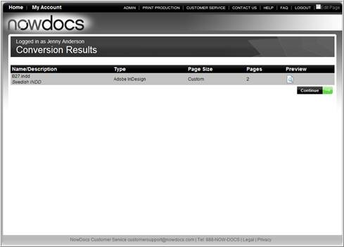

- Preview your document by clicking the Preview icon.
- Exit the preview and click the Continue button.

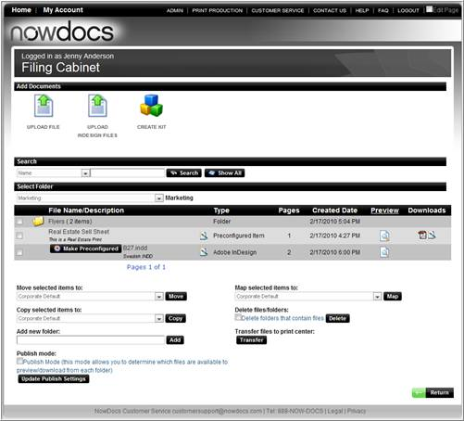

- The file is now uploaded to the Filing Cabinet.

Click here to watch a short video on Uploading an InDesign® File

Create Kit

The Create Kit option allows users to select multiple filing cabinet items and combine them into one item. Filing Cabinet Items need to be preconfigured prior to adding to a kit. Warehouse items that are mapped to the Filing Cabinet can be added to a kit.

Use the following steps to create a kit:

Note: Individual items need to be uploaded to the filing cabinet prior to using the Create Kit function.

- Navigate to the Filing Cabinet.

- Click the Create Kit icon

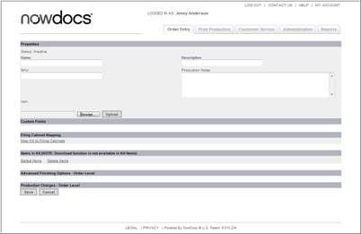

- Enter the Kit Name
- Center a Description for the kit.
- Enter a SKU for the kit (optional)
- Enter any specific Production Notes.
- Browse your computer and locate the desired kit image.
Note: the kit image needs to be in jpeg format.
- Click the Select Items link to locate kit items in the Filing Cabinet.

- Select the desired Filing Cabinet items.
- Click the Add Items button.

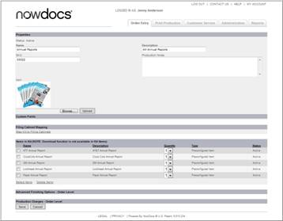

- The items are displayed.
- Click the Map Kit to Filing Cabinet link.

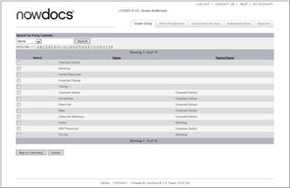

- Select the desired Filing Cabinet(s) for the kit.
- Click the Map to Cabinets button

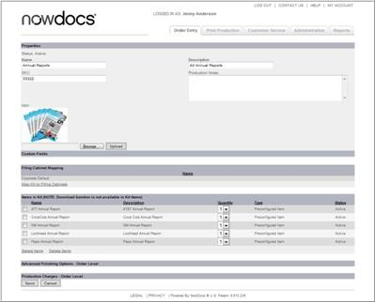

- Review your selections.
- Click the Save button.

The price of the kit will be based on the total sum of all items that make up the kit.

The kit is now displayed in the Filing Cabinet and can be accessed by users who have appropriate access right to the specific filing cabinet in the Catalog Workflow.

Filing Cabinet  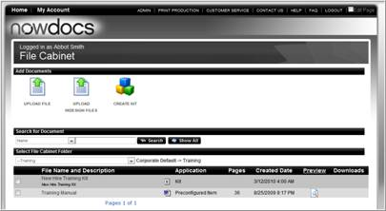 | Document Catalog  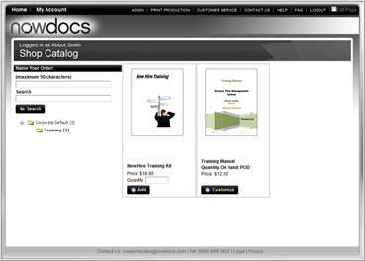

Click here to watch a short video on Creating a Kit

Move Selected Items

The move function allows users to move filing cabinet times to the desired folder in the drop-down list box.

Use the following steps to move filing cabinet items:

- Navigate to the Filing Cabinet.

- Select the desired files/folders.
- Select the desired folder from the Move Selected Items to dropdown list box.
- Click the Move button.

Click here to watch a short video on Managing the Filing Cabinet

Copy Selected Items

The copy function allows users to copy filing cabinet items to the desired folder in the drop-down list box.

Difference between copying and mapping: When a filing cabinet item is copied, NowPrint makes a separate copy of the item. Changes to one of the items, will result in the other item not being revised.

Mapping a filing cabinet item, it is just a pointer to the original item. It displays as a separate item in the filing cabinet and catalog, but it truly is the same item. If a change is made to one of the items, it will change the other item as well.

Use the following steps to copy filing cabinet items:

- Navigate to the Filing Cabinet.

- Select the desired files/folders.
- Select the desired folder from the Copy Selected Items to dropdown list box.
- Click the Copy button.

Click here to watch a short video on Managing the Filing Cabinet

Add New Folder

The Add New Folder function allows users to add a folder to the desired Filing Cabinet folder.

Use the following steps to add a new folder:

- Navigate to the Filing Cabinet.

- Select the Filing Cabinet you wish to add the new folder in.
- Enter a folder name in the Add New Folder text box.
- Click the Add button.

Click here to watch a short video on Managing the Filing Cabinet

Map Selected Items

Mapping Filing Cabinet items allows you to create an image of the Filing Cabinet items in the mapped folder.

Difference between copying and mapping: When a filing cabinet item is copied, NowPrint makes a separate copy of the item. Changes to one of the items, will result in the other item not being revised.

Mapping a filing cabinet item, it is just a pointer to the original item. It displays as a separate item in the filing cabinet and catalog, but it truly is the same item. If a change is made to one of the items, it will change the other item as well.

Use the following steps to map filing cabinet items:

- Navigate to the Filing Cabinet.

- Select the desired files/folders.
- Select the desired folder from the Map Selected Items to dropdown list box.
- Click the Map button.

Click here to watch a short video on Managing the Filing Cabinet

Delete Files/Folders

The Delete function allows users to remove selected files/folders from the Filing Cabinet.

Use the following steps to delete filing cabinet items:

- Navigate to the Filing Cabinet.

- Select the desired files/folders.
- (Optional) Click the Delete folders that contain files checkbox to confirm you are deleting folders that contain files.
- Click the Delete button.

Click here to watch a short video on Managing the Filing Cabinet

Address Book

Address Book

Addresses can be managed through the Address Book option under My Account. All users can manage their Personal Address book, adding, modifying or removing addressees. Users have the option of entering individual addressees or uploading multiple recipients in a CSV file. Depending on user settings, users can also modify the Corporate Address book.

Use the following steps to view/modify your Address Book:

- Click the My Account link from the Homepage.
- Select the Manage Address Book icon.

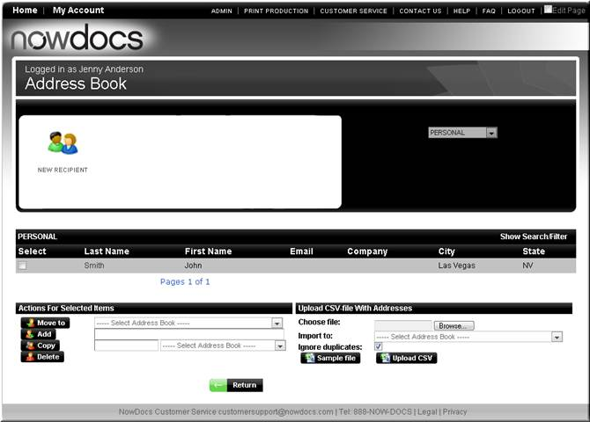

  - New Recipient: Enables user to add a new contact to the address book.
  - Show Search/Filter: toggles search and filtering functionality
  - Move To: Enables user to move the selected recipient to another address book.
  - Add: Enables user to add a new address book directory level.
  - Copy: Enables user to copy the selected recipient to another address book and/or copy recipients to a new address book.
  - Delete: Deletes selected recipients and/or address book.
  - Upload CSV file with Addresses: Enables user to bulk upload multiple recipients to selected address book.
  - Sample File: enables the user to download a csv template with sample data.

Add Recipient

Use the following steps to view/modify your Address Book:

- Click the My Account link from the Homepage.
- Select the Manage Address Book icon.
- Select the New Recipient icon.

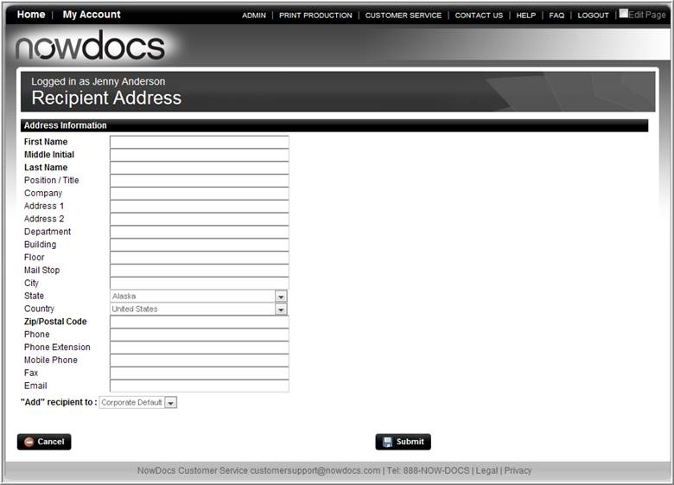

- Enter the Recipient Address Information.
- If applicable, select the desired Address Book.
- Click the Submit button.

Click here to watch a short video on Adding a Recipient

Modify Recipient

Use the following steps to modify an Address Book recipient:

- Click the My Account link from the Homepage.
- Select the Manage Address Book icon.

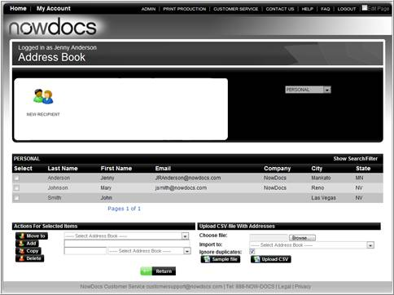

- Click on the recipient name.

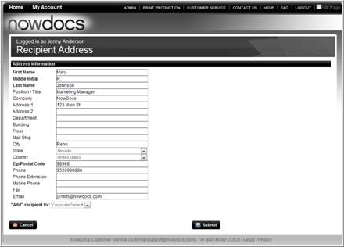

- Edit the Recipient Address information.
- If applicable, select the desired Address Book.
- Click the Submit button.

Click here to watch a short video on Modifying a Recipient

Move Recipient

The Move function enables users to move the selected recipient to another address book.

Use the following steps to Move an Address Book recipient:

- Click the My Account link from the Homepage.
- Select the Manage Address Book icon.

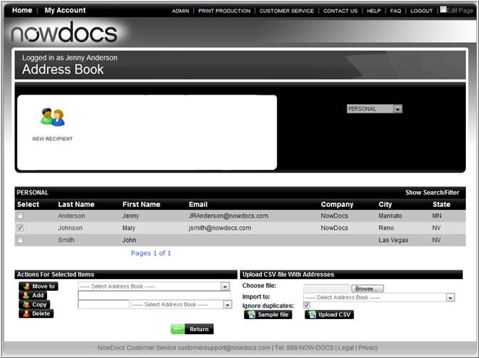

- Select the desired recipient(s).
- Select the desired address book.
- Click the Move To button.

Click here to watch a short video on Moving a Recipient

Add an Address Book Directory

The Add function enables users to add a new address book directory level.

Use the following steps to Add a Directory level to your Address Book:

- Click the My Account link from the Homepage.
- Select the Manage Address Book icon.

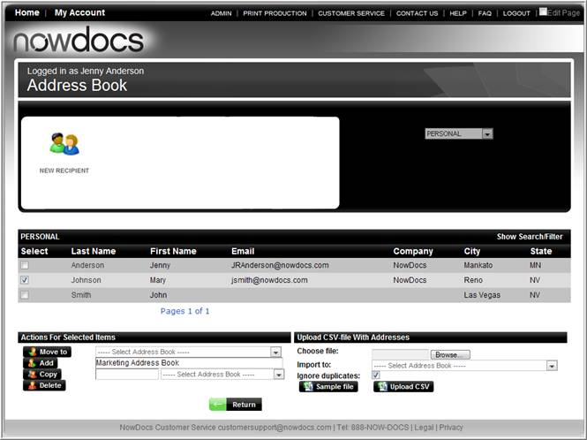

- Enter the desired Directory name.
- Click the Add button.

Click here to watch a short video on Adding an Address Book Directory

Copy Recipient

The Copy function enables users to copy the selected recipient(s) to another address book and/or copy recipients to a new address book.

Use the following steps to Copy a recipient:

- Click the My Account link from the Homepage.
- Select the Manage Address Book icon.

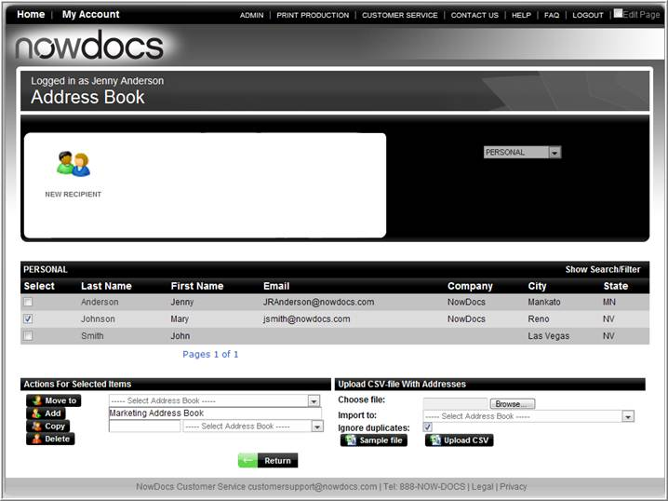

- Select the desired recipient(s).
- Select the desired address book.
- To create a new address book within the destination address book selected at step 4 above and copy the recipients to the new book, enter an address book name in the text box.
- Click the Copy button.

Click here to watch a short video on Copying a Recipient

Delete Recipient/Address Book

The Delete option allows users to delete selected recipients and/or address book. Only empty address books can be deleted. In order to delete an address book successfully, all of its contents have to be cleared.

Use the following steps to Delete a recipient or an address book:

- Click the My Account link from the Homepage.
- Select the Manage Address Book icon.

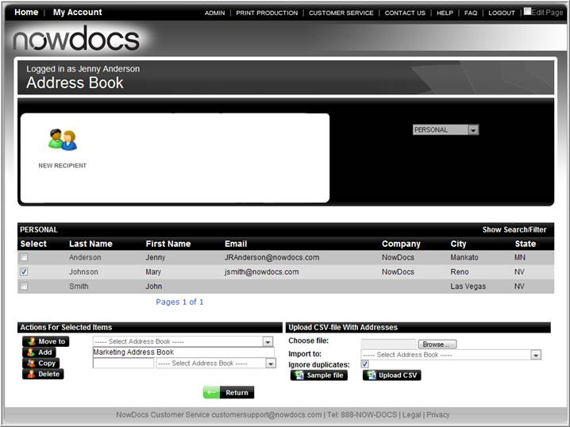

- Select the desired recipient(s) and/or address book(s) (The address book has to be empty in order to be deleted successfully).
- Click the Delete button.

Click here to watch a short video on Deleting a Recipient

Upload a CSV file with Addresses

Users can bulk upload multiple Address Book Recipients to the Address Book through the Upload CSV File with Addresses. A template is provided for the necessary upload fields.

Use the following steps to upload a CSV file to your Address Book:

- Click the My Account link from the Homepage.
- Select the Manage Address Book icon.

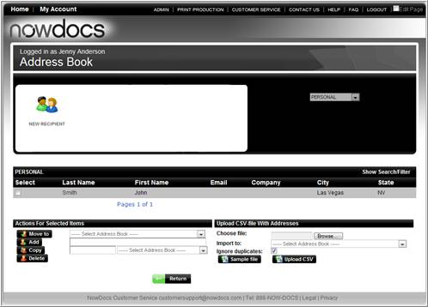

- Download, complete the template, and save to your computer.
- Click the Browse button.
- Locate the file on computer and click Open.
- Click the Upload CSV button.

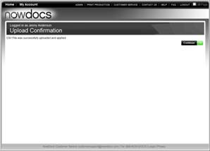

- Click the Continue button.
- The page will refresh and the user will see the new recipients loaded.

Click here to watch a short video on Uploading Multiple Recipients with a CSV File

Reports

Reports

Reports can be ran detailing NowPrint activities for a specified range of time. Reports can be run on the following:

- Bill of materials
- Impression by transaction
- Inventory quantity on hand
- Inventory total usage
- Job document page size
- Job document type
- Print center usage
- Track by impression
- Track jobs by impression
- Track orders by billing code
- Transaction by job
- Transaction by user
- Uploaded documents
- Vendor billing report

Use the following steps to run a report:

- Click the Admin link from the Homepage.
- Click the Reports tab.

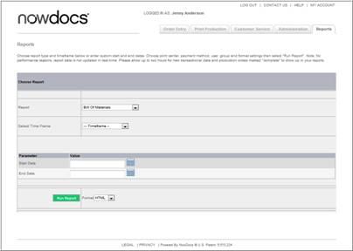

- Select the desired Report.
- Select the desired Timeframe.
OR
- Enter a start and end date.
- Select the desired report Format.
- Click the Run Report button.

Homepage

NowPrint Home Page

Depending on User access, the Home page will have different options. All users will have access to the following options:
- Workflow(s)
  - Document Submission – enables a user to upload files and configure the print options available
  - Catalog / Personalized Products – enables a user to order personalized products, kits, static documents and warehouse documents or products.
- Transaction History – enables a user to review previous orders. Users have the option to:
  - Track/Modify order – as the production queue is updated, users are updated real-time.
  - View order – view the order that was previous placed.
  - Reorder – order a job that was previously placed
- My Account – enables the users to manage their account information, preferences, settings, and orders.
- Contact Us – provides contact information, defined at the Corporate Account level.
- Help – provides online User Help.
- FAQ – provides an online user FAQ.

Additional Administrative Functions
- Admin: The Administration interface is used by the system administrator to manage the NowPrint accounts and website, as well as the groups, users, print centers, products, and other components within the system.
- Print Production: The Print Production interface is used by print production staff to view and manage orders. Orders are displayed in a queue that can be filtered and searched, and order tickets containing detailed information for each individual job can be accessed. Print production staff can manage an order's status, print orders, and perform order adjustments.
- Customer Service: The Customer Service interface is used by customer service personnel to view and manage orders.

Transaction History

The Transaction History screen enables users to track, view, and reorder previous orders. Depending on the system set-up, the buyer may be able to modify after order submission, but prior to the order being received by the production team.

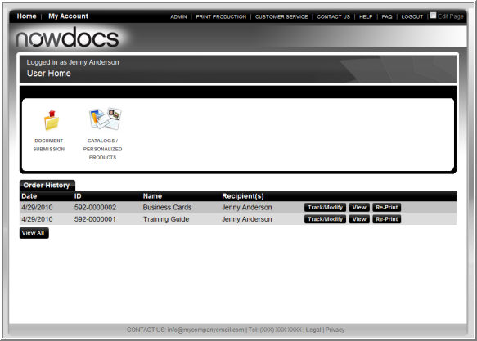

- Track/Modify – enables users to see the status of their order. As the production staff updates the status of the order, the track/modify screen is automatically updated.
- View – enables users to view a summary of their order.
- Re-order – enables users to re-order the previous order as previously ordered or with modifications to the order options.

Track an Order

The Track order screen is atomically updated when the production staff changes the order status in the Print Production queue.

Use the following steps to Track an Order:

- Click the Track/Modify button.
- The order information displays.

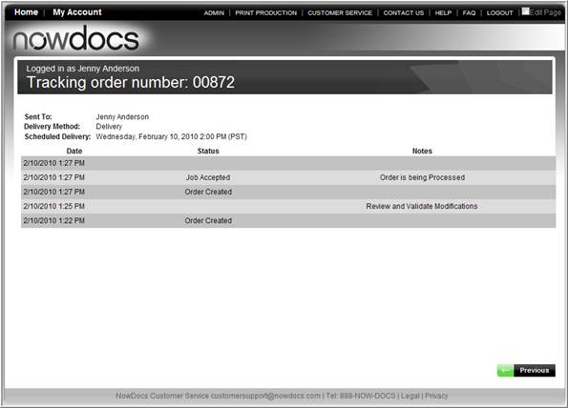

Modify Order

Orders can be modified prior to the order being received by the production staff. This option is only available when the “Allow Print Buyer to Resume Orders” feature is selected on the corporate functional settings page.

Use the following steps to modify an order:

- Click the Track/Modify Button.

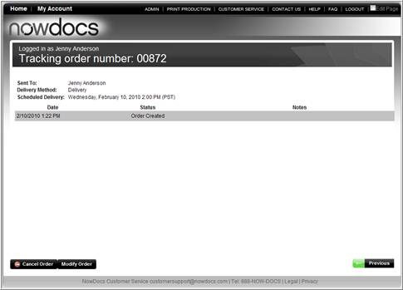

- Click the Modify Order button.

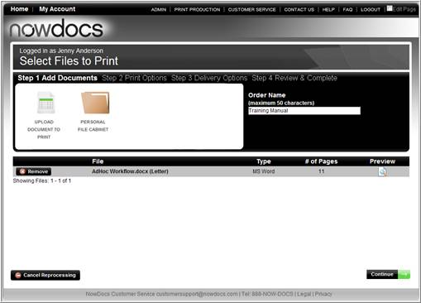

- To upload a new file, click Upload Document to Print.
  - Browse for the new file
  - Click the upload button.

OR

- To keep the current file and adjust Order Options, click the Continue button.

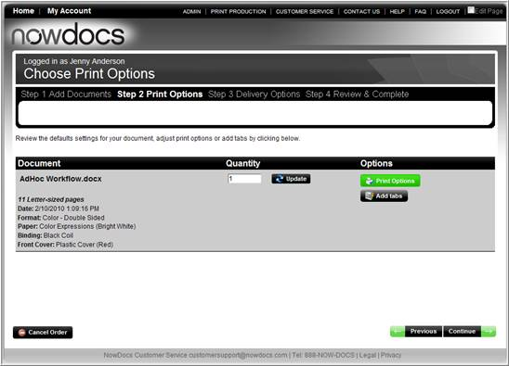

- To adjust the quantity, enter the new quantity in the text box.
- To adjust print options, click the Print Options button.
- Add tabs and/or page exceptions by clicking the Add Tabs button.
- Click the Continue button.

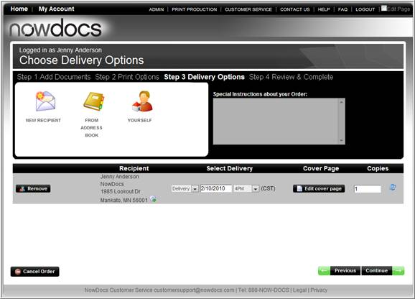

- Modify recipients.
- Adjust delivery type, due date, and time.
- Click the Continue button.

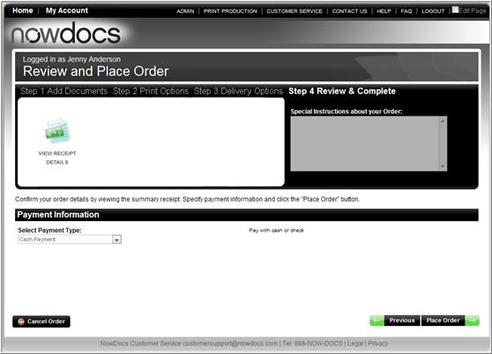

- Modify Payment Options.
- Click the Continue button.

Click here to watch a short video on Modifying an Order

Cancel Order

Orders can be canceled prior to the order being received by the production staff. This option is only available when the “Enable Print Buyer to Cancel Jobs” feature is selected on the corporate functional settings page.

Use the following steps to cancel an order:

- Click the Track/Modify button.

- Click the Cancel Order button.
- On the prompt confirmation window, click Yes.
Click here to watch a short video on Cancelling an Order

View Order

The view order option enables the buyer to view the order summary details for the order.

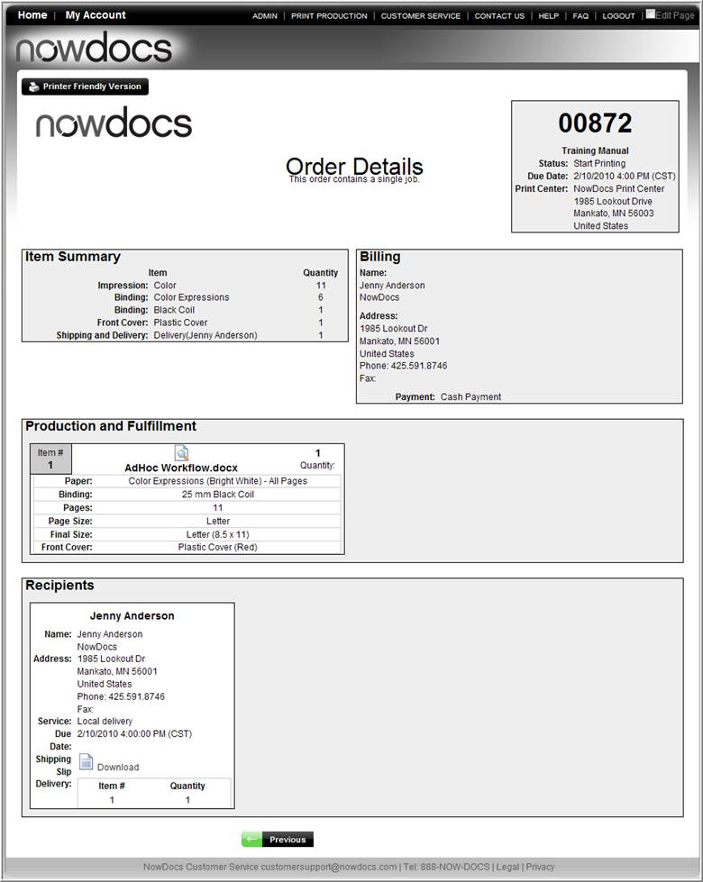

Reorder

The Reorder option enables users to re-order a job as previously ordered or with modifications to the order options.

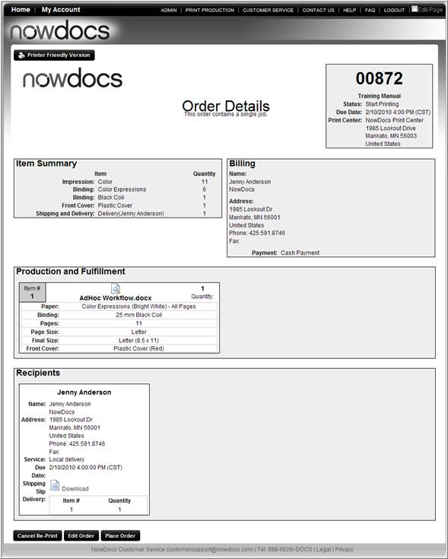

- To make changes to the re-order, click the Edit Order button.
- To place a reorder without changes, click the Place Order button.

Edit Reorder

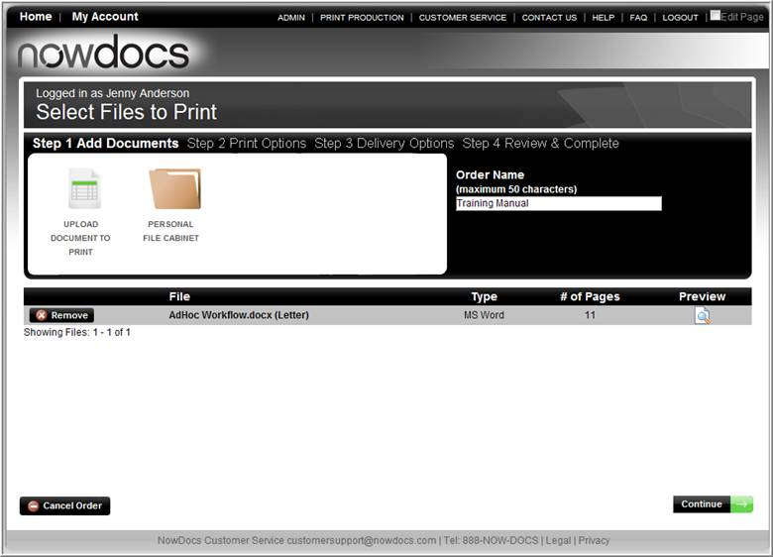

- To upload a new file, click Upload Document to Print.
  - Browse for the new file
  - Click the upload button.

OR

- To keep the current file and adjust Order Options, click the Continue button.

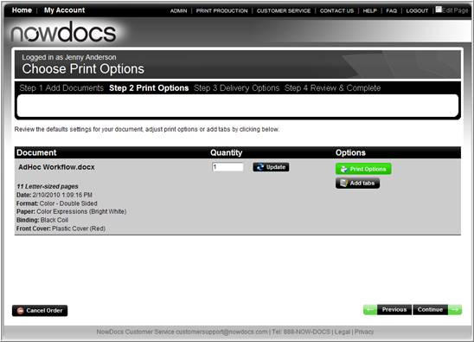

- To adjust the quantity, enter the new quantity in the text box.
- To adjust print options, click the Print Options button.
- Add tabs and/or page exceptions by clicking the Add Tabs button.
- Click the Continue button.

- Modify recipients.
- Adjust delivery type, due date, and time.
- Click the Continue button.

- Modify Payment Options.
- Click the Continue button.

Click here to watch a short video on Reordering with Edits

My Account

The My Account option allows users to view and/or modify their account settings.

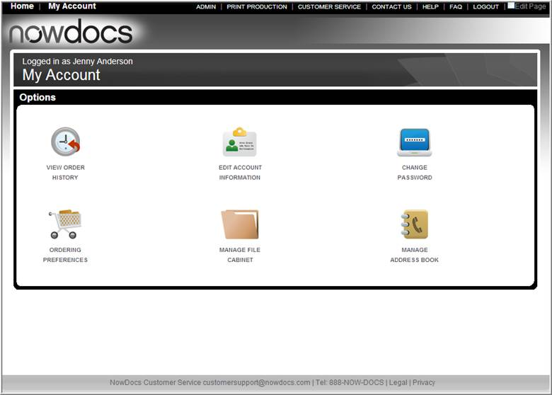

- View Order History – displays a comprehensive view of all unpurged previous orders. Corporate Account settings may purge previous orders after a period of time.
- Edit Account Information – enables the user to update contact information (for example, name, address, phone, etc).
- Change Password – allows the user to update/change their password.
- Ordering Preferences – enables the user to set their individual ordering preferences.
Note: Corporate Account settings will override the user settings.
- Manage File Cabinet – enables the user to view and manage their personal filing cabinet. If the user has update rights to the Corporate Filing Cabinet, they will be able to modify the Corporate Catalog documents as well.
- Manage Address Book – enables user to view and manage their personal Address Book. If the user has administrative rights to the Corporate Address Book, they will be able to modify the Corporate Address Book as well.

Edit Account/Login Information

Account/Login information is created during the account registration process. Required information is captured during self-registration or is entered by the Corporate Account Administrator.

Use the following steps to update Account Information:

- Click the My Account link from the Homepage.
- Select the Edit Account Information icon.

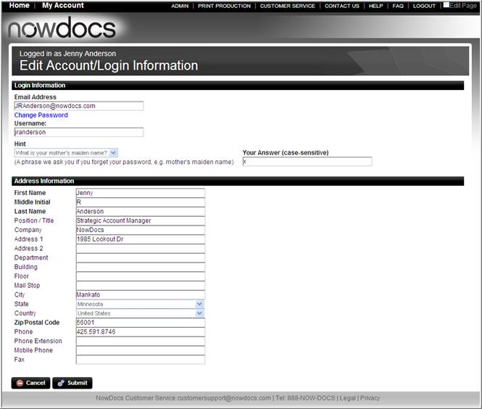

- Update the appropriate text box fields.
- Click the Submit button.

Change Password

Users can change their password from the My Account page.

Use the following steps to change the account password:

- Click the My Account link from the Homepage.
- Select the Change Password icon.

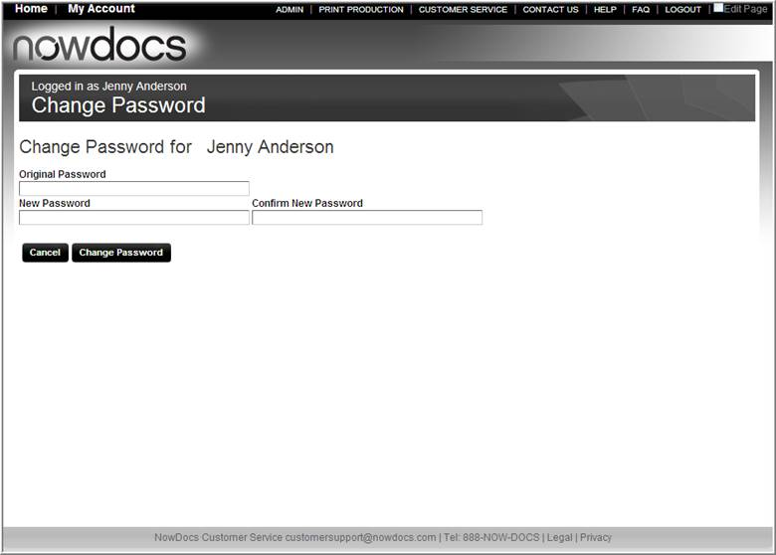

- Enter the Original Password.
- Enter the New Password.
- Confirm the New Password.
- Click the Change Password button.

Ordering Preferences

Ordering Preferences enables the user to establish defaults when placing an AdHoc order. Corporate Account print options will override the user settings.

Use the following steps to view/modify your Ordering Preferences:

- Click the My Account link from the Homepage.
- Select the Ordering Preferences icon.

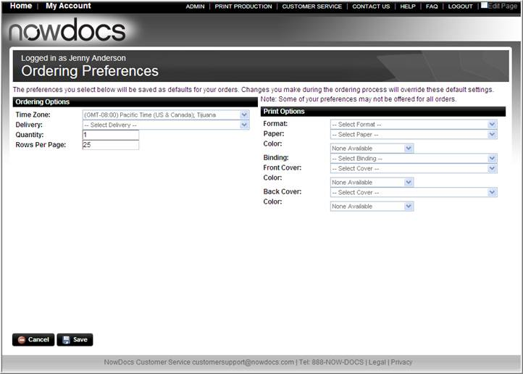

- Select desired preference from the applicable dropdown list box.
  - Time Zone – user’s time zone.
  - Delivery – preferred delivery option (options displayed by Corporate Account setting).
  - Quantity – preferred default order quantity.
  - Rows per page – The number of rows to be displayed when the page shows the records in a queue such as customer service queue.
  - Format – single or double sided, color or black and white (options displayed by Corporate Account setting).
  - Paper – preferred paper type (options displayed by Corporate Account setting).
  - Color – preferred paper color (options displayed by Corporate Account setting).
  - Binding – preferred binding option (options displayed by Corporate Account setting).
  - Front and Back Cover – preferred cover type(s) (options displayed by Corporate Account setting).
- Click the Save button.

Contact Us

The Contact Us page provides Corporate Account contact information. The contact information is determined by the Corporate Account Administrators

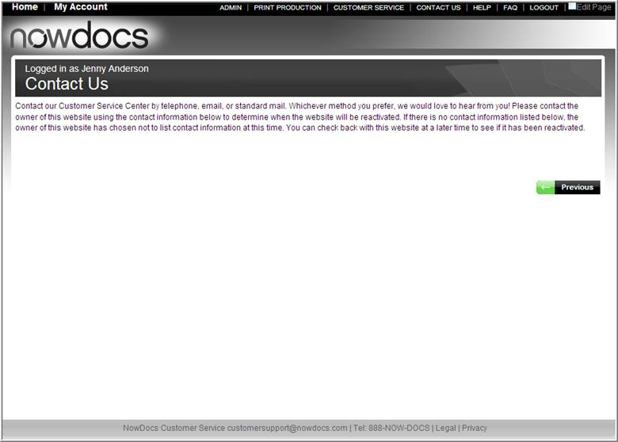

FAQ

The FAQ provides answers to frequently asked questions to guide users through the NowPrint service offering.

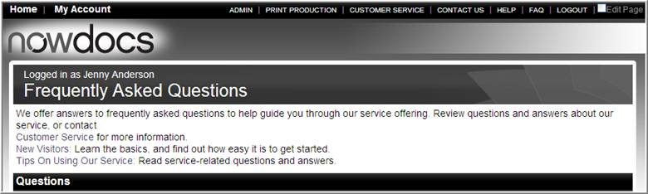

Edit Page

Corporate Account Administrators have rights to edit displayed text on the screens.

Use the following steps to update Ordering Preferences:

- Click the Edit Page check box.
- Click the pencil button located to the right of the text you wish to change.

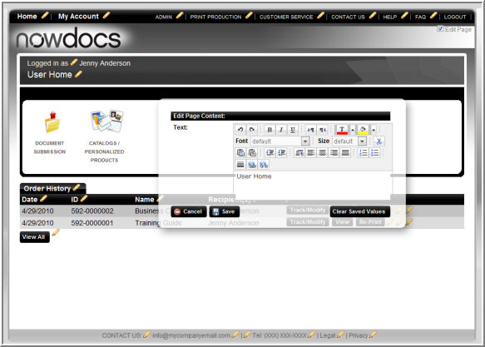

- Modify the text.
- Select the desired formatting option(s).
- Click the Save button.
Click here to watch a short video on Customizing the Homepage

Catalog Workflow

Customized Catalog Workflow

The Catalog Workflow allows users to order corporate documents and templates. Catalog items are stored by Corporate account. Catalog items are uploaded in the Admin Page.

- To view the catalog and/or order catalog items, select the Customized Catalog icon.

Click here to watch a short video on Adding a file with the Catalog Workflow

Document Catalog

The document catalog is divided into two sections:

- Folder View: Folders enable document organization. All users have access to the Corporate Default folder. Users can be assigned user access to individual sub-folders preventing the ability to order inappropriate documents.
- Catalog View: The right side of the document contains a thumbnail of the catalog item.
- Standard Catalog Items: Catalog items without variable data options allow the user to enter the desired quantity and add the item to the shopping cart.
- Variable Data Items: Catalog Items with variable data options allow the user to enter the desired quantity and customize the catalog item.

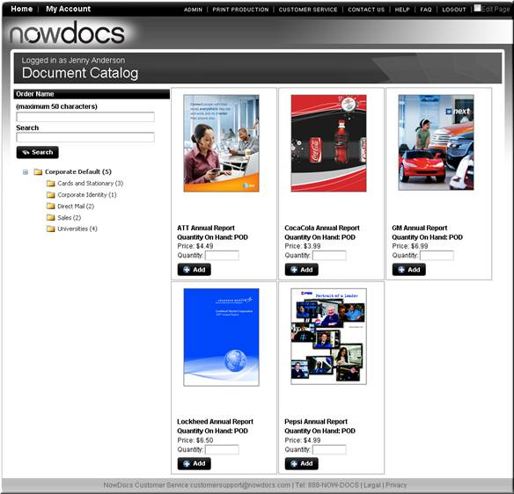

Utilize the following steps to place a Document Catalog order:

- Enter an order name in the Order Name text box.
- Enter the desired quantity in the Quantity text box.
- Click either the Add or Customize button.

Ordering Personalized Products

Depending on how the template was built, the Personalize your Product screen may be prefilled based on the User data located under My Account.

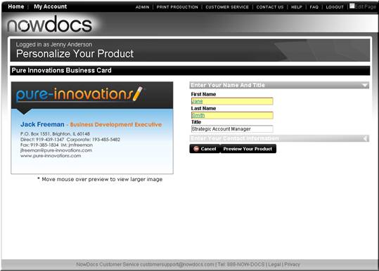

- Complete the text boxes, radio button, dropdown list boxes and/or browse fields.

Note: The template may be divided into sections. Click the section header to view the additional fields.
- Click the Preview Your Product button.

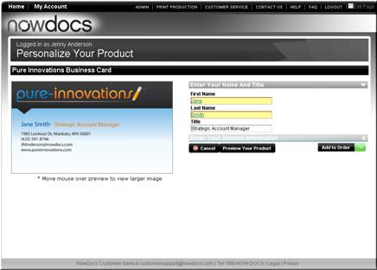

- The document preview updates with the variable data entered.
- Click the Add to Order button to proceed.

Catalog Order Shopping Cart

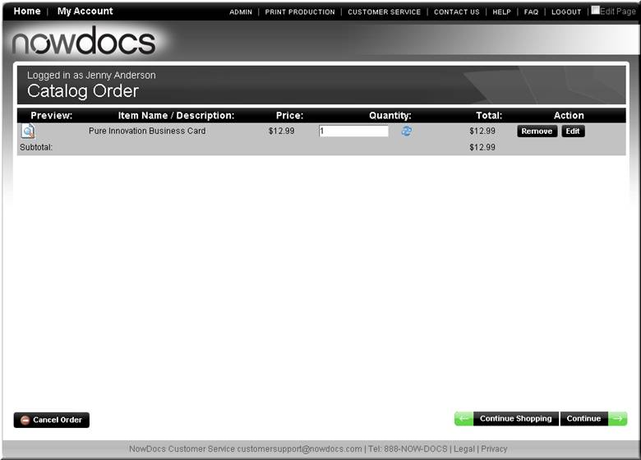

The Catalog Order Shopping Cart appears.

- Enter an order Quantity.
- To remove the catalog item, click the Remove Button.
- To modify the template, click the Edit button.
- To add additional Catalog items to the order, click the Continue Shopping button.
- To proceed to the next step in the order process, click the Continue button.

Select Recipients

Multiple recipients can be added to the order. Each recipient will receive the selected number of requested catalog items. Users can add and store a new recipient to their personalized Address Book. Recipient options include:

- New Recipient: Add a recipient to the order with the option to add to an Address Book.
- From Address Book: Add a recipient from the Personalized Address Book or from a Corporate Address book if the user has access to the Corporate Address Book.
- Yourself: User Name and Address information pulled from the User settings under My Account.

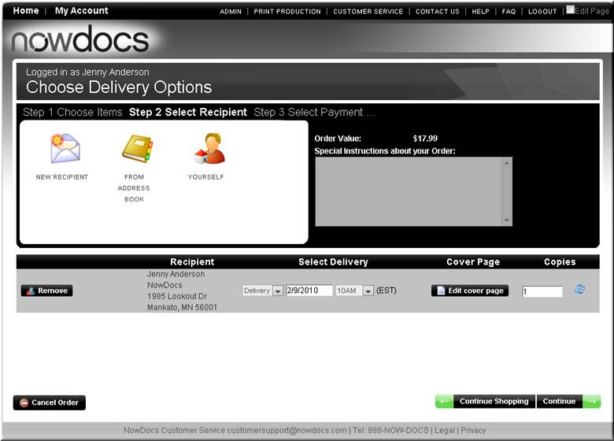

- Select desired delivery method.
- Select desired delivery date and time.
- Verify and/or change the desired quantity.
- Enter any applicable additional Special Instructions for your production individual in the text box.
- Click the Continue Button.

Note: To add notes to the recipient packing slip, click the Edit Cover Page button and enter applicable notes.

Review and Place Order

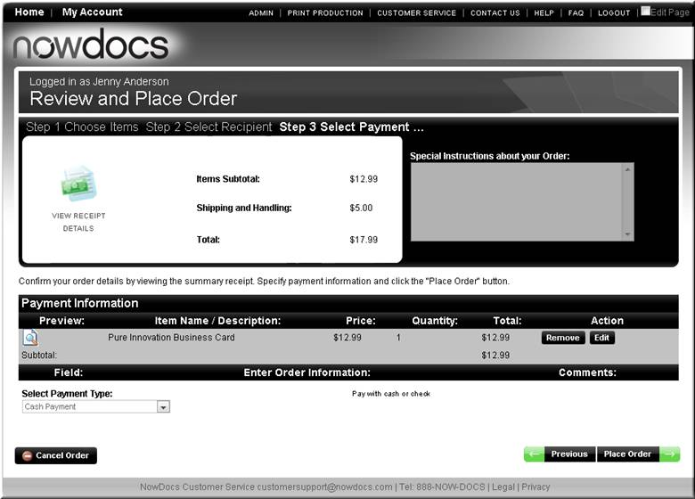

- Review order details.
- Select desired payment type.
- If applicable, enter payment information.
- Click the Place Order button.

Order Confirmation

The order confirmation page appears with the assigned order number. To view order details, click the View Receipt button.

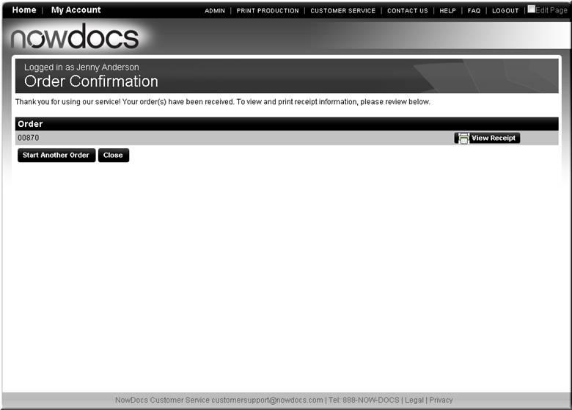

AdHoc Workflow

AdHoc Workflow

Users can upload, specify, and purchase ad hoc print requests in a self service fashion. Making it easy to place orders, enabling the user to create more complex orders through the print options, preview, and set specifications at the page level.

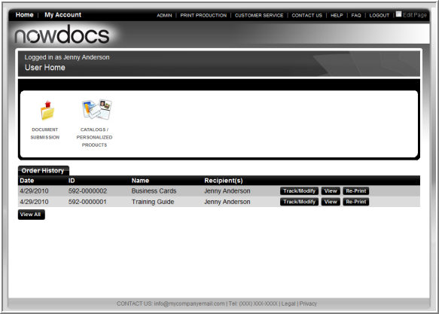

Use the following pages to upload a document to the print center:

- Click the AdHoc Workflow icon.

Note: The AdHoc workflow icon could be different depending on the customization of your site.

Click here to watch a short video on Placing an Order with the AdHoc Workflow

Add Document(s)

When adding documents, the user typically uploads a new file to the system. If enabled for the user, they can pull a file from their Personal Filing Cabinet or alert the Production Team, a hardcopy will be delivered for production.

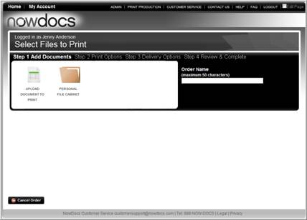

- Enter a name for your order.
- Click the Upload Document to Print icon.

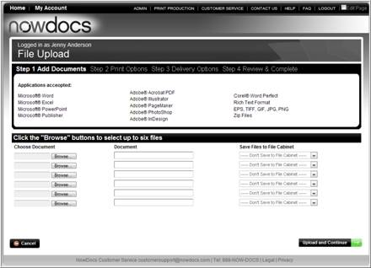

- Browse for the file(s) you wish to upload.

Optional: To name the document for the order and/or Filing Cabinet, enter a name in the Document text box. To save it to a Personal Filing Cabinet or depending on user access settings the Corporate Catalog choose your selection from the dropdown list box.

- Click Upload and Continue.
Once the file has uploaded and converted to PDF (if necessary), the summary page appears.

Single File in Order | Multiple Files in Order
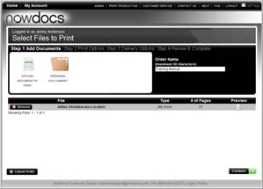 | 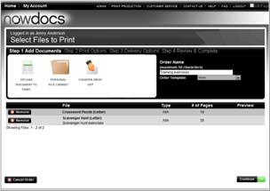

- Click the Preview icon to see the converted file.

Thumbnails of the pages appear for your review.

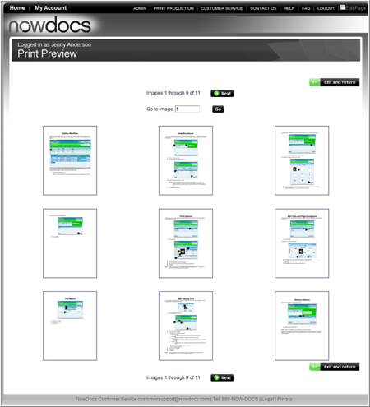

- Click on a thumbnail to zoom into the document to verify the formatting and text is correct.
- Click Exit and Return when you are satisfied with the preview.

The Document Summary page appears.

Single File in Order | Multiple Files in Order

- Click Continue.

Note: If the “Require Print Buyer to approve preview” option is selected on the workflow setup page, the user will be asked “Are you sure that you have previewed and approved your files?” after clicking on the Continue button.

Print Options

Print options and pricing are defined at the template account level and can be set uniquely at the Corporate Account level if desired. Defaults for ordering are defined under the My Account option.

Single File in Order | Multiple Files in Order
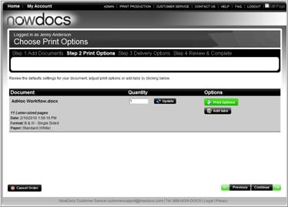 | 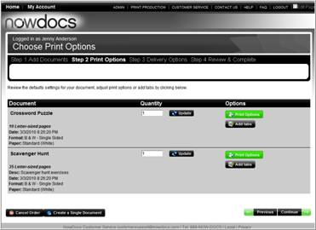

- To make modifications to print options for a single file order, click the Print Options button.

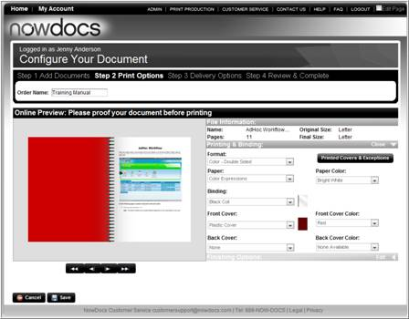

- Choose your print options from the drop-down list-box.
- View your selection(s) in the Preview window.
- Page through your document to see the impact of the selection(s).

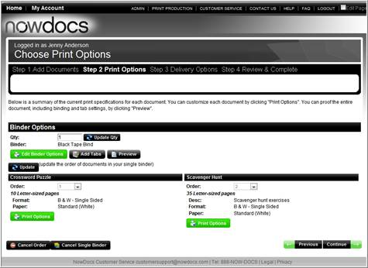

- If the order has multiple files and you wish to combine the files into one document, click the Create Single Binder button.
  - Click the Bindery button to set your binding options.
  - You can click the Print options button for each individual document to make changes.
Note: The Active Preview will not display a preview for the complete binder. You may only use the Active Preview at the document level.
- Click Save.

Note: To add page exceptions, click the Printed Covers and Exceptions button on the Print Options screen. For example, to specify you want the first page printed on cardstock.

Add Tabs and Page Exceptions

NowPrint allows for the insertion of tabs, blank pages, and/or page exceptions between any two pages of a document.

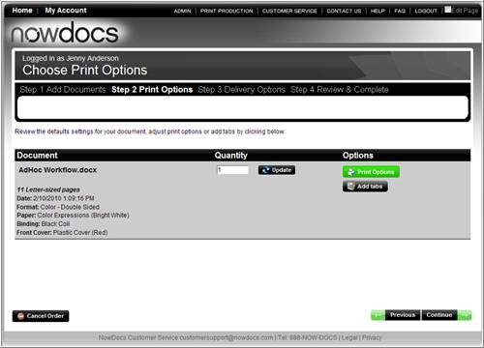

- Click Add Tabs

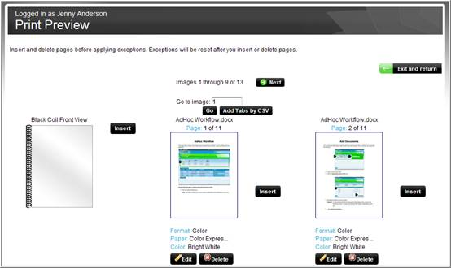

- Click Insert to add a tab or blank page between the pages displayed. When your document is set to be printed double sided, you will need to add a blank page before attempting to insert a tab between odd number pages (after pg 1, 3, 5, etc)
- Click Edit to make page level exceptions (different paper stock for the page, color vs. black and white, etc.)
- Click Delete to remove the page from the print order.

Tab Wizard

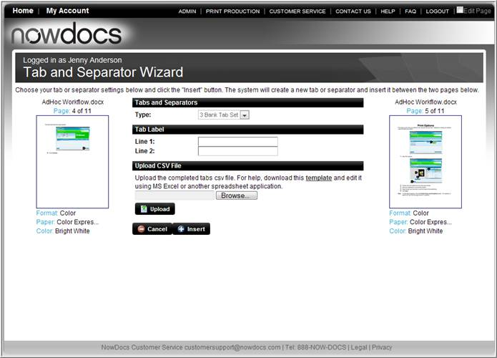

- Choose the Tab Type.
- Enter the Tab Label.
- Select Insert.

Add Tabs by CSV

As an alternative to adding each tab individually, tabs can be inserted using the Tab template. Use the following steps to add tabs from a template.

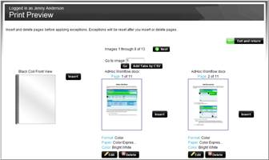

- Select Add Tabs by CSV button.

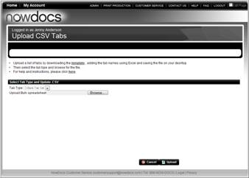
- Click on the Excel® Template in the page bullet instructions.
- Download the CSV Template.
- Open the file. You will see 4 columns:
  - document_index: this column indicates which file the tab should be associated with.
  - after_page: This column indicates what page you want the tab to go after.
  - tab_text_line_1: If necessary, this column indicates what you want the first line of text on the tab to be.
  - tab_text_line_2: If necessary, this column indicates what you want the second line of text on the tab to be.
- Complete the Excel spreadsheet with your tab labels.
- Save the file to your computer.
- Select the desired Tab Type.
- Click the Browse button
- Click Upload.

Note: If you have uploaded the CSV and want to change the order of your tabs, you will need to manually delete each tab first, and then upload the revised CSV.

Delivery Options

Delivery options are defined at the corporate level.

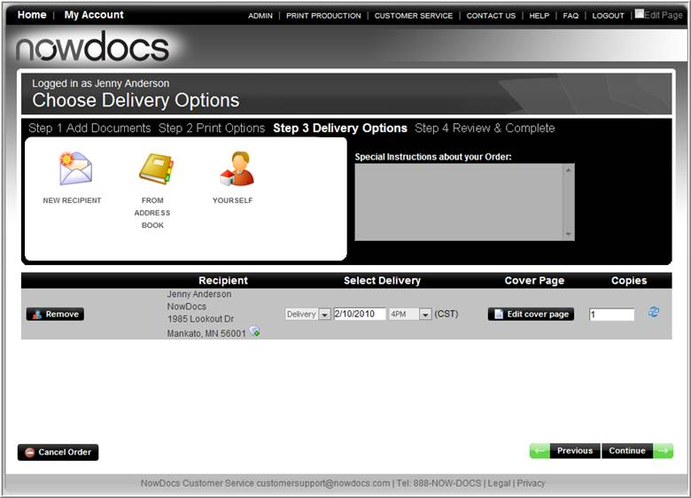

- Choose your desired delivery method from the drop-down list box.
- Select a delivery date and time.
- Click Continue.

Note: To add a New Recipient, click New Recipient and enter their details.

Recipients can be stored in a Personal address book or uploaded at the Corporate Account level.

Review and Place Order

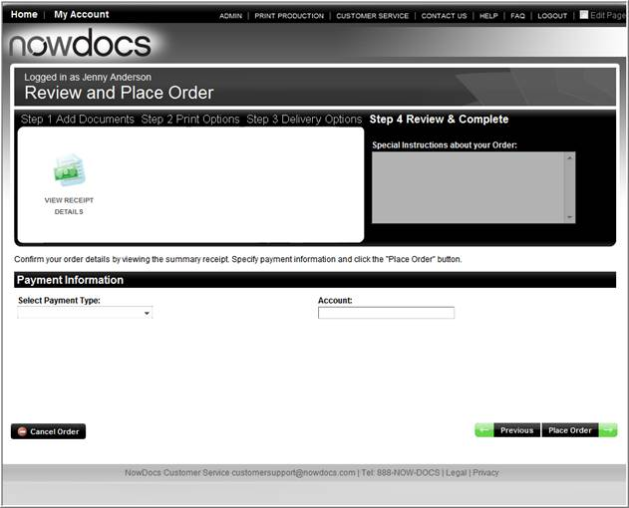

- Select desired payment option.
- If applicable, enter account details.
- Click Place Order to continue.

Order Confirmation

The Order Confirmation screen provides your order number.

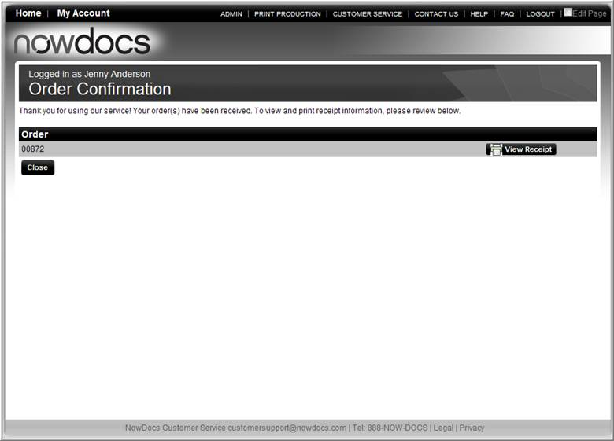

Ordering from a Personal Filing Cabinet

Users with access to a personal filing cabinet can store files to a Personal Filing Cabinet to place orders.

Use the following steps to place an order from a personal filing cabinet:

- Select the AdHoc workflow.

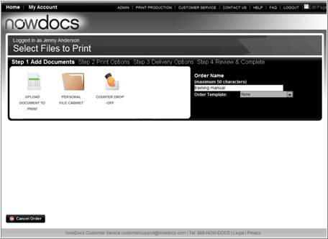

- Enter an Order Name.
- Select the Personal File Cabinet icon.

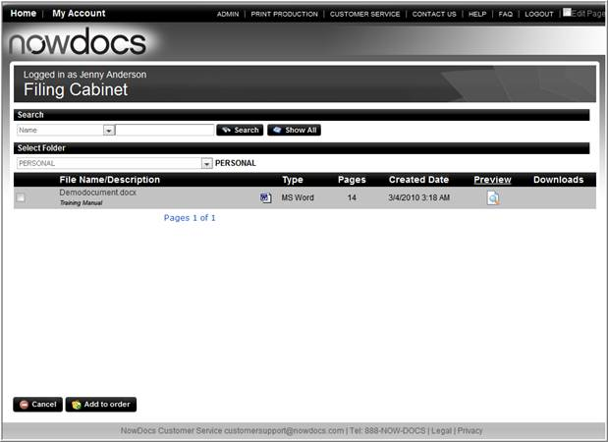

- Select the document(s) you wish to order.
- Click the Add to Order button.
- Continue through the ordering process as you would with an AdHoc order.

Placing an Order Using Order Templates

Order templates can be created and activated for Corporate Accounts to define specific production characteristics for orders. Users can choose from the order templates in the AdHoc workflow.

Use the following steps to place an order using an order template:

- Select the AdHoc workflow.

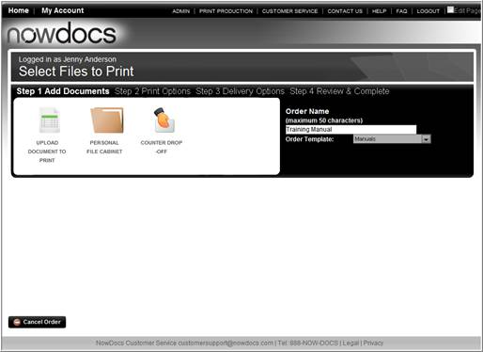

- Enter an Order Name.
- Select an Order Template.
- Click the Upload Document to Print, Personal Filing Cabinet, or Counter Drop-off icon.
  - If uploading a file, upload the file and click continue.
  - If using a Personal Filing Cabinet, select the file and click Continue
  - If using the Counter Drop-off option, enter the file information.

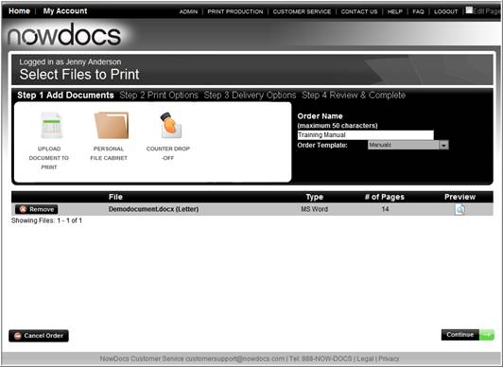

- Review the file information.
- Click the Continue button.

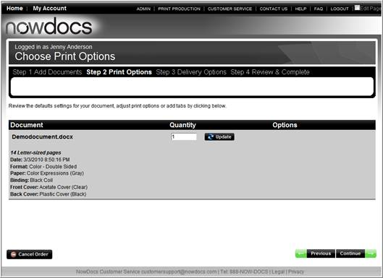

- Review the default settings for the order.
- Enter a Quantity.
- Click the Continue button.
- Continue with the order delivery and payment options.

Placing a Counter Drop-off Order

Users can enter an order without uploading a file using the Counter Drop-off option. This option is enabled in the AdHoc workflow settings.

Use the following steps for placing a counter drop-off order:

- Select the AdHoc workflow.

- Enter an Order Name.
- Select the Counter Drop-off icon.

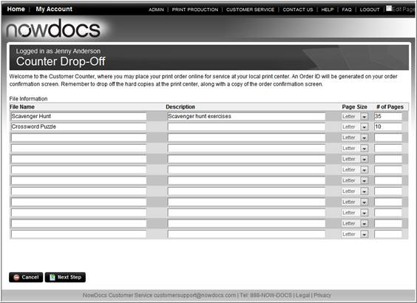

- Enter your order details.
- Click the Next Step button.

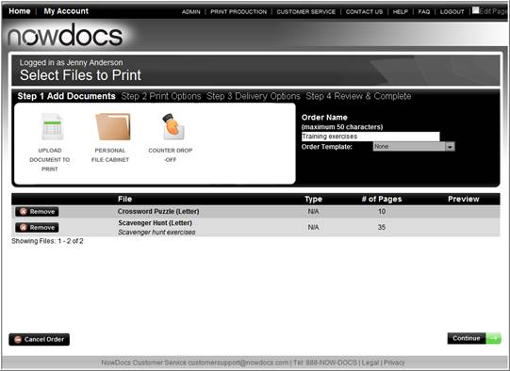

- Review your entry(s).
- Click the Continue button.
- Continue through the ordering process as normal.

Customer Service

Customer Service

The Customer Service interface is used by customer service personnel to view and manage orders. Orders are displayed in a queue that can be searched, and order tickets containing detailed information for each individual job can be accessed.

The Customer Service interface is accessed by clicking the Customer Service tab at the top of any NowPrint screen.

Access Roles and Customer Service

The Customer Service interface is visible only to users who have been given the appropriate access role. Access roles are set up by the system administrator when adding a user to the system. Access roles can be modified at any time. For complete instructions, see page Error! Bookmark not defined..

Viewing Customer Service Queue

The customer service queue displays the list of orders along with pertinent order information. The queue can be searched to show specific orders.

The customer service queue is displayed upon clicking the Customer Service link from the homepage.

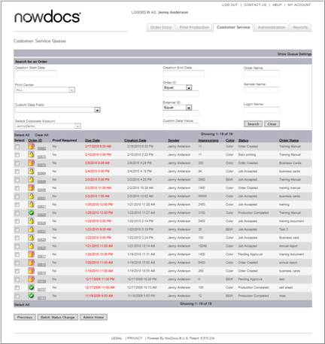

Orders icons display at-a-glance high level order status:
- The Checkmark icon indicates the order is complete.
- The Locked icon indicates the order has been created, the job ticket has been created, or the order has an exception.
- The Unlocked icon indicates the order has been received, produciton has started, or completed.
- The Red X icon indicates the order has been cancelled.

- Previous – navigates to the previous page.
- Admin Home – navigates to the Administrative page.
- Batch Status Orders – enables users to update the status of multiple orders.

Searching Customer Service Queue

- The customer service queue can be searched with the following options. Enter or select the desired data.

  - Creation start date
  - Creation end date
  - Order name
  - Print center
  - Order ID
  - Sender name
  - Custom data field
  - Login name
  - Corporate account
  - Custom data value

- Click the Search button to display the matching orders.

Changing Customer Service Queue Settings

You can change the customer service queue's settings and customize its display.

Use the following steps to change the customer service queue settings:

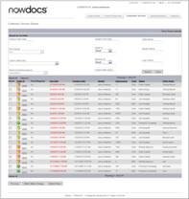

- In the upper right-hand corner of the screen, click the Show Queue Settings link. The system displays options for customizing the customer service queue.

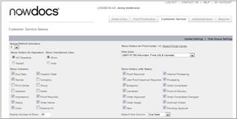

  - Use the Queue Refresh (minutes) drop-down menu to select the number of minutes for the queue to automatically refresh.
  - Use the Show Orders for Operators buttons to indicate whether you would like to display the orders for all operators, or only the orders for yourself.
  - Use the Show Orders for Print Center drop-down menu to select the print center(s) for which you would like to display orders.
  - Select your time zone from the Time Zone drop-down menu.
  - Use theShow Columns checkboxes to specify which queue columns you would like to display.
  - Use the Show Orders with Status checkboxes to specify which status types of orders you would like to display.
  - Enter the number of queue rows you would like to display in the Display Number of Rows field.
  - Use the Default Sort Column drop-down menu to select the column by which you would like the queue to be automatically sorted.

- In the upper right-hand corner of the screen, click the Update Settings link to save your selections.

Print Production Queue

Print Production Queue
The NowPrint Print Production interface is used by print production staff to view and manage orders. Orders are displayed in a dynamic job queue that can be filtered and searched according to the queue settings chosen by the administrator. Queue settings are unique to the administrator so each admin can have their own settings. Order tickets containing detailed information for each individual job can be accessed. Print production staff can manage an order's status, print orders, and perform order adjustments.

The Print Production interface is accessed by clicking the Print Production tab at the top of any NowPrint screen. The visibility of the Print Production tab is based on the user's access roles.

Orders icons display at-a-glance high-level order status:
- The Checkmark icon indicates the order is complete.
- The Unlocked icon indicates the order has been accepted, the job ticket has been created, or the order has an exception.
- The Locked icon indicates the order has been accepted, production has not started.
- The Red X icon indicates the order has been cancelled.

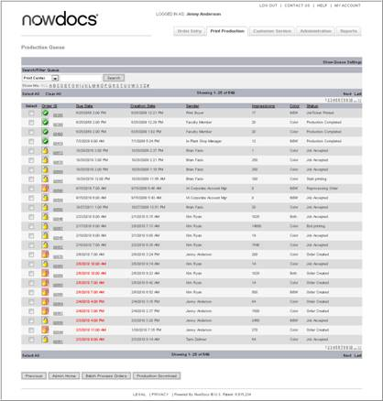

- Previous – navigates to the previous page.
- Admin Home – navigates to the Administrative page.
- Batch Process Orders – enables users to update the status of multiple orders.
- Production Download – enables users to download production files in bulk.

The production queue displays the list of orders along with pertinent order information. The queue can be filtered and searched to show specific orders, and you may change queue settings and customize its display.

Searching for Orders

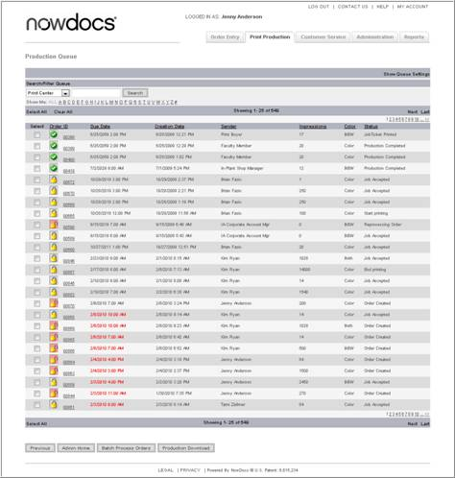

- Sort the contents of the queue by clicking on the individual column headings. For example, you may choose to sort by order ID, due date, or status. The default sort of the queue is by due date.
- Find specific orders using the search feature. You can choose to search print centers, operator names, sender names, order IDs, or external IDs. Select your choice from the drop-down menu, enter the desired search term in the entry field, and click the Search button. The queue will display all matching orders.
- Use the alphabetical list to display orders for a print center beginning with the selected letter by clicking on the desired letter of the alphabet, or click All to show all orders.

For example: If we search for orders by the print centers name “test”, all orders from the print centers with “test” in its name will be returned. If we select the alphabetical list “A”, only the orders that are from the print centers with “test” in its name AND with “A” as the first letter in the print center’s name will be displayed among the search result. For example, the orders belonging to the print center “ABCTest” will be showing and the orders from the print center “XYZTest” will not be displayed.

Changing Production Queue Settings

You can change the production queue's settings and customize its display.

Use the following steps to modify the Production Queue Setting:

- Click on the Print Production link to access the Production Queue.

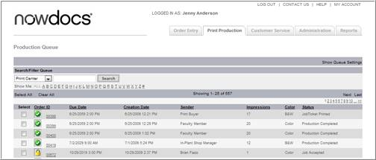

- Click the Show Queue Settings link.

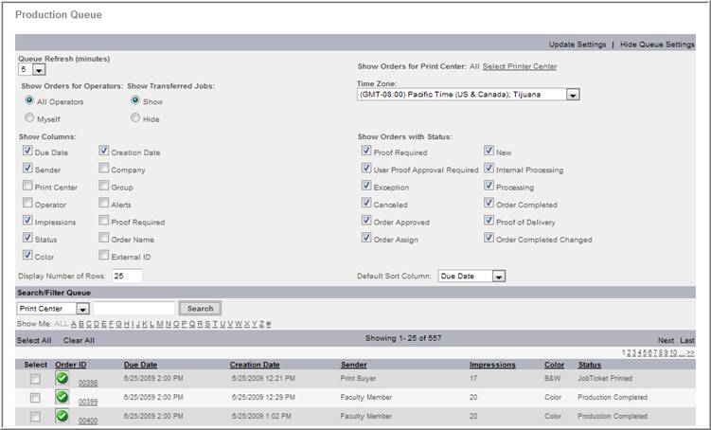

- Use the Queue Refresh (minutes) drop-down menu to select the number of minutes for the queue to automatically refresh.
- Use the Show Orders for Operators buttons to indicate whether you would like to display the orders for all operators, or only the orders for yourself.
- Use the Show Orders for Print Center drop-down menu to select the print center(s) for which you would like to display orders.
- Select your time zone from the Time Zone drop-down menu.
- Use theShow Columns checkboxes to specify which queue columns you would like to display.
- Use the Show Orders with Status checkboxes to specify which status types of orders you would like to display.
- Enter the number of queue rows you would like to display in the Display Number of Rows field.
- Use the Default Sort Column drop-down menu to select the column by which you would like the queue to be automatically sorted when the print production queue is initially loaded.
- Click the Update Settings link to save your selections.

Order Ticket

The Order Ticket provides detailed information on an order. Depending on user access settings the user may view, update, or modify the information on the order. The Order Ticket allows production staff to:

- Update the status of an order.
- Make order adjustments.
- View a summary of the order.
- View and/or download production files.
- View and/or download packing slips.
- View order details and history.

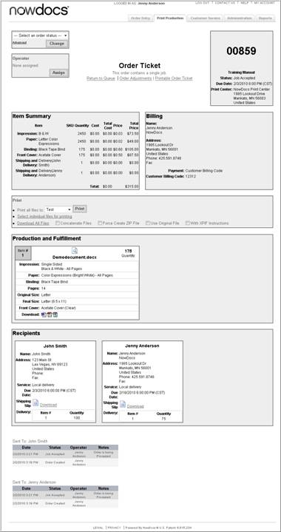

Order Status

Order status is an important facet of the production process because it ensures timely and accurate communication from the print center to the buyer. Order status is updated from the order ticket. When an order status is updated, the Job Details at the bottom of the Order Ticket are updated as well as the status update on the buyer side. Depending on email notification settings, buyers may receive email updates when the order status is updated.

The order can have the following order status options:

- Accept Job: Select this option to start processing an order and gain access to its production-ready files.
- Proof Approval Requested: Select this option of the buyer has indicated that he/she would like to receive a proof of the order before it is produced, to gain access to its production-ready files. The print production staff will not be able to process the job until the buyer approves the proof.
- Production Complete: Select this option when all production for the order has been completed.
- Start Printing: Select this option when printing activity begins. If meter reading has been enabled, you will be prompted to enter the current meter reading when the "Start Printing" status option is selected.
- End Printing: Select this option when printing activity ends. If meter reading has been enabled, you will be prompted to enter the end meter reading when the "End Printing" status option is selected.
- Job Unlocked: Select this option to unlock an order and allow the buyer to make modifications to the order.
- Job Ticket Printed: Select this option when the order ticket has been printed.

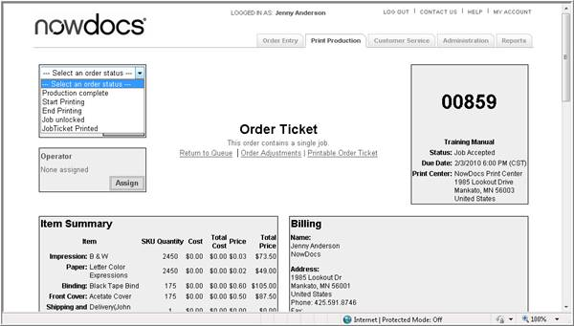

Update Order Status

Use the following steps to add an Update the Status of an Order:

- Click on the Print Production link to access the Production Queue.
- Click on the Order.

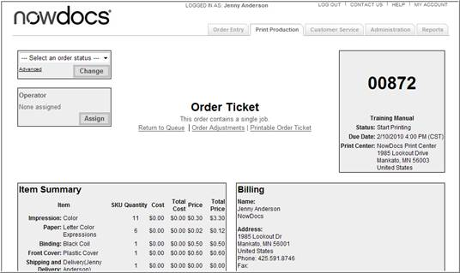

- Click on the Print Production link to access the Production Queue.
- Click on the Order.

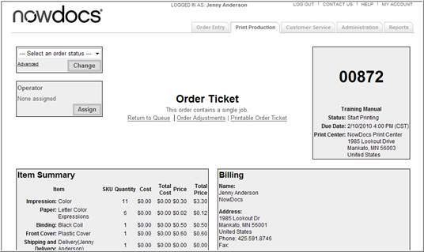

- Click the Select an Order Status drop down list box.
- Select a desired order status.
- Click the Change button.

Note: If a buyer has indicated that he/she would like to receive a proof of the order before it is produced, you must change the order's status to "Proof Approval Requested" and wait for buyer’s approval before you can gain access to its production-ready files.

Advanced Order Status Options

If you would like to negotiate the due date/time before accepting the order, follow these steps:

- At the top of the order ticket, click the Advanced link.

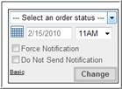

- Click the calendar icon to select a new due date. Use the time drop-down menu to select a delivery time.
- Select the Force Notification checkbox if you would like to send an email notification to the buyer who placed the order.
- Select the Do Not Send Notification checkbox if you do not want to notify the buyer by email.
- Click the Change button.

Assign Order to Print Operator

Orders can be assigned to specific print operators.

Use the following steps to assign the order to a print operator:

- Click on the Print Production link to access the Production Queue.
- Click on the Order.

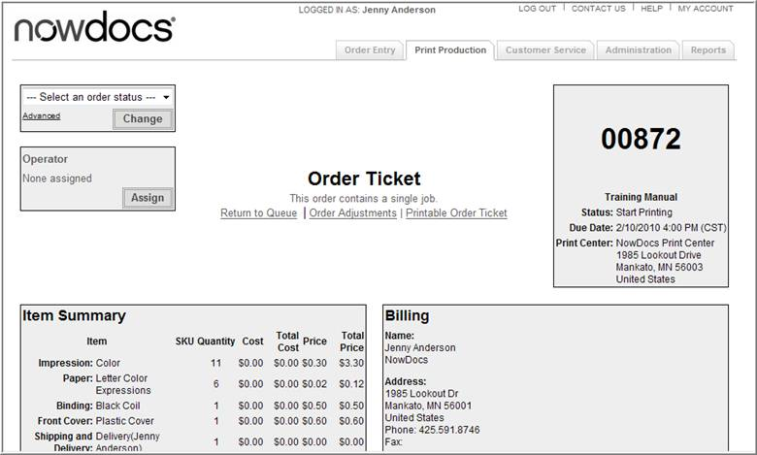

- Click the Assign button.
- The system opens a new window.

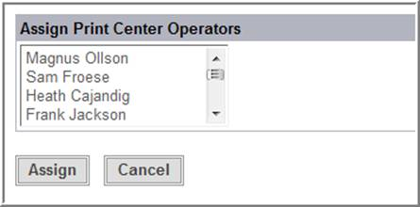

- Select the operator from the Assign Print Center Operators menu.
- Click the Assign button.

Downloading and Printing Files
Once an order's status is changed to "Job Accepted," you can access its production-ready files. Print options appear in the Print section of the order ticket, and download icons for the individual files appear in the Production and Fulfillment section of the order ticket, as shown in the illustration below.

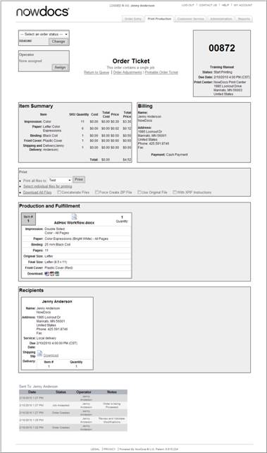

- You can download a ZIP file containing all files associated with the order from the Print section of the order ticket. The following options are available:
  - Select theConcatenate Files checkbox to create a single PDF from the individual files.
  - Select the Force Create ZIP File checkbox to create the ZIP file from scratch.
  - Select the Use Original File checkbox to include the original files in the ZIP file instead of the PDF(s).
  - Select the With XPIF Instructions checkbox to include XPIF instructions in the ZIP file.
- After selecting the desired checkboxes, click the Download all files link to download the ZIP file.

OR

- You can download individual files for the PDF, the native files, and the Xerox order ticket (XPIF) from the Production and Fulfillment section of the order ticket.

Batch Process Orders

You can process multiple orders together in a batch. Two batch processing options are available:
- Orders can be sent to an output device in a batch.
- Status can be changed for a batch of orders.

Use the following steps to Batch Process Orders:

- Click on the Print Production link to access the Production Queue.

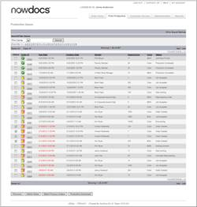

- Click the checkbox in the Select column next to each Order ID you would like to process.
- Click the Batch Process Orders button.
- The system opens the Batch Process Orders screen.

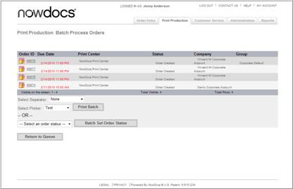
If you would like to send the orders to an output device in a batch, follow these steps:
- If desired, use the Select Separator drop-down menu to insert slipsheets.
- Select the output device to which you would like to send these orders from the Select Printer drop-down menu.
- Click the Print Batch button.

If you would like to change the status for the batch of orders, follow these steps:
- Select the desired order status from the Select an order status drop-down menu. See page 7-6 for more information on order status options.
- Click the Batch Set Order Status button.

Production Download

Production Operators can download files for multiple orders using the Production Download option in the Print Production Queue.

Use the following steps to begin a Production Download:

- Click on the Print Production link to access the Production Queue.

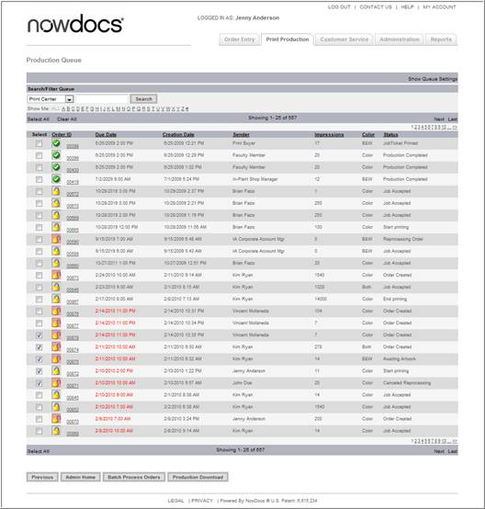

- Select the Orders you wish to download.
- Click the Production Download button.

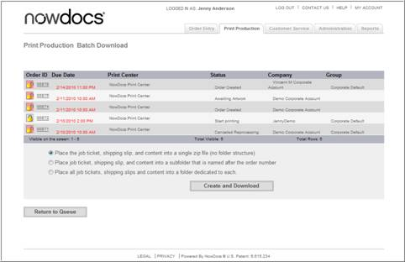

- Select the appropriate download option (see below for more details).
- Click the Create and Download button.

Place the job ticket, shipping slip, and content into a single zip file (no folder structure) – places downloaded items into one single zip file.

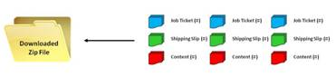

Place job ticket, shipping slip, and content into a subfolder that is named after the order number - all order documents into individual folders and then zipped into done download file.

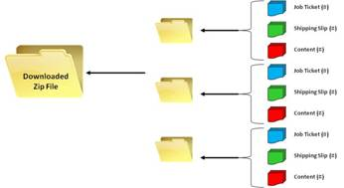

Place all job tickets, shipping slips and content into a folder dedicated to each – all “like” order documents are placed into their own individual folders and then zipped into one file.

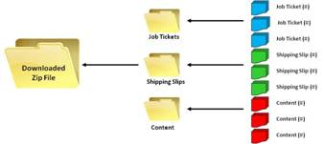

Order Adjustments
Print center staff can perform numerous order adjustments from the Order Adjustments screen. Adjustments to orders are recorded in the order's history, providing an audit trail for changes made to the original order ticket.

The options available from the Order Adjustments screen depend on the user's access roles, as well as the status of the order. Thus, some of the order adjustments options will not be visible to all users at all times.

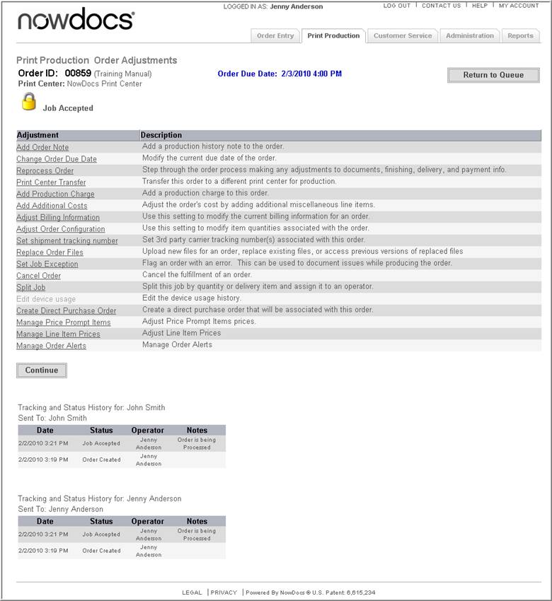

  - Add Order Note: Add a miscellaneous production note to an order.
  - Change Order Due Date: Modify the due date of an order.
  - Reprocess Order: Step through the Order Entry process and make adjustments to an order's files, print options, delivery options, and/or payment information.
  - Print Center Transfer: Transfer the production of an order to another print center.
  - Add Production Charge: Add production charge finishing items to an order.
  - Add Additional Costs: Adjust an order's cost by adding additional line items.
  - Adjust Billing Information: Modify the billing information that was supplied by the buyer for an order.
  - Adjust Order Configuration: Modify print options for specific recipients and their respective files.
  - Set Carrier Tracking Number: Enter a third-party carrier's tracking number for an order's recipients.
  - Replace Order Files: Modify which files are associated with an order by uploading new files, replacing existing files, or accessing previous versions of files.
  - Set Job Exception: Note any issues experienced while producing an order.
  - Cancel Order: Cancel the fulfillment of an order.
  - Split Job: Split an order by quantity.
  - Edit Device Usage: Adjust meter readings for an output device.
  - Create Direct Purchase Order: Create direct purchase orders for price prompt items.
  - Manage Price Prompt Items: Adjust price prompt items to set the correct sell and cost values.
  - Manage Line Item Prices: Adjust line item prices to set the correct sell value.
  - Manage Order Alerts: Set alerts for an order.

Add a Production Note

NowPrint enables production users to add free-form notes to an order. Notes can be made visible to the buyer on their status update or internal notes.

Use the following steps to add a Production Note:

- Click on the Print Production link to access the Production Queue.
- Click on the Order.
- In the Order Ticket, select Order Adjustments.

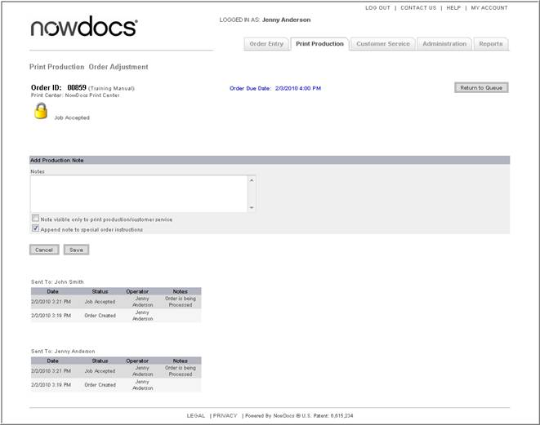

- Type note in the notes text box.
- Select the checkbox Note visible only to print production/customer service if you would like the note to be visible only to production and customer service staff, and not to the buyer who placed the order.
- Select the checkbox Append note to special order instructions if you would like this note to appear in the production instructions section of the order ticket.
- Click the Save button.

Change an Order Due Date

When placing an order, buyers select their desired due date and time. Production staff have the ability to modify order due dates and notate the change with a free-form text field. When a due date is modified, production staff has the option to have the buyer notified via email.

Use the following steps to modify the order due date:

- Click on the Print Production link to access the Production Queue.
- Click on the Order.
- In the Order Ticket, select Order Adjustments.
- Select Change an Order Due Date.

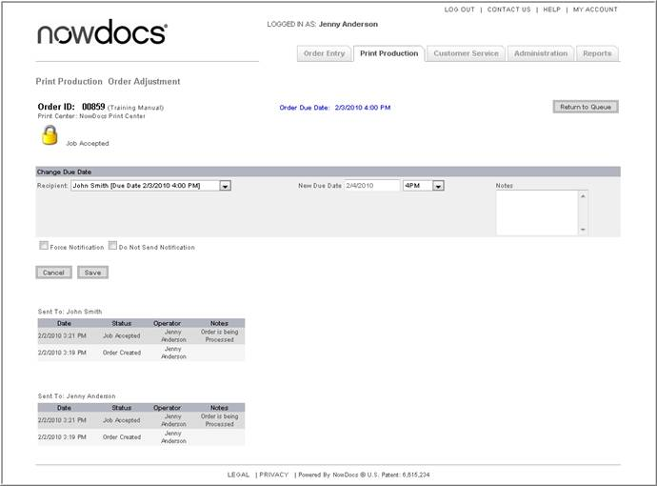

- Select the recipient from the drop-down list box (If applicable).
- Use the New Due Date calendar icon and the time drop-down menu to select the new order due date and time.
- Enter an explanatory note in the Notes field.
- Select the Force Notification checkbox if you would like to send an email notification of the changed due date to the buyer who placed the order.
- Select the Do Not Send Notification checkbox if you do not want to notify the buyer by email of the changed due date.
- Click the Save button

Reprocess Order

Reprocessing an order allows you to step through the Order Entry process and adjust the order's files, print options, delivery options, and/or payment information.

Use the following steps to Reprocess an Order:

- Click on the Print Production link to access the Production Queue.
- Click on the Order.
- In the Order Ticket, select Order Adjustments.
- Select Reprocess Order.

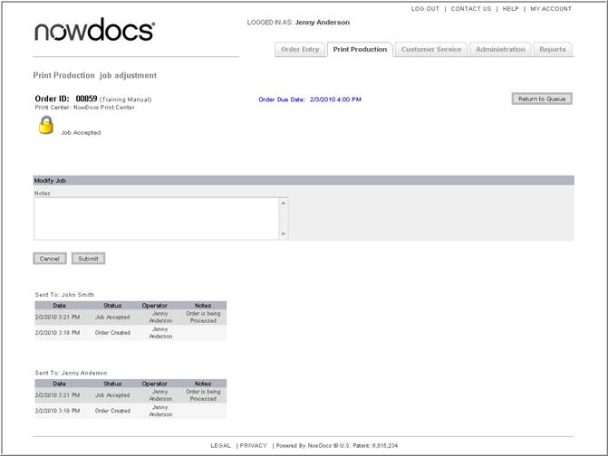

- Enter an explanatory note in the Notes field. This is a required field. The note will be displayed in the buyer's order history.
- Click the Submit button. The system routes you to Step 1 of the Order Entry process and you can continue through the entire process, making modifications as desired. Note: If the order is a catalog/personalized product order, the system routes you to Step 3 of the Order Entry process.

Note: When you have completed the reprocessing, click the Print Production tab to return to the production queue. The order will appear in the queue as a new order. To continue processing the order, you must accept the order by changing its status to "Job Accepted."

Print Center Transfer

For organizations with more than one print center, it may be necessary at times to transfer an order from one print center to another, in order to balance the workload.

Use the following steps to transfer the production of an order to another print center:

- Click on the Print Production link to access the Production Queue.
- Click on the Order.
- In the Order Ticket, select Order Adjustments.
- Select Print Center Transfer.

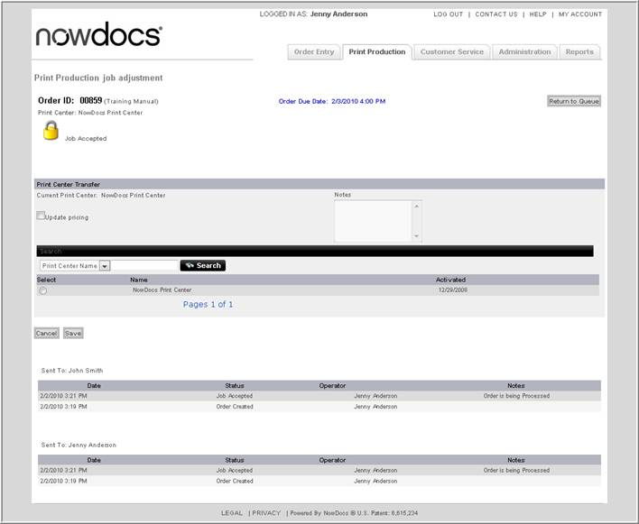

- Select the desired print center from the Transfer Job to print center drop-down menu.
- Select the Update pricing checkbox if you would like to have the order recalculated based on the new print center’s pricing.
- Enter an explanatory note in the Notes field. The note will be displayed in the buyer's order history.
- Click the Save button.

Add Print Production Charge

You can add production charge finishing items to an order to accommodate any number of production scenarios.

Use the follow these steps to add a production charge:

- Click on the Print Production link to access the Production Queue.
- Click on the Order.
- In the Order Ticket, select Order Adjustments.
- Select Add Print Production Charge.

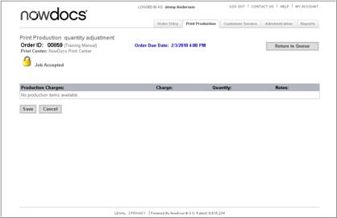

- Select the recipient for whom you would like to add a production charge from the Select the recipient to add a production charge for drop-down menu.
- Click the Continue button. The system opens a new screen.

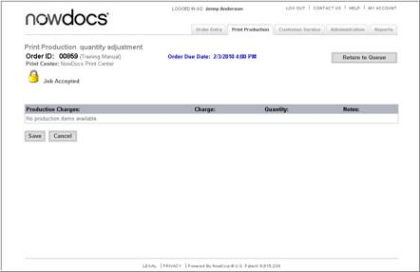

- Select the checkbox next to the desired production charge, or enter a value in the Quantity field to indicate the increment to charge. (For example, if proofing is measured in increments of 15 minutes and you would like to charge for 45 minutes, then enter a 3 in the Quantity field.)
- Click the Save button.

Add Additional Costs

When the buyer enters an order, each selection is assigned a price based on the Corporate Account Pricing structure. Production staff can add additional production costs to the order to capture additional charges not programmed into NowPrint. Depending on the buyer set-up, the buyer may need to approve additional charges prior to order fulfillment.

Use the follow these steps to Add Additional Costs:

- Click on the Print Production link to access the Production Queue.
- Click on the Order.
- In the Order Ticket, select Order Adjustments.
- Select Add Additional Costs.

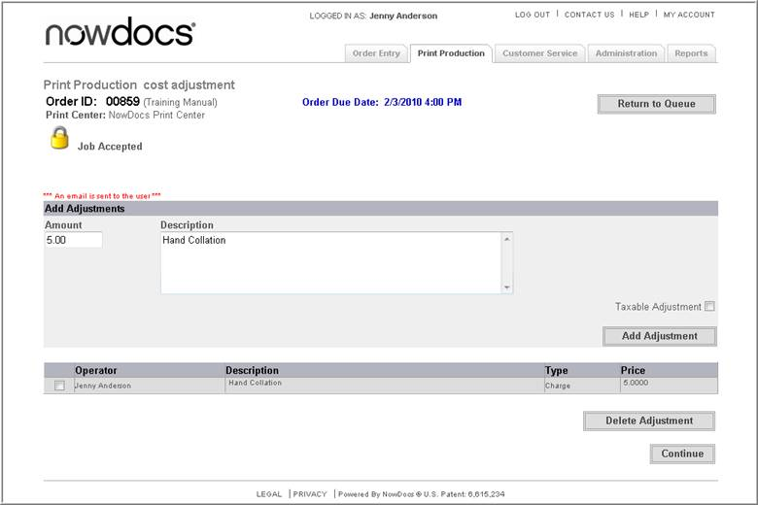

- Enter the amount of the adjustment in the Amount field.
- Enter a description of the adjustment in the Description field.
- Select the Taxable Adjustment checkbox if the adjustment is subject to sales tax.
- Click the Add Adjustment button.
- If you would like to remove an adjustment, select the checkbox next to the adjustment and then click the Delete Adjustment button. An email notification of the deleted cost is sent to the buyer who placed the order.
- When you have finished, click the Continue button.

Adjust Billing Information

You can modify the billing information that was supplied by the buyer for the order.

Use the follow these steps to Adjust Billing Information:

- Click on the Print Production link to access the Production Queue.
- Click on the Order.
- In the Order Ticket, select Order Adjustments.
- Select Adjust Billing Information.

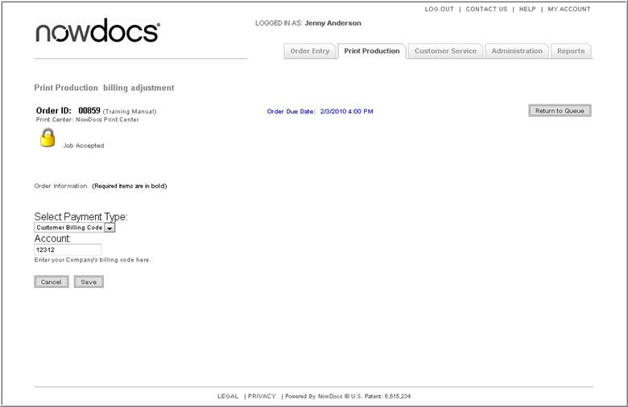

- Select the new payment option from the Select Payment Type dropdown list box.
- Enter the account information (if required).
- Click the Save button.

Adjust Order Configuration

When a buyer enters the order, they specify their print and tab options. If order specifications need to be modified, the Adjust Order Configuration screen is used.

Use the follow these steps to Adjust the Order Configuration:

- Click on the Print Production link to access the Production Queue.
- Click on the Order.
- In the Order Ticket, select Order Adjustments.
- Select Adjust Order Configuration.

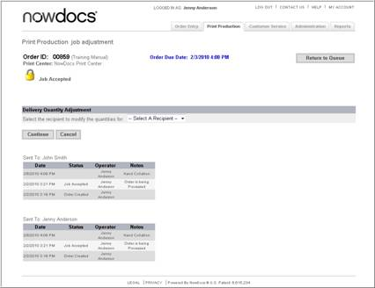

- If the order has more than one recipient, the system opens the screen below. If there is only one recipient for the order, you will bypass this screen.
- Click the Continue button.

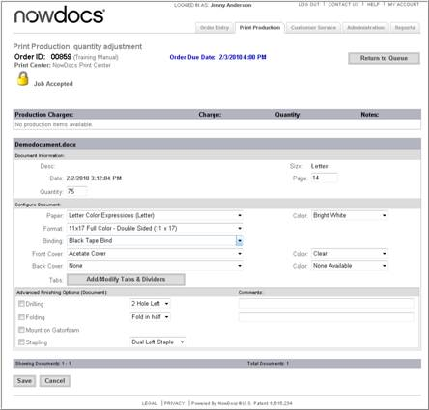

- If applicable, use the Production Charges fields to modify production charges.
- Use the Advanced Finishing Options (Order) checkboxes to modify order-level finishing options.
- Use the Pages field to modify the number of pages.
- Use the Quantity field to modify the number of copies desired.
- Use the Paper and adjacent Color drop-down menus to modify the paper type and color.
- Use the Format drop-down menu to modify the format method.
- Use the Binding drop-down menu to modify the binding.
- Use the Front Cover and Back Cover and adjacent Color drop-down menus to modify the covers.
- Click the Add/Modify Tabs & Dividers button to modify tabs.
- Use the Advanced Finishing Options (Document) checkboxes to modify finishing options for the file.
- Click the Save button.

Set Shipment Tracking Number

When an order's delivery is to be provided by a third-party carrier, you should enter the carrier's tracking number for each of the order's recipients. This enables the recipient to track the delivery status of the order. The tracking number will appear in buyer’s order history as a clickable link that takes them directly to the carrier's website for the specific tracking information.

First, you must ship the order to obtain the carrier tracking number.

Use the follow these steps to Set the Shipment Tracking Number:

- Click on the Print Production link to access the Production Queue.
- Click on the Order.
- In the Order Ticket, select Order Adjustments.
- Select Set Shipment Tracking Number.

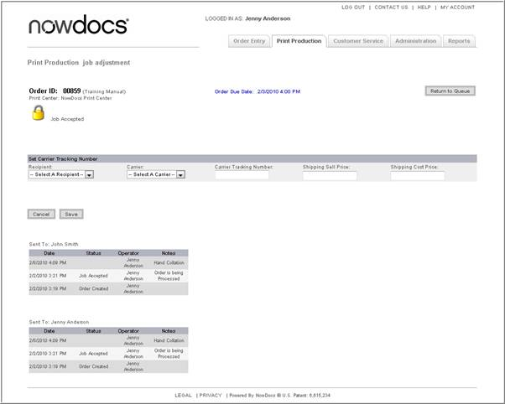

- Select the appropriate recipient.
- Select the appropriate carrier.
- Enter the tracking number.
- Enter the buyer’s shipping cost.
- Enter the actual shipping costs.
- Click the Save button.

Replace Order Files

Production staff has the option to upload additional order files, replace order file, and specify which files should be used for the order. A documented history of changes is recorded to enable production staff members to retrieve the original production files.

Use the follow these steps to Replace Order files:

- Click on the Print Production link to access the Production Queue.
- Click on the Order.
- In the Order Ticket, select Order Adjustments.
- Select Replace Order Files.

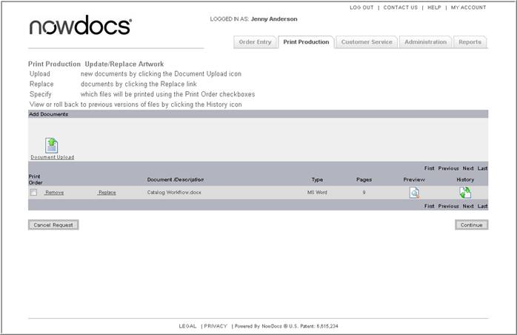

  - Document upload – upload new documents to be added to the order.
  - Replace – change the file used for the order. Updating the file maintains all previous file configurations for the order.
  - Remove – detach a file from the order.
  - History – view or roll back to previous file versions.

Add File(s) to Order

Use the following steps to add a file to the order:

- Click on the Print Production link to access the Production Queue.
- Click on the Order.
- In the Order Ticket, select Order Adjustments.
- Select Replace Order Files.

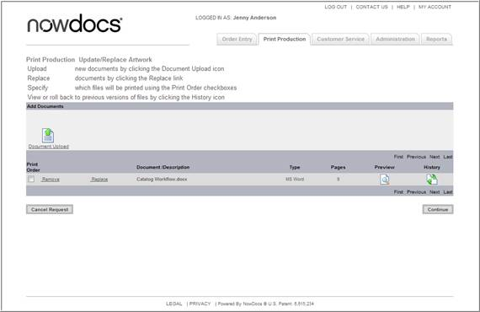

- Click the Document Upload link.

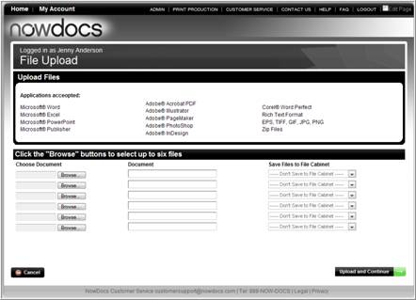

- Click the Browse button.
- Locate the new file on your computer.
- Click the Upload button.

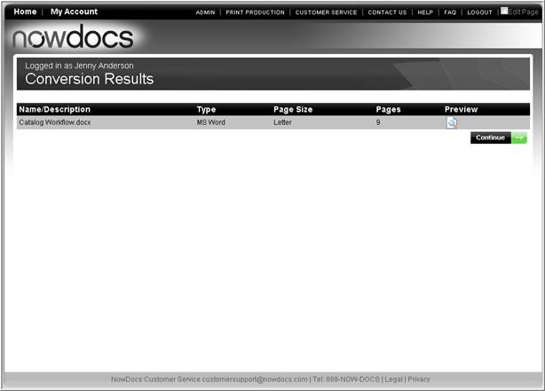

- Click the Preview icon to ensure verify the file conversion.
- Exit the preview and click the Continue button.

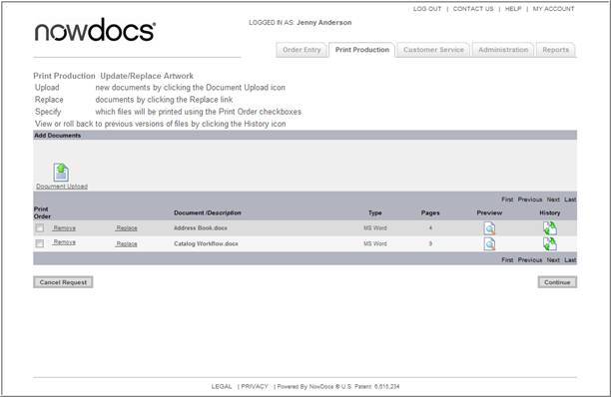

Replace File

Use the following steps to replace an order file:

1 Click on the Print Production link to access the Production Queue.
2 Click on the Order.
3 In the Order Ticket, select Order Adjustments.
4 Select Replace Order Files.

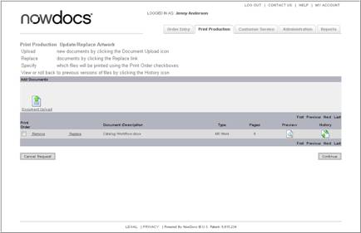

5 Click the Replace link for the appropriate file.

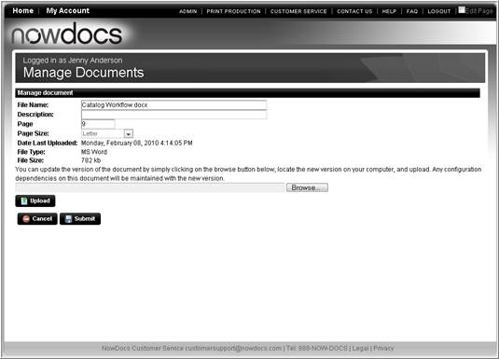

6 Click the Browse button.
7 Locate the new version on your computer.
8 Click the Upload button.
9 Click the Submit button.

View Version History

Use the following steps to view the addition, replacement, or deletion of files for an order:

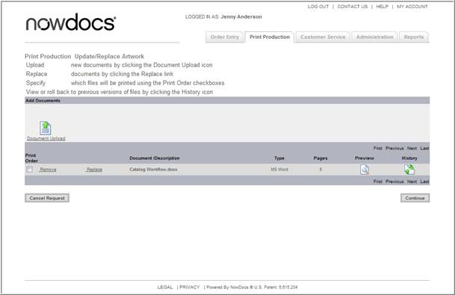

- Click the History link.

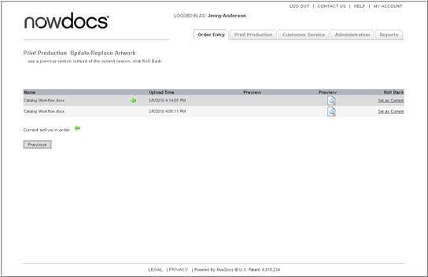

The green arrow () indicates the active document for the file.

Set Order Exception

Setting a job exception indicates that there is an error associated with the order. You can set job exceptions to note any issues experienced while producing the order.

Use the following steps to add Set an Order Exception:

- Click on the Print Production link to access the Production Queue.
- Click on the Order.
- In the Order Ticket, select Order Adjustments.
- Select Set Order Exception.

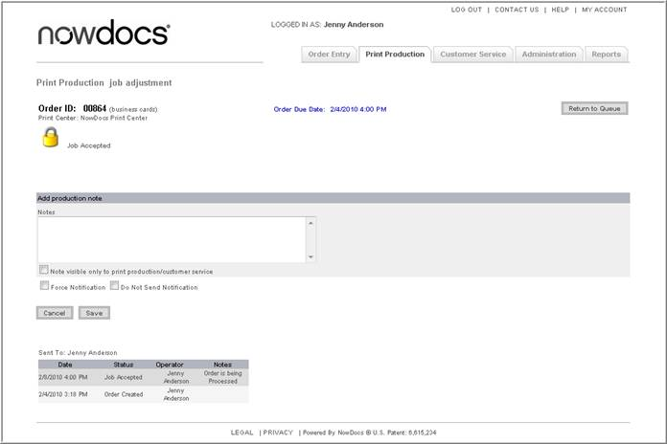

- Enter an explanatory note in the Notes field.
- Select the checkbox Note visible only to print production/customer service if you would like the note to be visible only to production and customer service staff, and not to the buyer who placed the order.
- Select the Force Notification checkbox if you would like to send an email notification of the job exception to the buyer who placed the order.
- Select the Do Not Send Notification checkbox if you do not want to notify the buyer by email of the job exception.
- Click the Save button.

Cancel Order

If an order needs to be cancelled out of the system, the Cancel Order function is utilized.

Use the following steps to Cancel an Order:

- Click on the Print Production link to access the Production Queue.
- Click on the Order.
- In the Order Ticket, select Order Adjustments.
- Select Cancel Order.

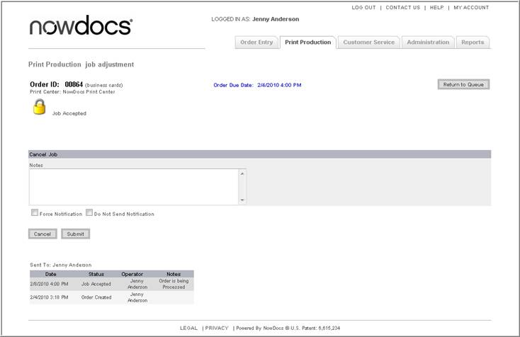

- Enter notes indicating the reason for cancellation.
- Select the notification preference.
  - Force Notification
  - Do not Send Notification
- Click the Submit button.

Split Job
You can split a job by quantity; for instance, if a certain amount is needed by an earlier date.

Use the following steps to Split a Job:

- Click on the Print Production link to access the Production Queue.
- Click on the Order.
- In the Order Ticket, select Order Adjustments.
- Select Split Job.

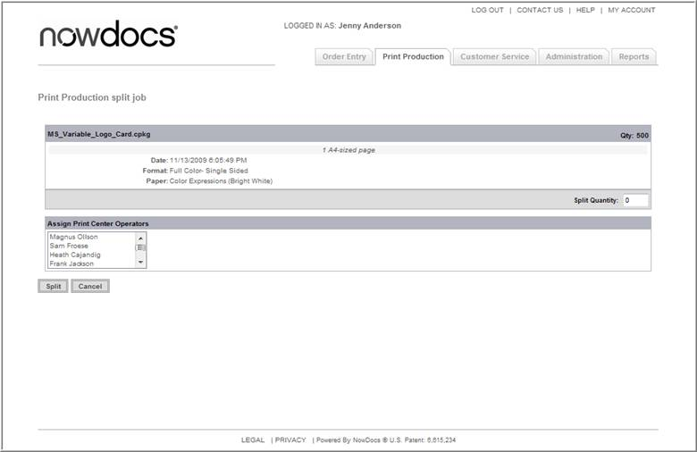

- Enter the split quantity.
- Select a Print Center Operator.
- Click the Split button.

Editing Device Usage

In cases where impressions are being tracked by meter reads, you can adjust the meter readings for an output device.

Use the following steps to Edit Device Usage:

- Click on the Print Production link to access the Production Queue.
- Click on the Order.
- In the Order Ticket, select Order Adjustments.
- Select Device Usage.

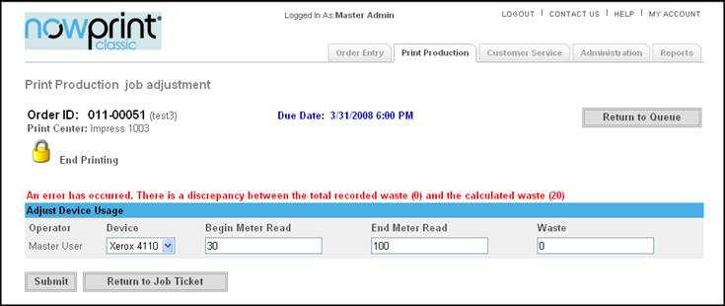
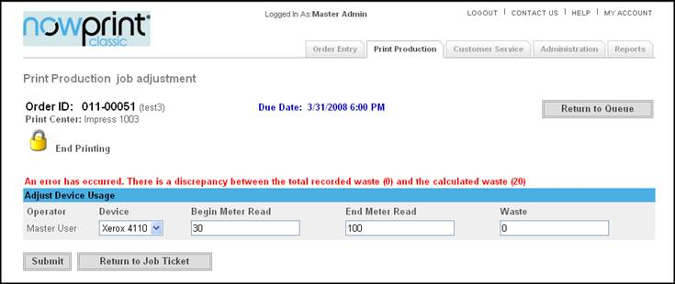
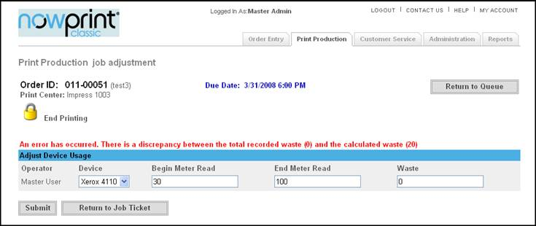
Select the output device from the Device drop-down menu.
- Adjust the meter readings by changing the values in the Begin Meter Read, End Meter Read, and/or Waste fields.
- Click the Submit button.

Adjust Price Prompt Items

You can adjust price prompt items to set the correct sell and cost values. Line items associated with those items will be updated.

Use the following steps to Adjust Price Prompt Items:

- Click on the Print Production link to access the Production Queue.
- Click on the Order.
- In the Order Ticket, select Order Adjustments.
- Select Adjust Price Prompt Items.

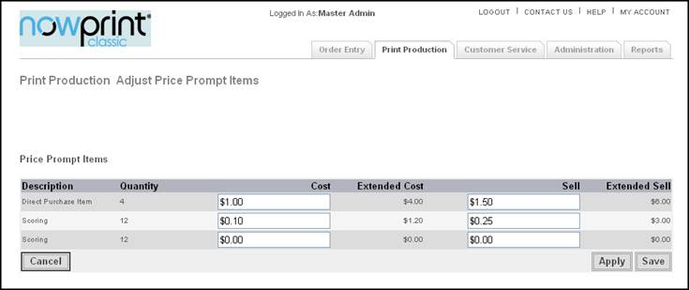

- Enter the appropriate values in the Cost and Sell fields for each price prompt item.
- Click the Save button.

Manage Line Item Price

Line item pricing skus can be adjusted on an individual order.

Use the following steps to Manage Line Item Prices:

- Click on the Print Production link to access the Production Queue.
- Click on the Order.
- In the Order Ticket, select Order Adjustments.
- Select Manage Line Item Price.

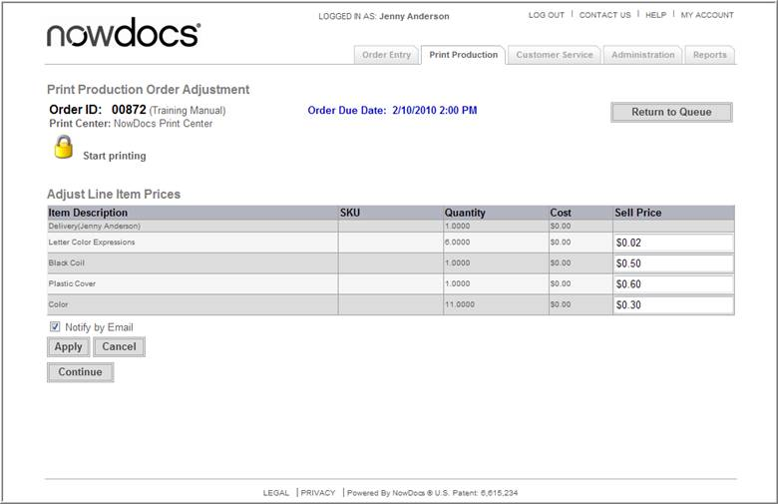

- Change the price for the desired line item/sku.
- Select the Notify by Email checkbox if you would like to send an email notification of the adjustment to the buyer who placed the order.
- Click the Continue button.

Manage Alerts

You can trigger alerts for an order. The alerts you choose to set will be displayed on the Order Ticket.

Use the following steps to Manage Alerts:

- Click on the Print Production link to access the Production Queue.
- Click on the Order.
- In the Order Ticket, select Order Adjustments.
- Select Manage Alerts.

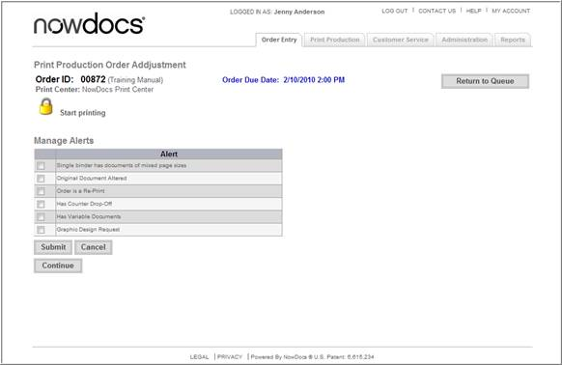

- Click the checkbox next to the alert(s) you would like to set. Also, uncheck the alert that you want to hide on the job ticket page.
- Click the Submit button.
- Click the Continue button

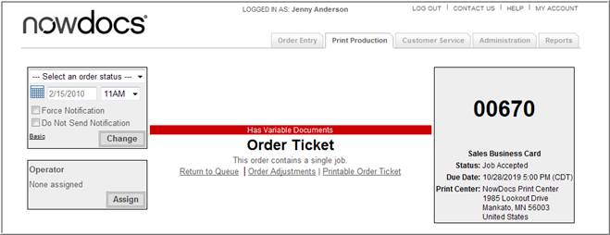

This Order Ticket has a sample alert for Variable Documents.

Printable Order Ticket

An Order Ticket can be printed to maintain paper tracking of an order.

Use the following steps to Print an Order Ticket:

- Click on the Print Production link to access the Production Queue.
- Click on the Order.

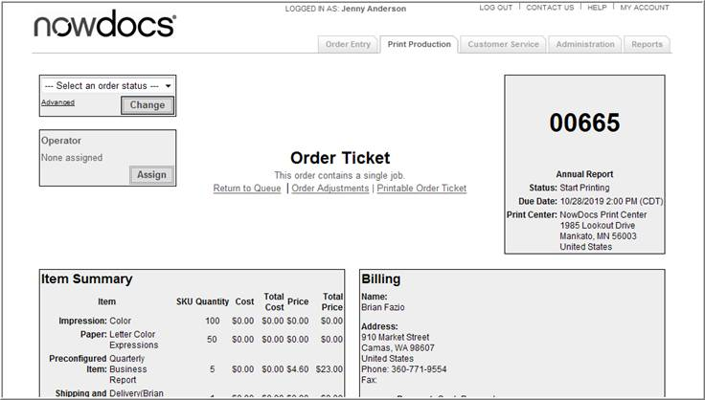

- In the Order Ticket, select Printable Order Ticket.

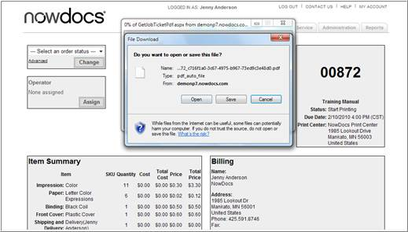

- To view the Order Ticket, click the Open button. To Save the Order Ticket click the Save button.

Shipping Slip

A Shipping Slip can be printed to be used for the order.

Use the following steps to Print an Order Ticket:

- Click on the Print Production link to access the Production Queue.
- Click on the Order.

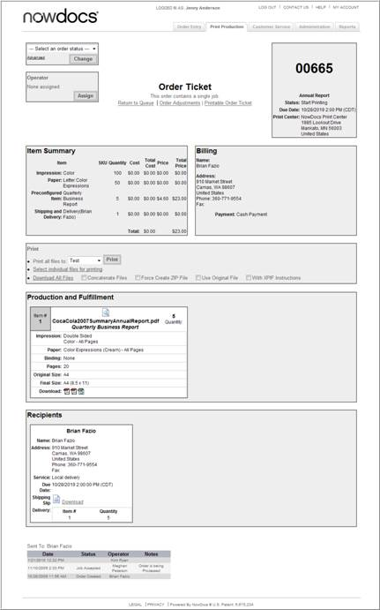

- Click on the Download link in the Recipients section of the Order Ticket.

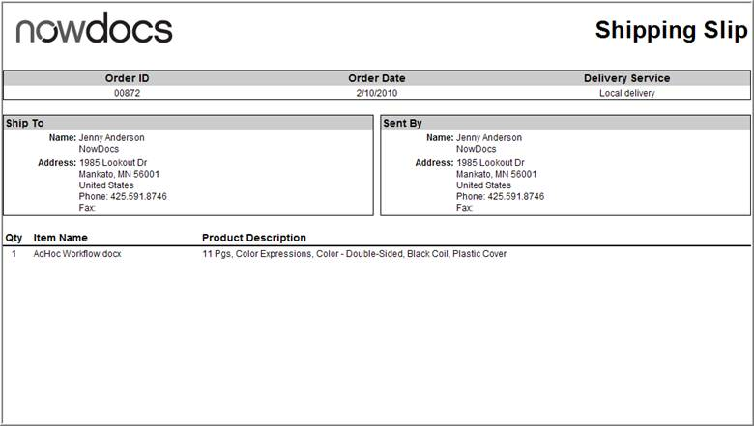

Index

A
Access Rights 25
Access Roles 5, 25
Access Roles setting 25
Accessing 122
Personal 122
Account 1
Account Admin 5
Account Overview 2
Ad Hoc 121
Add 5, 25, 121, 144, 148, 151, 172, 187, 192, 197, 199, 232, 236, 238
Production Note 232
Add Additional Costs 238
Add Document 192
Add New Folder 144
Add New User 5, 25
Add Recipient 148
Add Tabs 172, 197, 199
Adding new users during 5
Address Book 5, 147, 150, 151, 153, 154
Address Book Directory 151
Address Field Settings 43
Address Fields 43
Addresses 5, 43, 147, 151, 153, 154
AdHoc Workflow 191
Adjust Billing Information 239
Adjust Order Configuration 240
Adjust Price Prompt Items 253
Admin 5, 12, 25
Admin Capabilities 5
Admin Home Overview 12
Adobe InDesign 93
All 5, 217
All Users 5
AND 217
Approver 25
Approvers 25
Assign Order 224
Print Operator 224
B
Basic File Upload Workflows 121
Batch Process Orders 227
Browse 25
Bulk Load Users 25
C
CA 5
Cancel 5, 167, 249
Order 249
Cancel Order 5, 167, 249
Carriers 5
Catalog 25, 121, 128, 183, 187
Catalog Items 128, 184, 187
Catalog Order Shopping Cart 187
Catalog Workflow 25, 121, 183
Change 5, 177, 214, 218, 233
Order Due Date 233
Production Queue Settings 218
Change Password 177
Columns 25
Contact Info 14
Contact Us 180
Continue 172, 187, 255
Continue Shopping 187
Copy Recipient 152
Copy Selected Items 143
Corporate 4, 5, 11, 25, 121
Corporate Account 4, 5, 11, 25, 53, 121
Corporate Account Admin 11
Corporate Account Group 25
Corporate Account Settings 4, 25
Corporate Default 25, 121, 184
Cost 253
Counter Drop 208
Placing 208
Create Kit 138
Creating 93, 97
Personalized Product 93, 97
Credit 5
CSM 5
CSM group 5
CSR 5
defined 5
described 5
CSR group 5
CSV 25, 154, 199
Custom Data Fields 44
Customer Service 5, 11, 211, 213, 214
Customer Service Capabilities 5
Customer Service Queue 5, 213, 214
Customer Service Queue Settings 214
Customer Service Representative 5
Customize Columns 25
Customize Edit User Display 25
Customized 25, 183
D
Defined 5
CSR 5
Delete Files 146
Delete Recipient 153
Delete User 25
Deleting 120
Personalized Product 120
Delivery Custom Data Fields 52
Delivery Options 200
Described 5
CSR 5
Description 5
Device Usage 5, 251
Document Catalog 184
Downloading 226
Dropdown list 25, 239
E
Edit 5, 25, 119, 121, 133, 172, 176, 182, 187, 251
Device Usage 251
Edit Account 176
Edit Page 182
Edit Preconfigured Item 133
Edit Reorder 172
Personalized Product 119
F
Filing Cabinet 5, 25, 121, 122, 124, 125, 203
Filing Cabinet Options 124
Filing Cabinet Overview 121
Filter 25
Folders 121, 146
Force Notification 249
Functionality Settings 15
Functions 9, 121, 249
G
Getting Started 1
Group 5, 25, 35, 121
Group Address Book 25
Group Approver 25
Group Display 25
Group Filing Cabinet 25
Group Payment Options 25
H
Homepage 151, 154
I
InDesign File 135
Inventory 5
Items 5, 53, 121, 253
L
Locate 25
Registration Template 25
Login Information 176
M
Manage Address Book 148, 150, 151, 154
Manage Alerts 255
Manage Groups 5, 35
Manage Items 5
Manage Line Item Price 254
Manage Users 5, 25
Manager 5, 25, 88
Map Selected Items 145
Microsoft Publisher 97
Modify Order 163
Modify Payment Options 172
Modify Recipient 149, 172
Move Recipient 150
Move Selected Items 142
My Account 151, 175
N
NowPrint 5
NowPrint ASAP 1
NowPrint ASAP site 1
O
Online Help 1
Order Adjustments 5, 230, 239, 249, 253, 255
Order Approver 25
Order Confirmation 190, 202
Order Defaults 78
Order Due Date 233
Order Entry 5, 11
Order Entry Capabilities 5
Order ID 217
Order needs 249
Order Note 5
Order on Behalf 5, 11
Order Options 172
Order Status 221
Order Templates 76
Order Ticket 220, 239, 249, 253, 255
Order Using Order Templates 205
Order Workflows 79, 183, 191
Orders 5, 25, 76, 78, 79, 121, 161, 172, 178, 185, 187, 189, 190, 191, 202, 203, 205, 217, 220, 221, 230, 233, 239, 249, 253, 255
Cancel 249
Personalized Products 185
Placing 191
Preferences 178
Searching 217
Track 161
Orders belonging 217
P
Page Exceptions 172, 197
PCA 5
PCA group 5
PCM 5
PCM group 5
Permissions 121
Personal 121, 122, 125, 203
Accessing 122
Upload File 125
Personalized Products 92, 93, 97, 100, 116, 119, 120, 185
Creating 93, 97
Deleting 120
Editing 119
Ordering 185
Preconfiguring 116
Uploading 100
PFS 5
PFS group 5
Place Order 189, 191, 201
Preconfiguring 116
Personalized Product 116
Preferences 178, 249
Ordering 178
Print 5, 47, 172, 195, 215, 224, 226, 235, 236
Upload Document 172
Print Buyers 5
Print Center Transfer 235
Print Centers 5, 47, 191, 217, 235
Print Central Administrator 5
Print Fulfillment Specialist 5
Print Operator 5, 224
Assign Order 224
Print Options 172, 191, 195
Print Production 5, 11, 25, 215, 236, 239, 249, 253, 255
Print Production Charge 236
Print Production Queue 25, 215
Print Production Capabilities 5
Print Production Coordinator 5
Printable Order Ticket 256
Printing Files 226
Production Download 228
Production Note 232
Production Queue 218, 239, 249, 253, 255
Changing 218
Production Queue Settings 218
Purchase Orders 5
Q
Quantity 187
Quotes 5
R
Recipient Address Information 148
Registration Template 25
Remove 25, 187
User 25
Reorder 171, 172
Replace File 246
Replace Order Files 243
Report Capabilities 5
Report Writer 5
Reports 5, 11, 157
Reprocess Order 234
Review 201
S
Sales function 121
Sales Manager 5
Sales Representative 5
Searching 213, 217
Orders 217
Select 25, 188
Select Payment Type 239
Select Recipients 188
Senior Level 5
Senior Level Operations Staff 5
Set Order Exception 248
Set Shipment Tracking Number 242
Shipping Slip 257
Standard Catalog Items 184
Status Emails 24
Submit 25, 249, 255
T
Tab Wizard 198
Track 5, 161
Tracking Number 5
Transaction History 160
U
Unmap Print Centers 35
Unmap Services 35
Update Access Roles 25
Update Order Status 222
Update User Group Access Roles 25
Update User Roles 25
Upload 128, 135, 154
Upload CSV 154, 199
Uploading 100, 128, 135, 154
InDesign File 135
Personalized Products 100
User Access 5
User Access Roles 5
User Interface 18, 25
User Settings 25, 121
User's access 25
V
Variable Data Items 184
Variable Documents 255
Vendors 5
View Order 169
View Version History 247
W
Website 79
Wide 79, 121
Workflows 11, 79, 121

